

Draft CfP Phase 2 / Testing and Evaluation:
TV 3.0 Project
____________________________________

15 September 2020

Brazilian Digital Terrestrial Television System Forum
Table of Contents
1 Introduction 6
2 Glossary 8
3 TV 3.0 Architecture 12
4 TV 3.0 Testing and Evaluation 12
4.1 General Aspects 13
4.2 Over-the-air Physical Layer 16
4.2.1 Conditions for Laboratory Test 17
4.2.1.1 Equipment to be provided by the proponent 17
4.2.1.2 General test parameters and setups 18
4.2.1.3 Propagation channel models – Channel Ensembles 18
4.2.1.4 MIMO setup 21
4.2.1.5 Basic SISO/MIMO setup 22
4.2.2 Conditions for Field Test 24
4.2.2.1 Infrastructure available in the field 24
4.2.2.2 Equipment available in the stations 27
4.2.2.3 Equipment to be provided by the proponent 28
4.2.3 Laboratory Tests 28
4.2.3.1 Device Verification Tests 28
4.2.3.1.1 RF frequency accuracy (precision) 29
4.2.3.1.2 Phase noise of local oscillators 29
4.2.3.1.3 RF/IF signal power 30
4.2.3.1.4 RF out of band emissions and linearity characterization (Spectrum Mask) 31
4.2.3.1.5 I/Q analysis – Constellation and MER 31
4.2.3.2 Evaluation Tests 32
4.2.3.2.1 C/N - Carrier power vs AWGN 32
4.2.3.2.2 C/N - Carrier power vs Rayleigh and AWGN 35
4.2.3.2.3 Receiver maximum and minimum level 39
4.2.3.2.4 Co-channel Interference with own system 41
4.2.3.2.5 Co-channel and adjacent channel interference (at N±1 and N±2 channels) to ISDB-T 44
4.2.3.2.6 Impulse noise 46
4.2.3.2.7 Single echo static multipath interference 50
4.2.3.2.8 Channel bonding 52
4.2.3.2.9 Channel identification stability in frequency reuse-1 condition 54
4.2.3.2.10 FM Radio (88 to 108 MHz) Interference 54
4.2.4 Field Tests 57
4.2.4.1 Scope 57
4.2.4.2 Coverage Measurement 61
4.2.4.3 Service Measurement 61
4.2.4.4 Drive Test 62
4.2.4.5 RF Capturing 63
4.3 Transport Layer 63
4.3.1 Conditions for tests 66
4.3.1.1 Equipment to be provided by the proponent 66
4.3.1.2 Files to be provided by the proponent 66
4.3.1.3 Laboratory’s equipment 67
4.3.1.4 General test conditions 67
4.3.1.5 Testing cases 68
4.3.1.6 Setup for tests 69
4.3.2 Laboratory Tests 73
4.3.2.1 System Tests 73
4.3.2.1.1 Enable frame-accurate synchronization of video, audio, and data for single or multi-platform (TL1.1 and TL1.2) 73
4.3.2.1.2 Multiplexing latency (TL3.1) 75
4.3.2.1.3 Measure % of Overhead (TL3.3) 76
4.3.2.2 System Verification 77
4.3.2.2.1 Check ease to rebroadcast content over different distribution platforms (TL2.1 and TL2.2) 77
4.3.2.2.2 Check error detection mechanism in over the air delivery as well as in the internet delivery (TL3.2) 77
4.3.2.2.3 Check if it avoids unnecessary metadata duplication (TL3.4) 78
4.3.2.2.4 Check internet content delivery with encryption (TL4.1) 78
4.3.2.2.5 Check the possibility of TV network, originating station, and transmission station identification (TL5.1) 78
4.3.2.2.6 Check the emergency warning message transmission signaling (TL6.1) 79
4.3.2.2.7 Check internet-based wake-up capability (TL7.1) 79
4.3.2.2.8 Check Support as much as possible the same Alerting Protocol used by the Brazilian Government, or a similar one (TL8.1) 80
4.3.2.2.9 Check flexible geographic targeting for emergency warnings (TL9.1 – TL9.7) 80
4.3.2.2.10 Check future extensions to the transport layer (TL10.1) 81
4.4 Video Coding 81
4.4.1 Documentation analysis 85
4.4.2 Subjective quality assessment reports 85
4.4.3 Features and objective performance evaluation 86
4.4.3.1 Test 1 (Video resolution) 94
4.4.3.2 Test 2 (Dynamic range) 97
4.4.3.3 Test 3 (Temporal resolution) 105
4.4.3.4 Test 4 (Video coding quality) 106
4.4.3.5 Test 5 (Video end to end latency) 106
4.4.3.6 Test 6 (Sign language) 108
4.4.3.7 Test 7 (Video emergency warning information) 108
4.4.3.8 Test 8 (New immersive video services) 109
4.4.3.9 Test 9 (Seamless decoding and A/V alignment) 110
4.4.3.10 Test 10 (Interoperability with different distribution platforms) 111
4.4.3.11 Test 11 (Video scalability and extensibility) 111
4.5 Audio Coding 115
4.5.1 Documentation analysis 117
4.5.2 Subjective quality assessment reports 118
4.5.3 Features evaluation 118
4.5.3.1 Test 1 (Immersive audio) 121
4.5.3.2 Test 2 (Interactivity and personalization) 123
4.5.3.3 Test 3 (Audio description) 131
4.5.3.4 Test 4 (Audio emergency warning information) 136
4.5.3.5 Test 5 (Flexible audio playback configuration) 138
4.5.3.6 Test 6 (Consistent loudness) 139
4.5.3.7 Test 7 (Seamless configuration changes and A/V alignment) 142
4.5.3.8 Test 8 (Audio coding efficiency) 150
4.5.3.9 Test 9 (Audio End to end latency) 151
4.5.3.10 Test 10 (A/V synchronization) 151
4.5.3.11 Test 11 (New immersive audio services) 152
4.5.3.12 Test 12 (Interoperability with different distribution platforms) 153
4.5.3.13 Test 13 (Audio scalability and extensibility) 154
4.6 Captions 155
4.6.1 Documentation analysis 156
4.6.2 Features and subjective performance evaluation 156
4.6.2.1 Test 1 (Frame-accurate synchronization) 158
4.6.2.2 Test 2 (Character set) 159
4.6.2.3 Test 3 (Live and offline closed-captioning) 160
4.6.2.4 Test 4 (Text styling control) 160
4.6.2.5 Test 5 (Displaying non-textual information) 164
4.6.2.6 Test 6 (Multiple caption streams) 164
4.6.2.7 Test 7 (Emergency warning information) 165
4.6.2.8 Test 8 (Interoperability with different platforms) 166
4.7 Application Coding 166
4.7.1 Expected deliverables 169
4.7.2 Common testing environment specification 170
4.7.2.1 Network subsystem 172
4.7.2.2 Presentation subsystem 172
4.7.2.3 Companion subsystem 173
4.7.3 Common testing steps 174
4.7.4 Evaluation methodology 175
4.7.5 Requirement-specific notes 177
5 Schedule 191
5.1 Responding to Phase 2 of the TV 3.0 Call for Proposals 192
6 SBTVD Forum Disclaimer 193

Introduction
The SBTVD Forum was created by the Brazilian Presidential Decree # 5 280 / 2006, to advise the Brazilian Government regarding policies and technical issues related to the approval of technical innovations, specifications, development, and implementation of the Brazilian Digital Terrestrial Television System (SBTVD). The SBTVD Forum is composed of representatives of the broadcasting, academia, transmission, reception, and software industry sectors, and has the participation of Brazilian Government representatives as non-voting members.
Free-to-air terrestrial television is the main audiovisual distribution platform in Brazil, covering almost all Brazilian households and used in more than 70% of them. It secures to most of the Brazilian population a free-of-charge, universal and democratic access to information and entertainment, made by Brazilians for Brazilians. It is, therefore, an important social cohesion, national, and cultural identity factor.
For its first generation Digital Terrestrial Television system, after thorough testing and careful studies, the Brazilian Government adopted in June 2006 the ISDB-T standard, incorporating technological innovations that were deemed relevant, such as MPEG-4 AVC (H.264) video coding, MPEG-4 AAC audio coding, an appropriate closed caption character set for the Brazilian Portuguese, and a new middleware for interactive applications (Ginga).
The SBTVD Forum developed the first SBTVD standards, that were published in 2007, allowing the official opening of transmissions in that same year. Since then, the standards have been continuously revised and updated by the Forum. The technological innovations proposed by Brazil were incorporated into the International ISDB-T standard, which is currently adopted by 20 countries.
In 2016, Brazil started a safe and gradual analog TV switch-off process, that was designed to assure that no one would be deprived of the terrestrial free-to-air TV. The process was divided into two stages: in the first stage (2016 to 2019) the analog television switch-off was performed in all the state capitals, metropolitan areas, and other areas where it was required to release the 700 MHz band; on the second stage (up to 2023) the analog television switch-off would be performed in the remaining of the country. During the first stage, 1 362 cities in 47 different clusters were impacted, accounting for nearly 128 million people (62% of the population). More than 12 million Digital TV reception kits were distributed for low-income families. The analog switch-off had no significant impact on the free-to-air terrestrial TV audience. Regarding the second stage, the remaining 38% of the population (more than 79 million people) is distributed in 4 208 cities. After the implementation of Digital Terrestrial Television Brazil adopted an industrial policy that determined that all flat-panel TVs manufactured from 2012 must have an integrated Digital TV receiver and from 2013 no more CRT TVs were manufactured. Therefore, it is anticipated, based on the expected product lifetimes, that by 2023 Brazil would have nearly all its TV sets already equipped with an integrated Digital TV receiver, thus facilitating the analog television switch-off without additional Digital TV reception kits distribution.
As the Brazilian digital television switch-over began, the SBTVD Forum started considering the next steps for the evolution of the Brazilian Television. The analog TV (that we conventionally call "TV 1.0"), which started in Brazil in 1950, was black and white with monophonic sound. Then, some backward-compatible improvements (that we conventionally call "TV 1.5"), such as color (in the 1970s), stereo sound and closed caption (in the 1980s) were added to it. From 2007, the first generation of Digital Terrestrial Television (that we conventionally call "TV 2.0") was introduced in Brazil, bringing high-definition video, surround sound, mobile reception, and interactivity. Since then, the technological landscape has changed a lot. The rhythm of development and introduction of innovations is increasingly accelerated. These innovations create new consumption habits and increase the expectations of technological services users regarding the quality and convenience of these services. Since the introduction of SBTVD, new immersive audio and video formats have emerged, and are already present in the new TV sets available in the market. The TV sets currently available have resolution and contrast greater than those supported in the first generation SBTVD standard. That is the opposite of the market situation when Digital TV was launched in Brazil, as the HDTV sets offer was very low. The availability and the speed of Internet access in Brazil, especially in metropolitan areas, increased significantly, enabling the consumption of on-demand audiovisual content. This connectivity is already in use by TV sets (Smart TVs) and by broadcasters’ Over-The-Top (OTT) offers. However, in the first generation SBTVD standard, there was not an integration between the broadcasting service and the Internet content offer. Furthermore, new techniques for signal coding, transport, and modulation were also developed, allowing greater efficiency in audiovisual transmission. Many Digital Terrestrial Television systems have also been evolving, including in this evolution not only enhancements in quality and efficiency but also new convergent services between the broadcasting and the Internet. Based on this technological landscape, the SBTVD Forum recognized the necessity to evolve the SBTVD. It also acknowledged that changing the physical layer, the transport layer, and/or audiovisual coding would not be backward-compatible. Nevertheless, the transition to a new generation of Digital Terrestrial Television is a long process, based on the investments required for both broadcasters and consumers and the expected life span of TV transmitters and receivers. It was, therefore, deemed necessary to increase the life span of the existing Digital Terrestrial Television system as much as possible through a backward-compatible evolution (a project we called "TV 2.5") and to start the development of the next generation Digital Terrestrial Television system (the project we called "TV 3.0").
The "TV 2.5" project comprised two aspects: broadcast-broadband integration and audiovisual quality. The first aspect involved the development of a new receiver profile for the middleware Ginga (receiver profile D, a.k.a. "DTV Play"), addressing use cases such as on-demand video, synchronized companion device, audiovisual enhancement over the Internet, and targeted content. The second aspect was addressed through the introduction of three new optional immersive audio codecs (MPEG-H Audio, E-AC-3 JOC, and AC-4) while retaining MPEG-4 AAC main audio for backward-compatibility, and through the introduction of two new optional HDR video formats (SL-HDR1 dynamic metadata and HLG "preferred transfer characteristics" signaling) while keeping MPEG-4 AVC (H.264) / 8-bit / BT.709 / 1080i for backward-compatibility. The revision of the SBTVD standards containing both "TV 2.5" aspects has already been published (available at https://forumsbtvd.org.br/legislacao-e-normas-tecnicas/normas-tecnicas-da-tv-digital/english/).
For the "TV 3.0" project, the SBTVD Forum, after agreeing on its requirements (use cases and corresponding technical specifications), decided to release a Call for Proposals (available at https://forumsbtvd.org.br/wp-content/uploads/2020/07/SBTVDTV-3-0-CfP.pdf) for any interested organization to submit its proposed candidate technologies for any of the system components or sub-components. The new system is expected to start operating in the next few years, but based on the Brazilian experience on the transition from analog to digital television, the complete transition from the current SBTVD to the TV 3.0 is expected to last at least 15+ years.
As described in the aforementioned Call for Proposals document, the response to this Call for Proposals is divided into two phases.
Phase 1 responses are due by 30 November 2020. It comprises the identification of each proposed candidate technology and appropriate contact persons and filling the compliance form of the appropriate components or sub-components corresponding to the proposed candidate technology. Please note that if the proponent is a for-profit organization, SBTVD Forum membership will be required for the submission of the proposal. Responses shall be provided using the online form available at https://forms.gle/6DUWE9bFVbHFou4n8.
Phase 2 responses are due by 29 January 2021. It comprises providing the full specification of the proposed candidate technology and adhering to the SBTVD Forum Intellectual Property Rights Policy and the additional requirements considering general information and resources needed for evaluating and comparing the proposed candidate technologies.
This document provides further information and requirements for Phase 2, along with the test procedures for evaluating and comparing the proposals of candidate technologies and instructions on providing Phase 2 responses.

Glossary
2.0 stereo (two full-bandwidth channels) sound
3D Three-Dimensional
3DoF Three Degrees of Freedom
5.1 surround (five full-bandwidth channels and one low-frequency effects channel) sound
5.1 + 4H 3D (five full-bandwidth channels, one low-frequency effects channel, and four overhead channels) sound
6DoF Six Degrees of Freedom
A/V Audio / Video
ABNT Associação Brasileira de Normas Técnicas (Brazilian Technical Standards Association)
ADM Audio Definition Model
API Application Programming Interface
AR Augmented Reality
AWGN Additive White Gaussian Noise
BD Bjøntegaard Delta
BER Bit Error Rate
BW64 Broadcast Wave 64-bit
C/N Carrier-to-Noise ratio
DCI Digital Cinema Initiatives
DM Dynamic Mapping
DTH Direct-To-Home
DTT Digital Terrestrial Television
DTTB Digital Terrestrial Television Broadcasting
FER Frame Error Rate
fps frames per second
GPS Global Positioning System
HDMI High-Definition Multimedia Interface
HDR High Dynamic Range
HEVC High Efficiency Video Coding
HLG Hybrid Log-Gamma
HOA Higher-Order Ambisonics
HW Hardware
IEEE Institute of Electrical and Electronics Engineers
IP Internet Protocol
IPTV Internet Protocol Television
ISDB-T Integrated Services Digital Broadcasting-Terrestrial
ITU International Telecommunications Union
MER Modulation Error Rate
MFN Multi-Frequency Network
MIMO Multiple-Input and Multiple-Output
MOS Mean Opinion Score
MUSHRA MUltiple Stimuli with Hidden Reference and Anchor
MS-SSIM Multi-Scale Structural Similarity Index Measure
NBR Norma Brasileira Regulamentadora (Brazilian National Standard)
NTP Network Time Protocol
OASIS Organization for the Advancement of Structured Information Standards
OFDM Orthogonal Frequency-Division Multiplexing
OTA Over-the-air (broadcast delivery)
OTT Over-the-top (internet delivery)
P1dB 1 dB compression point
PCap Packet Capture
PNG Portable Network Graphics
PPS Pulse Per Second
PQ Perceptual Quantizer
PR Protection Ratio
PSNR Peak Signal to Noise Ratio
QEF Quasi Error Free
QP Quantization Parameter
reuse-1 the use of the same RF channel by independent stations covering adjacent service areas
RF Radio Frequency
RF64 RIFF/WAVE Format 64-bit
SBTVD Sistema Brasileiro de Televisão Digital (Brazilian Digital Television System)
SDI Serial Digital Interface
SDO Standards Developing Organization
SDR Standard Dynamic Range
SFN Single-Frequency Network
SISO Single-Input and Single-Output
STB Set-Top Box
SW Software
TIFF Tagged Image File Format
TOV Threshold Of Visibility
UHF Ultra High Frequency
VHF Very High Frequency
VR Virtual Reality
WCG Wide Color Gamut
wPSNR Weighted PSNR
XR eXtended Reality
YUV uncompressed ("raw") video file format, using one luma component (Y') and two chrominance components (U and V)

TV 3.0 Architecture
The TV 3.0 system components described in this document reflect the reference TV 3.0 architecture, as depicted in Figure 1.
 |  | Application Coding
Video Coding |  | Audio Coding |  | Captions
Transport Layer
Over-the-air  Physical Layer |  |  |  | Broadband Interface
Figure 1: TV 3.0 Architecture
For further information about TV 3.0 architecture, please refer to the TV 3.0 Call for Proposals document.

TV 3.0 Testing and Evaluation
Subsection 4.1 introduces TV 3.0 general testing and evaluation aspects, and the following subsections (4.2 to 4.7) introduce the specific testing and evaluation aspects of each system component, as described in the TV 3.0 Architecture (see Section 3).

General Aspects
Per convention, this document adopts the following definitions:
- shall: this word, or terms “required” or “must”, indicates specific provisions that are to be followed strictly (no deviation is permitted).
- shall not: this phrase, or the phrase “must not”, indicates specific provisions that are absolutely prohibited.
- should: this word, or the adjective “recommended”, indicates that a certain course of action is preferred but not necessarily required.
- should not: this word, or the adjective “not recommended”, indicates that a certain possibility or course of action is undesirable but not prohibited.
The proposals of candidate technologies will be tested and evaluated against the requirements set in the TV 3.0 Call for Proposals document, by the SBTVD Forum appointed Test Labs, according to the procedures established in this document.
The proponents are also encouraged to submit detailed information about the features that exceed the TV 3.0 requirements.
Additional tests and evaluations can be performed by the SBTVD Forum, at its own discretion.
All Test Labs will be required to implement a procedural recording subsystem. Full HD video (i.e., spatial resolution 1 920 x 1 080 pixels) and audio will be captured in real-time for documenting and auditing purposes. A/V Camera shall focus on a scene that includes all the test setup and lab analysts. The procedural recording is a separate subsystem that does not interfere with any other test subsystem.
The Test Lab cannot be a proponent organization. All the tests shall be executed by a group of at least two lab analysts. The lab analysts shall not have a personal or working relationship with the proponents.
The proponents shall make available all the resources (documentation, hardware, software, etc.) needed for evaluating and comparing the proposed candidate technologies, as specified in Subsections 4.2 to 4.7 for each system component or sub-component. Unless otherwise specified, the required equipment can be implemented and provided as a combination of multiple hardware and/or software modules, provided that it enables the specified test with the appropriate interfaces. Likewise, multiple required equipment can be implemented in a single module and this is acceptable as long as all tests can be accomplished.
The tests that assess minimum technical specifications not indicated in the TV 3.0 Call for Proposals document as "required" for neither over-the-air delivery nor for Internet delivery are optional. Therefore, the proponent may not provide the resources that are specific for these tests, if the proposed technology does not meet these "desirable" or "recommended" minimum technical specifications. Proponents of the Physical Layer, Transport Layer, Audio Coding and Captions shall meet all the minimum technical specifications required in the respective component and shall provide at least all the resources needed for the tests that are not optional. Proponents of the Video Coding may address only a set of the sub-components as specified in 4.4 and provide the corresponding resources. Proponents of the Application Coding can address a subset of the minimum technical specifications as specified in 4.7 and provide the corresponding resources.
The proponent test resources will be provided to the SBTVD Forum, which will make them available to the appropriate Test Lab. The Test Lab may be required by the proponent to sign specific license agreements for using the test resources provided. The proponents and the Test Lab analysts shall not interact directly, except during presentations, training, and support sessions arranged by the SBTVD Forum. Any further communication required shall be intermediated by the SBTVD Forum. SBTVD Forum will provide an efficient communication channel that works 24/7.
The proponents are encouraged (and in some cases required) to implement the test setups and perform the test procedures as specified in this document. The proponent's test results report should be sent to the SBTVD Forum to enable cross-checking the results.
Test Labs will cross-check if proponents’ results can be reproduced. If results differ, the Test Lab shall inform the proponent (through SBTVD Forum intermediation) and make a reasonable effort to clarify the issue. The Test Lab is responsible for the publication of final test results.
As indicated in the TV 3.0 Call for Proposals document, the proponent's documentation for Phase 2 should also include the full specification of the proposed candidate technology (GT3 and GT4) and adhering to the SBTVD Forum Intellectual Property Rights Policy (GI3). GT3, GT4, and GI3 are repeated here for the convenience of the reader:
GT3. All technical proposals shall be fully specified, preferably in technical standards of internationally recognized SDOs.
GT4. The full specification of the technical proposal shall be made available for the SBTVD Forum free of charge.
GI3. All technical proposals licensing or any other form of commercialization shall adhere to fair, reasonable, and non-discriminatory terms, as specified in the SBTVD Forum Intellectual Property Rights Policy (see the TV 3.0 Call for Proposals document, Annex A).
All proponents are also required to commit to contributing with SBTVD Forum on drafting the TV 3.0 normative specifications and implementing its conformity assessment tests (reference implementations, reference streams, test suites, etc.) if their proposed candidate technologies are fully or partially adopted.
The failure to submit Phase 1 and/or Phase 2 responses before their deadlines, or to make all the required documentation and all the resources needed for testing and evaluation procedures arrive in time in the SBTVD Forum, according to the schedule detailed in Section 5, may cause the proposal not to be considered by SBTVD Forum.
The testing and evaluation reports produced by the Test Labs are going to be made publicly available by the SBTVD Forum. They are supposed to support the SBTVD Forum decision on which proposed candidate technologies to recommend for adoption by the Brazilian Government for the next generation Digital Terrestrial Television system. It should be noted, however, that these reports will address only the technical aspects of the proposed candidate technologies, while the SBTVD Forum decision (and ultimately, the Brazilian Government decision), will also take into account commercial and intellectual property aspects.
It should also be noted that, although the Test Labs will test and evaluate each system component individually, for the SBTVD Forum to be able to recommend a set of candidate technologies for adoption, all of them should meet all the requirements established in the TV 3.0 Call for Proposals document, they should be interoperable, they should be technically and commercially viable, and the TV 3.0 system resulting from that combination of technologies should be able to transport simultaneously at least:
- in a single 6 MHz channel:
  - one 1080p60 HDR video;
  - one 5.1+4H + 2 mono objects main audio;
  - one stereo second language (separate full mix);
  - one stereo audio description (separate full mix);
  - one closed caption;
  - one emergency information as a separate caption stream;
  - one sign language interpreter video as a second video stream or one sign language gloss as a separate caption stream; and
  - one interactive application.
- in a second 6 MHz channel (when using channel bonding):
  - one video enhancement layer (from 1080p60 HDR to 2160p60 HDR).
If these conditions are not met, the SBTVD Forum may relax some of the requirements established in the TV 3.0 Call for Proposals document, extend the process deadlines, and/or release a second Call for Proposals (not necessarily encompassing all the system components or sub-components).

Over-the-air Physical Layer
The over-the-air physical layer requirements set in the TV 3.0 Call for Proposals document, against which the proposals of candidate technologies will be tested and evaluated, are repeated here for the convenience of the reader. For further details, please refer to the TV 3.0 Call for Proposals document.
use case |  | minimum technical specification |  |  | over-the-air delivery
PL1 | Enable side-by-side operation with existing ISDB-T systems in the same frequency bands, with minimum impact over existing network planning. | PL1.1.1 | frequency band | 174-216 MHz | required
PL1 |  | PL1.1.2 | frequency band | 174-230 MHz | not required for Brazil, but may be useful for other countries that may wish to adopt the same DTTB system
PL1 |  | PL1.1.3 | frequency band | 470-698 MHz | required
PL1 |  | PL1.1.4 | frequency band | other frequency bands | desirable to provide more flexibility to the system
PL1 |  | PL1.2.1 | channel bandwidth | 6 MHz | required
PL1 |  | PL1.2.2 | channel bandwidth | 7 MHz | not required for Brazil, but may be useful for other countries that may wish to adopt the same DTTB system
PL1 |  | PL1.2.3 | channel bandwidth | 8 MHz
PL1 |  | PL1.2.4 | channel bandwidth | other channel bandwidths | desirable to provide more flexibility to the system
PL1 |  | PL1.3 | co-channel PR  (wanted: ISDB-T / unwanted: TV 3.0) | ≤ 19 dB | required
PL1 |  | PL1.4 | adjacent-channel PR (wanted: ISDB-T / unwanted: TV 3.0) | ≤ -36 dB | required
PL2 | Enable scalable broadcast network deployment (in terms of coverage and capacity), flexible frequency reuse with spatial content segmentation (reuse-1), and the most efficient spectrum use possible, targeting both fixed indoor and mobile (high-speed) outdoor reception. | PL2.1 | MIMO | 2x2 | required
PL2 |  | PL2.2 | multi-RF channel transmission | channel bonding - content is spread over two or more RF channels | support to bonding at least 2 channels is required
PL2 |  | PL2.3 | high-speed reception | 120 km/h | required
PL2 |  | PL2.4 | spectrum efficiency | bit/s/Hz @ C/N ≤ 0 dB  in Rayleigh channel | higher is better
PL3 | Provide "wake-up" capability for compatible receivers in case of an emergency warning. | PL3.1 | "wake-up" capability |  | required
PL4 | Enable future extensions to the physical layer (e.g. to support new modulation schemes). | PL4.1 | extensibility |  | required
PL-AR1. Provide free of charge reference modulator and demodulator (hardware or software-defined radio) with its corresponding documentation, strictly for temporary technical evaluation of the SBTVD Forum (non-commercial usage).
PL-AR2. Provide information about available implementations of the modulator and demodulator, the latter both for professional (broadcast) and consumer electronic applications.
PL-AR3. Provide some reference information about the demodulator for TV sets manufacturing.
The proponent's physical layer system will be evaluated in two steps. The “steps” referred here are the “Laboratory Tests” and the “Field Tests”. The proponent of the physical layer shall make available prototype or commercial equipment for the evaluation, as defined in the following subsections.

Conditions for Laboratory Test

Equipment to be provided by the proponent
The technology proponent shall deliver, for the laboratory tests purpose, a set of 2 Exciters and 2 Receivers. The Exciters and Receivers shall be capable of MIMO operation. The Exciter shall be equipped with baseband input with Internet Protocol (IP) interface, two Intermediate Frequency (IF) outputs of 44 MHz, due to Multiple Input Multiple Output (MIMO) operation, and Radio Frequency (RF) outputs at VHF (174 to 216 MHz) and UHF (470 to 698 MHz) frequency bands.
The Receiver shall have a baseband output with an IP interface and shall be equipped with an interface to allow the measurement of Bit Error Rate (BER) / Frame Error Rate (FER) or indication of the detection of the receiving threshold of Quasi Error Free (QEF) point. The proponent should specify the QEF quality target point. Also, the Receiver shall have a universal interface, such as Ethernet or USB, to allow connection to a PC to deliver information sufficient to display the constellation of the received modulated signal, as well as the measurement of Modulation Error Rate (MER), through an application software provided by the proponent.
The technology proponent shall prepare an appropriate set of test streams for the laboratory tests.
To allow the configuration of the test stream during the laboratory tests, it is requested to the proponent to provide the system multiplexer (using the IP-based Transport Layer technology selected by the proponent).
If the proposed system requires for synchronization purpose interface different than 10 MHz and 1 PPS, provided by ordinary GPS receivers, as the Network Time Protocol (NTP), it is requested to provide a GPS receiver with NTP Time Server.

General test parameters and setups
All the tests will be conducted only for modulation parameters that allow Carrier to Noise Ratio (C/N) ≤ 0 dB in a Rayleigh payload channel. The tests will be conducted in the Modulation Codification (MODCOD) parameter with negative values of C/N near to 0 dB, in the condition of the environment defined as RF1 in the Channel Ensembles, presented in 4.2.1.3, in Single Input Single Output (SISO) configuration. The test should be repeated in case the proposed system utilizes a special transmission channel for configuration. These parameters will be established by the technology proponent.
The Laboratory Tests are divided into two sets. The Device Verification (DV) tests and System Evaluation (SE) tests. The DV tests are conducted with the intention to verify the basic characteristics of the sample Exciter device itself in order to give assurance of no significant interference, during the on-site field evaluation tests, on the other TV channels already in operation, and have no intention to be an evaluation item of the candidate TV 3.0 system. The SE tests shall be used to evaluate and classify the results.

Propagation channel models – Channel Ensembles
In most of the system evaluation test item, the Exciter IF or RF output signal will be submitted to a fading, by emulating the real propagation conditions through the use of Fading Simulators. A set of six (6) propagation channel models was defined:
- Single Path Rayleigh;
- Outdoor to Indoor or Pedestrian – A;
- Outdoor to Indoor or Pedestrian – B;
- Vehicular – A;
- Vehicular – B;
- Modified Typical Urban – 6.
The configuration for the fading simulators for the channel ensembles is presented in the tables: Table 1 to Table 6.
The term TBC inside the Tables means “To Be Calculated”. The value of the phase of the tap shall be calculated in function of the RF frequency being in use for the test, in case the simulator does not allow to input directly the speed.
Table 1: Channel Ensemble RF1 – Single path Rayleigh
Reference | Channel Model Designation | Fading Simulator Set Up |  |  |  |  |  |  | Remarks
RF1 | Single Path Rayleigh | Speed of 3 Km/h at RF - Doppler in Hz depending on the RF frequency - round up value in Hz for first decimal.
RF1 | Single Path Rayleigh |  | Path 1 | Path 2 | Path 3 | Path 4 | Path 5 | Path 6
RF1 | Single Path Rayleigh | Profile | Doppler | N/A | N/A | N/A | N/A | N/A
RF1 | Single Path Rayleigh | Path Loss (dB) | 0 | N/A | N/A | N/A | N/A | N/A
RF1 | Single Path Rayleigh | Delay (µs) | 0 | N/A | N/A | N/A | N/A | N/A
RF1 | Single Path Rayleigh | Phase (Hz) | TBC | N/A | N/A | N/A | N/A | N/A
Table 2: Channel Ensemble RF2A – Outdoor to Indoor or Pedestrian A
Reference | Channel Model Designation | Fading Simulator Set Up |  |  |  |  |  |  | Remarks
RF2A | Outdoor to Indoor or Pedestrian A | Speed of 3 Km/h at RF - Doppler in Hz depending on the RF frequency - round up value in Hz for first decimal. |  |  |  |  |  |  | ITU-R M.1225
RF2A | Outdoor to Indoor or Pedestrian A |  | Path 1 | Path 2 | Path 3 | Path 4 | Path 5 | Path 6 | ITU-R M.1225
RF2A | Outdoor to Indoor or Pedestrian A | Profile | Rayleigh | Rayleigh | Rayleigh | Rayleigh | Rayleigh | Rayleigh | ITU-R M.1225
RF2A | Outdoor to Indoor or Pedestrian A | Path Loss (dB) | 0.0 | -9.7 | -19.2 | -22.8 | N/A | N/A | ITU-R M.1225
RF2A | Outdoor to Indoor or Pedestrian A | Delay (µs) | 0.00 | 0.11 | 0.19 | 0.41 | N/A | N/A | ITU-R M.1225
RF2A | Outdoor to Indoor or Pedestrian A | Phase (Hz) | TBC | TBC | TBC | TBC | N/A | N/A | ITU-R M.1225
Table 3: Channel Ensemble RF2B – Outdoor to Indoor or Pedestrian B
Reference | Channel Model Designation | Fading Simulator Set Up |  |  |  |  |  |  | Remarks
RF2B | Outdoor to Indoor or Pedestrian B | Speed of 3 Km/h at RF - Doppler in Hz depending on the RF frequency - round up value in Hz for first decimal. |  |  |  |  |  |  | ITU-R M.1225
RF2B | Outdoor to Indoor or Pedestrian B |  | Path 1 | Path 2 | Path 3 | Path 4 | Path 5 | Path 6 | ITU-R M.1225
RF2B | Outdoor to Indoor or Pedestrian B | Profile | Rayleigh | Rayleigh | Rayleigh | Rayleigh | Rayleigh | Rayleigh | ITU-R M.1225
RF2B | Outdoor to Indoor or Pedestrian B | Path Loss (dB) | 0.0 | -0.9 | -4.9 | -8.0 | -7.8 | 23.9 | ITU-R M.1225
RF2B | Outdoor to Indoor or Pedestrian B | Delay (µs) | 0.00 | 0.20 | 0.80 | 1.20 | 2.30 | 3.70 | ITU-R M.1225
RF2B | Outdoor to Indoor or Pedestrian B | Phase (Hz) | TBC | TBC | TBC | TBC | TBC | TBC | ITU-R M.1225
Table 4: Channel Ensemble RF 3A – Vehicular A
Reference | Channel Model Designation | Fading Simulator Set Up |  |  |  |  |  |  | Remarks
RF3A | Vehicular A | Speed of 120 Km/h at RF - Doppler in Hz depending on the RF frequency - round up value in Hz for first decimal. |  |  |  |  |  |  | ITU-R M.1225
RF3A | Vehicular A |  | Path 1 | Path 2 | Path 3 | Path 4 | Path 5 | Path 6 | ITU-R M.1225
RF3A | Vehicular A | Profile | Rayleigh | Rayleigh | Rayleigh | Rayleigh | Rayleigh | Rayleigh | ITU-R M.1225
RF3A | Vehicular A | Path Loss (dB) | 0.0 | -1.0 | -9.0 | -10.0 | -15.0 | -20.0 | ITU-R M.1225
RF3A | Vehicular A | Delay (µs) | 0.00 | 0.31 | 0.71 | 1.09 | 1.73 | 2.51 | ITU-R M.1225
RF3A | Vehicular A | Phase (Hz) | TBC | TBC | TBC | TBC | TBC | TBC | ITU-R M.1225
Table 5: Channel Ensemble RF 3B – Vehicular B
Reference | Channel Model Designation | Fading Simulator Set Up |  |  |  |  |  |  | Remarks
RF3B | Vehicular B | Speed of 120 Km/h at RF - Doppler in Hz depending on the RF frequency - round up value in Hz for first decimal. |  |  |  |  |  |  | ITU-R M.1225
RF3B | Vehicular B |  | Path 1 | Path 2 | Path 3 | Path 4 | Path 5 | Path 6 | ITU-R M.1225
RF3B | Vehicular B | Profile | Rayleigh | Rayleigh | Rayleigh | Rayleigh | Rayleigh | Rayleigh | ITU-R M.1225
RF3B | Vehicular B | Path Loss (dB) | -2.5 | 0.0 | -12.8 | -10.0 | -25.2 | -16.0 | ITU-R M.1225
RF3B | Vehicular B | Delay (µs) | 0.0 | 0.3 | 8.9 | 12.9 | 17.1 | 20.0 | ITU-R M.1225
RF3B | Vehicular B | Phase (Hz) | TBC | TBC | TBC | TBC | TBC | TBC | ITU-R M.1225
Table 6: Channel Ensemble RF4 – Modified Typical Urban 6
Reference | Channel Model Designation | Fading Simulator Set Up |  |  |  |  |  |  | Remarks
RF4 | Modified Typical Urban 6 | Speed of 120 Km/h at RF - Doppler in Hz depending on the RF frequency - round up value in Hz for first decimal. |  |  |  |  |  |  | COST 207
RF4 | Modified Typical Urban 6 |  | Path 1 | Path 2 | Path 3 | Path 4 | Path 5 | Path 6 | COST 207
RF4 | Modified Typical Urban 6 | Profile | Rayleigh | Rayleigh | Rayleigh | Rayleigh | Rayleigh | Rayleigh | COST 207
RF4 | Modified Typical Urban 6 | Path Loss (dB) | 3.0 | 0.0 | 2.0 | 6.0 | 8.0 | 10.0 | COST 207
RF4 | Modified Typical Urban 6 | Delay (µs) | 0.0 | 0.2 | 0.5 | 1.6 | 2.3 | 5.0 | COST 207
RF4 | Modified Typical Urban 6 | Phase (Hz) | TBC | TBC | TBC | TBC | TBC | TBC | COST 207

MIMO setup
For the test item to be conducted in the MIMO configuration, the set up shown in Figure 2 to Figure 4 should be used.
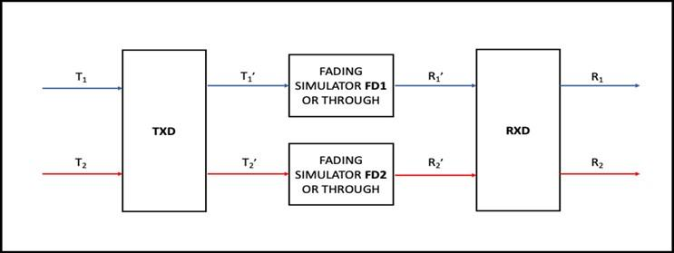
Figure 2: MIMO setup
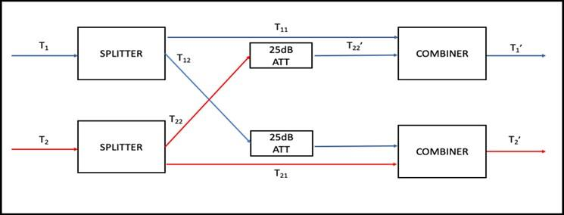
Figure 3: Setup of TXD – Transmitting antenna cross-polarization discrimination
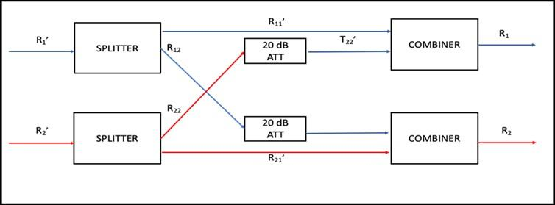
Figure 4: Receiving antenna cross-polarization discrimination

Basic SISO/MIMO setup
Figure 5 shows the “Basic SISO setup” that is used in the SISO configuration tests. The details of the block named “Basic SISO setup” in the specific test setup refer to Figure 5.
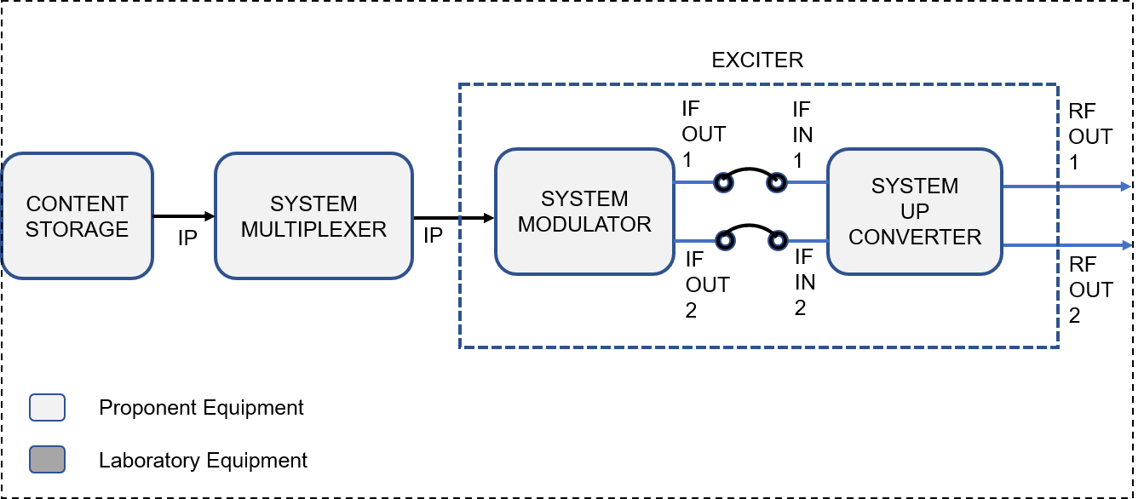
Figure 5: Basic SISO setup
Figure 6 shows the “Basic MIMO setup” that is used in the MIMO configuration tests. The details of the block named “Basic MIMO setup” in the specific test set up refer to Figure 6.
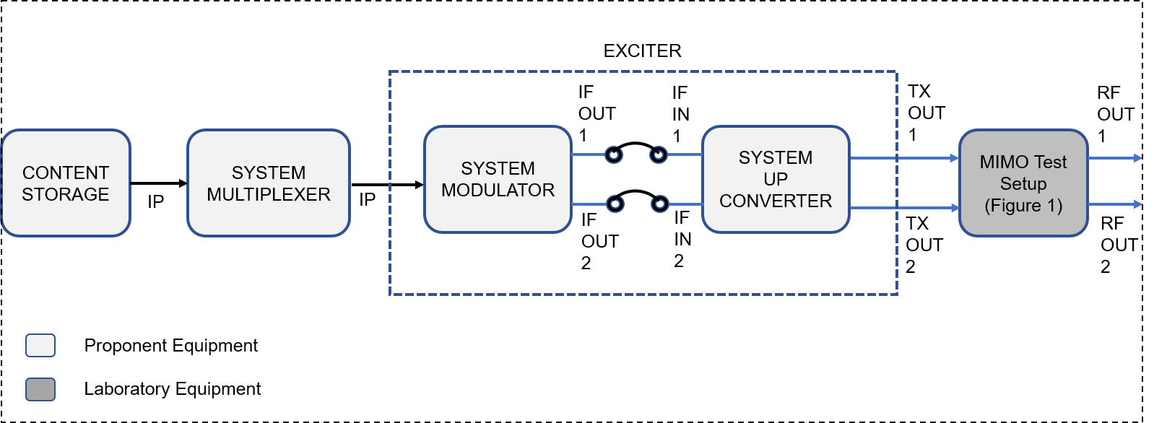
Figure 6: Basic MIMO setup
The same convention of “Proponent Equipment” and “Laboratory Equipment” used in Figure 5 and Figure 6 will be used throughout Section 4.2.
In the “Basic SISO/MIMO setup”, the block “Content Storage” shall be a PC with multiple IP streams content using the IP-based Transport Layer technology selected by the proponent, with appropriate video, audio, and data content (using content and technologies selected by the proponent) for the tests. The Exciter shall have 2 coaxial 75 Ω impedance IF Output, for MIMO operation, operating at 44 MHz frequency. In general, IF OUT 1 and IF OUT 2 should be directly connected to IF IN 1 and IF IN 2, respectively, with a U-Link.

Conditions for Field Test

Infrastructure available in the field
Transmission Frequency: 566–572 MHz (UHF channel 30 in Brazil)
602–608 MHz (UHF channel 36 in Brazil)
Transmitting antenna systems
Connector: EIA
Combiner: Manifold with bandpass filters
Gain (per polarization): 5.9 dBd
Half-power vertical beamwidth: 27°
Front-to-back ratio > 20 dB
VSWR < 1.1:1
Cross-polarization discrimination: 30 dB
Max power: 5 kW
Arrangement 1
Type: circular arrangement of 2 horizontal / vertical 1 meter high dual-polarized panels (1 level, 2 faces at 90°)
Arrangement 2
Type: circular arrangement of 2 +45° / -45° 1 meter high dual-polarized panels (1 level, 2 faces at 90°)
Equipment shelters
Construction: Masonry
Cooling: Air Conditioning
Electric power: three-phase, 127 V / 220 V, 60 Hz, with UPS (Uninterruptible Power Supply) and diesel generator set
Transmitter Site 1 (Morro do Sumaré - Rio de Janeiro - RJ - Brazil)
Latitude: 22° 57' 05" S
Longitude: 43° 14' 14" W
Transmitting antenna (arrangement 1 and arrangement 2)
Height: 80 m above ground level
Azimuth: 215°
Cable loss: 3 dB
Transmitter Site 2 (Igreja Nossa Senhora da Penna - Rio de Janeiro - RJ - Brazil)
Latitude: 22° 56' 29" S
Longitude: 43° 20' 54" W
Transmitting antenna (arrangement 1 and arrangement 2)
Height: 15 m above ground level
Azimuth: 180°
Cable loss: 1 dB

Equipment available in the stations
Transmitter Site 1 (Morro do Sumaré - Rio de Janeiro - RJ - Brazil)
Power amplifiers: NEC DLP-240 (200 W OFDM RMS per polarization per channel)
2-way combiner: NEC TXG-240
Input connector: BNC
Input RF level: -7 dBm (OFDM RMS)
Frequency range: 474–858 MHz
Gain: 60.8 dB
Transmitter Site 2 (Igreja Nossa Senhora da Penna - Rio de Janeiro - RJ - Brazil)
Power amplifiers: NEC DLP-120 (100 W OFDM RMS per polarization per channel)
2-way combiner: NEC HPC-1056
Input connector: BNC
Input RF level: -7 dBm (OFDM RMS)
Frequency range: 474–858 MHz
Gain: 57.8 dB
NOTE: The proponent can send its own power amplifiers and 2-way combiners to be used in the test if it wishes. In this case, the output power must be in the range between 100 and 500 W OFDM RMS and the transmission frequencies available for the test must be observed, as specified in 4.2.2.1.

Equipment to be provided by the proponent
The technology proponent shall deliver, for the field tests purpose, a set of two (2) Multiplexers (using the IP-based Transport Layer technology selected by the proponent), two (2) Exciters, two (2) Receivers, and a set of four (4) MIMO receiving antennas – two (2) antennas referred as “MIMO Indoor Antenna” (one horizontal / vertical dual-polarized antenna and one +45° / -45° dual-polarized antenna) that may have some directivity, and two (2) antennas referred as “MIMO Omnidirectional Antenna” (one horizontal / vertical dual-polarized antenna and one +45° / -45° dual-polarized antenna) for drive tests purpose, considered adequate by the technology proponent for the proposed system. The proponent shall provide a complete characterization of all the antennas provided (including impedance, gain, frequency response, horizontal / vertical diagrams, cross-polarization discrimination, and, if it is an active antenna, its noise figure and P1dB). The SBTVD Forum may also use other indoor MIMO antennas manufactured by other providers, for reference.
The Exciters should be equipped with linearization circuits to interface with the power amplifiers specified in 4.2.2.2 unless the proponent decides to provide its own power amplifiers and 2-way combiners to be used in the test.
The technology proponent shall provide the RF Capturing Device adapted for MIMO signal recording.
The conduction of the field tests will require a special test tool for the drive test, specified in 4.2.4.4.
The special test tool should be a PC with application software, provided by the technology proponent, to be connected to the Receiver. The PC shall monitor and record modulation parameters - to be determined according to the modulation technology used by the proposed technology, errored bits, errored packets, total quantity of packets received in the one-second interval, C/N of the channel being received, received level, and others parameters according to the proposed technology. The data should be refreshed at each one-second interval.
A GPS system consisting of a GPS antenna, a GPS receiver, and a PC with application software shall be prepared. In the PC date, hour, car speed, longitude, latitude, number of locked GPS satellites, GPS satellite signal quality, orientation, channel lock state shall be collected and recorded, at each one-second interval.

Laboratory Tests
The laboratory tests shall be conducted using the test streams provided by the technology proponent, as informed in 4.2.1.1. In all tests, there is a need to supply the specified equipment, both the equipment under test and the test equipment, the synchronization signal of 10 MHz and 1 PPS / NTP. Such connections are not presented in the test setups, to simplify the figures.

Device Verification Tests
Five test items were established for the device (Exciter) verification. All the tests shall be conducted in the parameters established in Table 7.
Table 7: Device test parameters configuration
Transmission Configuration | Channel and Level
SISO | VHF Ch 10 and UHF Ch 33, at the maximum nominal output power

RF frequency accuracy (precision)
The RF frequency precision should be measured with an RF frequency counter. The Devices Under Test (DUT) as well as the frequency counter shall be connected to GPS 10 MHz reference. Refer to Figure 6 for the test set up.
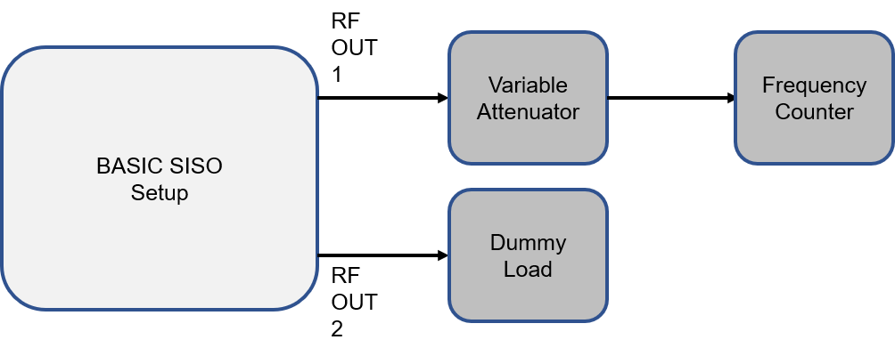
Figure 7: RF frequency accuracy test setup
The test results shall be recorded according to the Table 8 template.
Table 8: Template for recording RF frequency accuracy (precision) results
Channel | Measured Frequency | Deviation (ppm)
10 (192-198 MHz)
33 (584-590 MHz)

Phase noise of local oscillators
The phase noise of the Local oscillator should be measured at the Local Oscillator 50 Ω monitor output. Alternatively, if the Local Oscillator does not have a 50 Ω monitor output, it can be measured at the RF OUT. In the latter case, the modulator shall have a Continuous Wave (CW) output setting. Figure 8 shows the test set up for the measurement at the RF OUT. The Variable Attenuator should be adjusted for a level adequate to the Spectrum Analyzer in use. Care should be taken to adjust the Sweep Bandwidth, Resolution Bandwidth, and Sweep Time for this measurement.

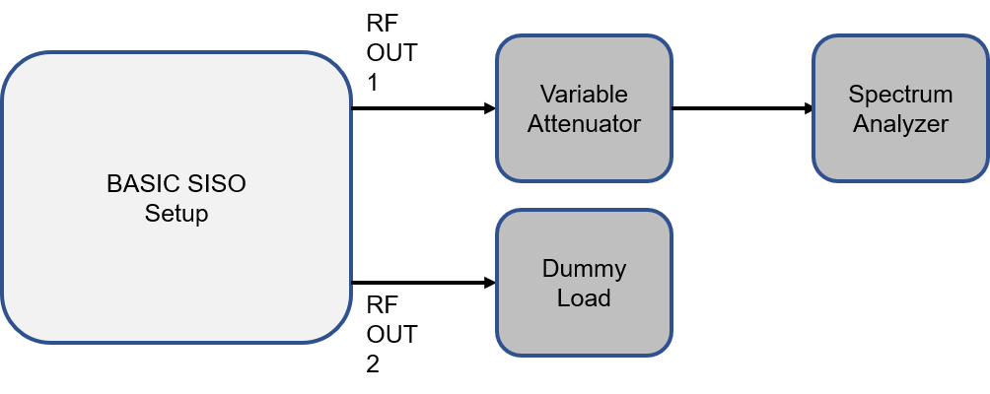
Figure 8: RF OUT spectrum test setup
Capture the Spectrum Analyzer display picture for channels 10 and 33.

RF/IF signal power
The RF/IF signal power shall be measured at the IF OUT1 or RF OUT 2. In the case of RF signal power, the measurement shall be done at the RF OUT 1 using the Figure 7 test set up without the Variable Attenuator. In the case of IF signal power, use the test set up in Figure 9. The loss of the Impedance Adaptor should be measured beforehand and subtracted from the result in the IF signal power measured.
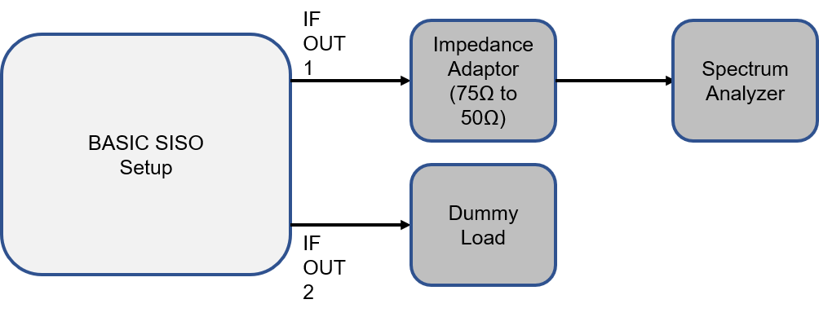
Figure 9: IF signal power test setup
Record the RF/IF signal power test results according to the Table 9 template.
Table 9: Template for recording RF/IF signal power measurement results
Channel | Measured Power (dBm)
IF (41-47 MHz)
10
33

RF out of band emissions and linearity characterization (Spectrum Mask)
The RF out-of-band emissions and the spectrum mask shall be measured using the test setup of Figure 8.
The RF out-of-band emissions measurement and specifications shall be in conformance to the ITU-R Recommendation SM.1541-6 (Unwanted emissions in the out-of-band domain), specifically its Annex 6 (OoB domain emission limits for television broadcasting systems).
At this point, there is no spectrum mask defined for TV 3.0, which will depend upon the technology and the specifications of the proposed Physical Layer. The proponent shall propose an emission spectrum mask at the Exciter RF OUT. In any case, the specifications PL1.3 and PL1.4 must be satisfied.
Capture the Spectrum Analyzer display picture for channels 10 and 33.

I/Q analysis – Constellation and MER
The Physical Layer proponent should provide for SBTVD Forum a Test Tool for the measurement of Constellation and MER. The Test Tool should be an Application Software to be installed on a PC to be connected by a universal interface (USB, Ethernet, etc.) to the Receiver provided by the proponent. Figure 10 shows the test setup.
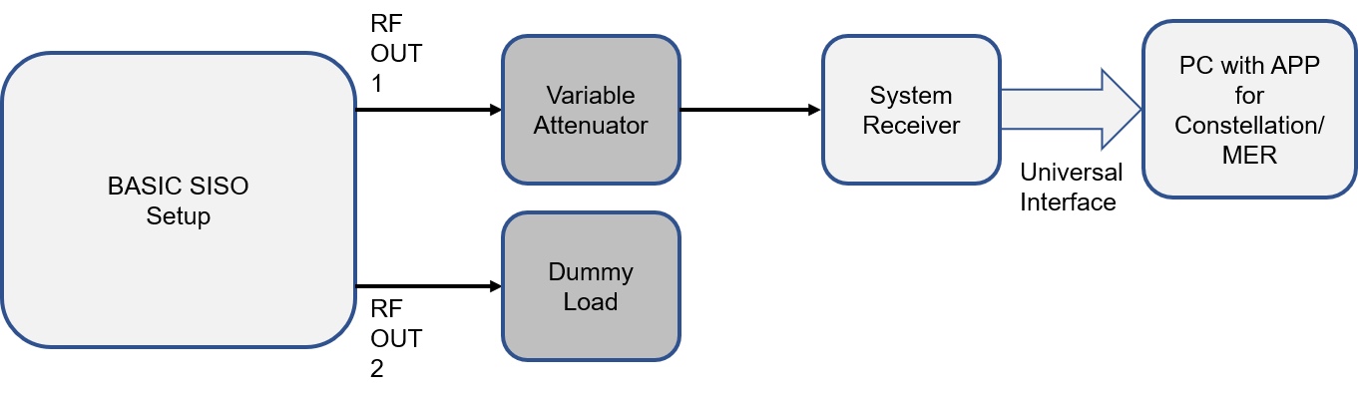
Figure 10: Constellation and MER test setup
Capture the application display picture for channels 10 and 33.

Evaluation Tests

C/N - Carrier power vs AWGN
The C/N – Carrier Power vs AWGN test shall be conducted with SISO and MIMO configurations for the VHF Ch 7, 13 and UHF Ch 14, 33, 51, and System Receiver RF IN 1 and RF IN 2 levels of -28, -53, -68, -83 dBm.
The test setup for the SISO configuration is shown in Figure 11, and for MIMO configuration in Figure 12.
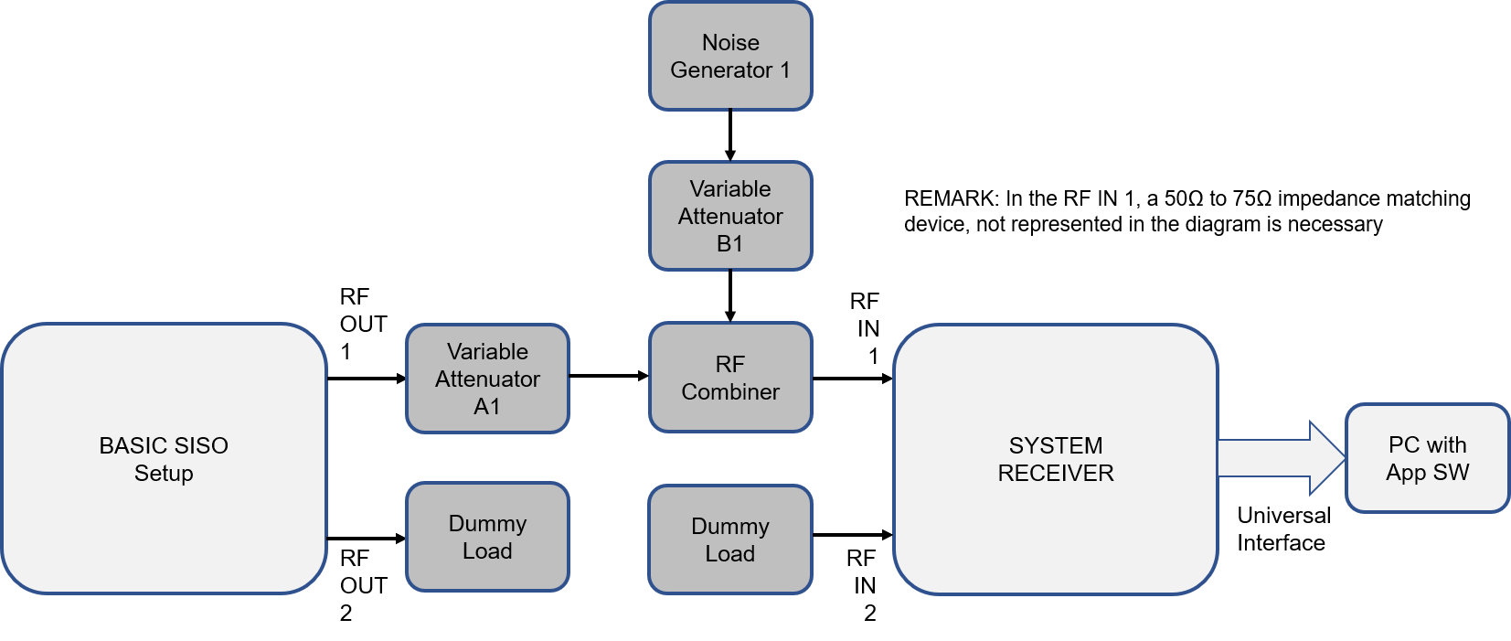
Figure 11: C/N – Carrier power vs AWGN test setup for SISO configuration
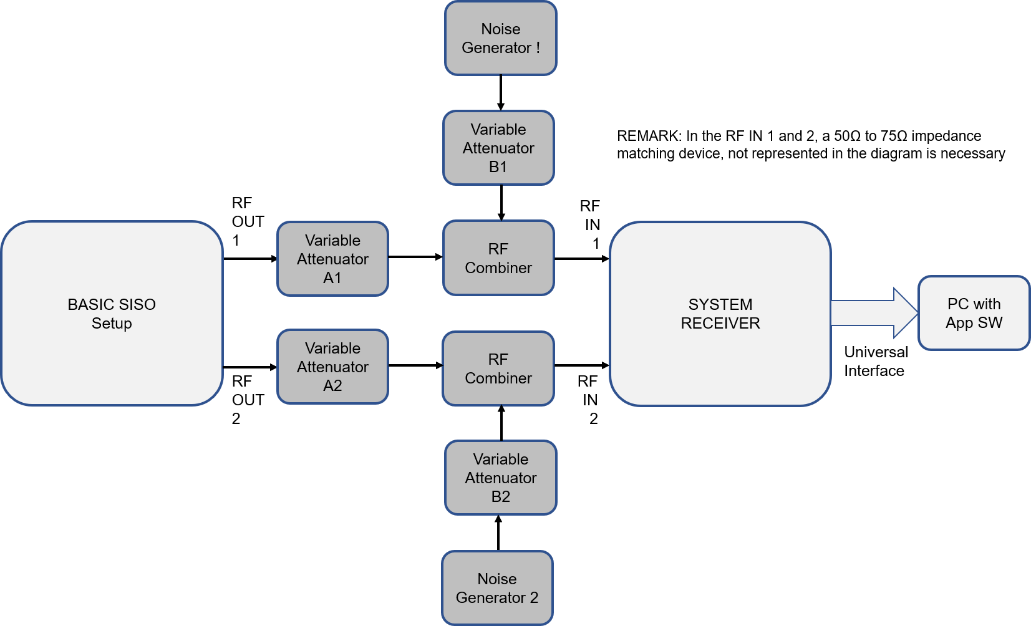
Figure 12: C/N – Carrier power vs AWGN test setup for MIMO configuration
Test Procedure (for SISO and MIMO):
  - Configure the modulation parameters to one of the configurations that offers C/N ≤ 0 dB, set the maximum output level, and set to the VHF Ch 7;
  - Register the modulation parameters used and the corresponding net bitrate;
  - Set AWGN Noise Generator frequency to the selected channel, and maximum output power, and the Variable Attenuator B1 (and B2) to the maximum attenuation;
  - Adjust the Variable Attenuator A1 (and A2) in order to obtain -28 dBm in the RF IN1 (and RF IN2) of the System Receiver;
  - Start to reduce the attenuation of the Variable Attenuator A1 (and simultaneously and synchronized attenuation of A2), in steps of 0.1 dB, up to the receiver QEF;
  - Register the input level of RF IN 1 (and RF IN 2 – which must be the same value of RF IN 1), 0.1 dB before the QEF point, and compute the C/N;
  - Register the C/N (dB) computed according to the template in Table 10 (apply the same template for SISO and for MIMO);
  - Repeat the test for other channels, and levels specified in step (a);
  - Repeat the test for other modulation configurations.
Table 10: Template for recording C/N – Carrier power vs AWGN test results (SISO or MIMO)
Channel | RF IN Level (dBm) | C/N (dB)
7 | -28
7 | -53
7 | -68
7 | -83
.  .  . | .  .  . | .  .  .
51 | -28
51 | -53
51 | -68
51 | -83

C/N - Carrier power vs Rayleigh and AWGN
The C/N – Carrier Power vs Rayleigh and AWGN test shall be conducted with SISO and MIMO configurations for the VHF Ch 7, 13 and UHF Ch 14, 33, 51, and System Receiver RF IN 1 and RF IN 2 levels -28, -53, -68, -83 dBm.
The test set up for the SISO configuration is shown in Figure 13, and for MIMO configuration in Figure 14.
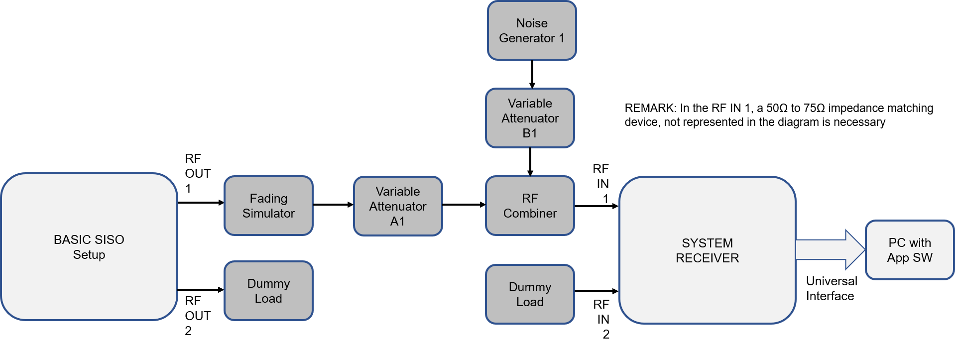
Figure 13: C/N – Carrier power vs Rayleigh and AWGN test setup for SISO configuration
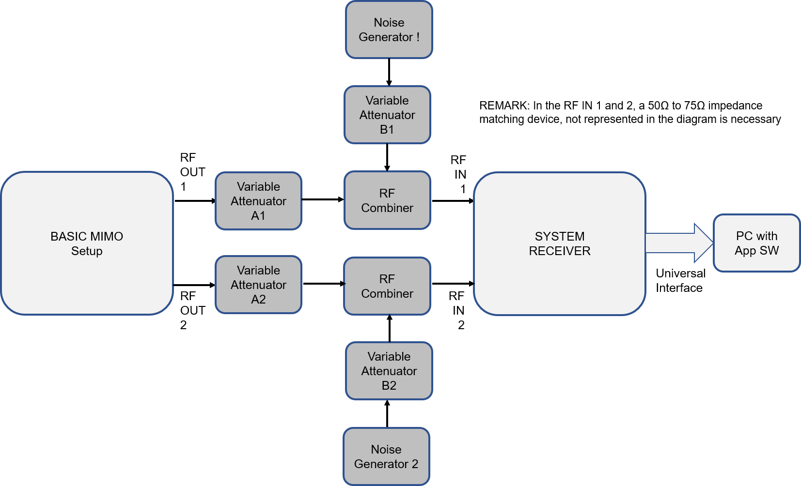
Figure 14: C/N – Carrier power vs Rayleigh and AWGN test setup for MIMO configuration
Test Procedure (for SISO):
  - For SISO configuration the tests shall be conducted for Fading Simulator configured in RF1, RF2A, RF2B, RF3A, RF3B, and RF4, presented in Table 1 to Table 6;
  - Start setting the configuration of the Fading Simulator to the channel ensemble RF1;
  - Configure the modulation parameters to one of the configurations that offers C/N ≤ 0 dB, set the maximum output level, and set to the VHF Ch 7;
  - Register the modulation parameters used and the corresponding net bitrate;
  - Set AWGN Noise Generator frequency to the selected channel, and maximum output power, and the Variable Attenuator B1 to the maximum attenuation;
  - Adjust the Variable Attenuator A1 in order to obtain -28 dBm in the RF IN1 of the System Receiver;
  - Start to reduce the attenuation of the Variable Attenuator B1, in steps of 0.1 dB, up to the receiver QEF;
  - Register the thermal noise input level at RF IN 1 (and RF IN 2 – which must be the same value of RF IN 1), 0.1 dB before the QEF point, using a Spectrum Analyzer with channel power set to the system bandwidth, and compute the C/N;
  - Register the C/N (dB) computed in the table of test results (use the template shown in Table 10), prepared for the corresponding channel ensemble;
  - Repeat the test for other channels, and levels specified in the step "b";
  - Repeat the test for other modulation configurations;
  - Repeat the test for other channel ensembles.
Test Procedure (for MIMO):
  - For MIMO configuration the tests shall be conducted for Fading Simulator FD1 and FD2, both configured for the same RF2A and repeated for RF2B, RF3A, and RF3B. These channel ensembles configurations are presented in Table 2 to Table 5. The channel ensembles chosen corresponds for fixed indoor antenna and mobile outdoor environments, which are the main receiving environment targets for TV 3.0;
NOTE: The propagation impairments applied to both MIMO channels are completely correlated. It does not represent the real environment but should be one case to analyze. If the proponent has a more representative propagation model for laboratory testing to propose, the SBTVD Forum is willing to study it. Performing such a test will depend on the availability of the corresponding simulator.
  - Start the testing session with channel ensemble RF2A;
  - Configure the modulation parameters to one of the configurations that offers C/N ≤ 0 dB, set the maximum output level, and set to the VHF Ch 7;
  - Register the modulation parameters used and the corresponding net bitrate;
  - Set AWGN Noise Generator frequency to the selected channel, and maximum output power, and the Variable Attenuator B1 (and B2) to the maximum attenuation;
  - Adjust the Variable Attenuator A1 and A2 in order to obtain -28 dBm in the RF IN1 and RF IN2 of the System Receiver;
  - Start to reduce the attenuation of the Variable Attenuator B1, and simultaneously and synchronously attenuate B2, in steps of 0.1 dB, up to the receiver QEF;
  - Register the thermal noise input level at RF IN 1 (and RF IN 2 – which must be the same value of RF IN 1), 0.1 dB before the QEF point, using a Spectrum Analyzer with channel power set to the system bandwidth, and compute the C/N;
  - Register the C/N (dB) computed in the table of test results (use the template shown in Table 10), prepared for the corresponding channel ensemble;
  - Repeat the test for other channels, and levels specified in the step "b";
  - Repeat the test for other modulation configurations;
  - Repeat the test for another channel ensembles.

Receiver maximum and minimum level
The receiver maximum and minimum level test shall be conducted with SISO and MIMO configurations for the VHF Ch 7, 13, and UHF Ch 14, 33, 51.
The test set up for the SISO configuration is shown in Figure 15, and for MIMO configuration in Figure 16.
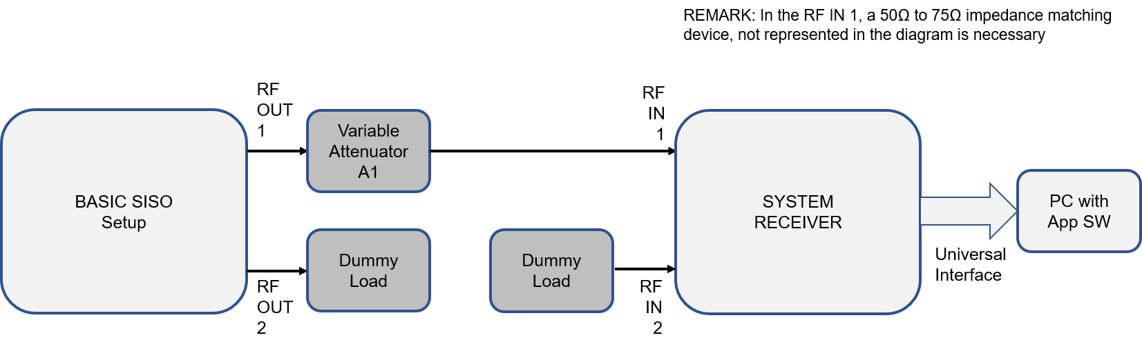
Figure 15: SISO configuration test set up for maximum and minimum level
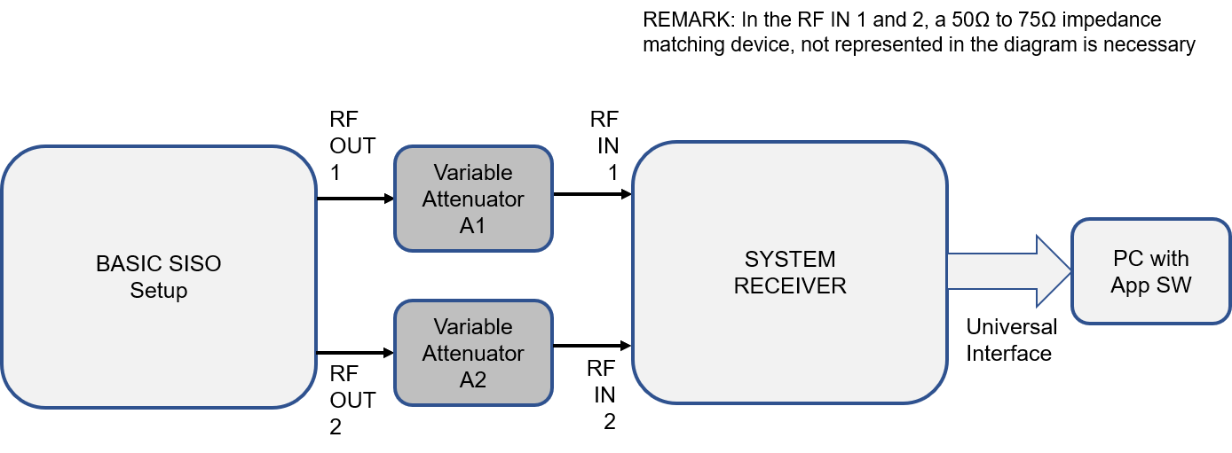
Figure 16: MIMO configuration test setup for maximum and minimum level
Test Procedure (for SISO and MIMO) for maximum level:
  - Configure the modulation parameters to one of the configurations that offers C/N ≤ 0 dB, set the maximum output level, and set to the VHF Ch 7;
  - Register the modulation parameters used and the corresponding net bitrate;
  - Adjust the Variable Attenuator A1 (and A2) in order to obtain -28 dBm in the RF IN1 (and RF IN2) of the System Receiver;
  - Start to reduce the attenuation of the Variable Attenuator A1 (and simultaneously and synchronized attenuation of A2), in steps of 0.1 dB, up to the receiver QEF;
  - Register the input level of RF IN 1 (and RF IN 2 – which must be the same value of RF IN 1), 0.1 dB before the QEF point, as the maximum level;
  - Repeat the test for another channel;
  - Repeat the test for other modulation configurations.
Test Procedure (for SISO and MIMO) for minimum level:
  - Configure the modulation parameters to one of the configurations that offers C/N ≤ 0 dB, set the maximum output level, and set to the VHF Ch 7;
  - Register the modulation parameters used and the corresponding net bitrate;
  - Adjust the Variable Attenuator A1 (and A2) in order to obtain -28 dBm in the RF IN1 (and RF IN2) of the System Receiver;
  - Start to raise the attenuation of the Variable Attenuator A1 (and simultaneously and synchronized attenuation of A2), in steps of 0.1 dB, up to the receiver QEF;
  - Register the input level of RF IN 1 (and RF IN 2 – which must be the same value of RF IN 1), 0.1 dB before the QEF point, as the minimum level;
  - Repeat the test for other channels;
  - Repeat the test for other modulation configurations.

Co-channel Interference with own system
The Co-channel interference with own system test shall be conducted with SISO and MIMO configurations for the VHF Ch 10 and UHF Ch 33, and System Receiver RF IN 1 and RF IN 2 levels of -53 dBm.
The test set up for the SISO configuration is shown in Figure 17, and for MIMO configuration in Figure 18.
The test shall be conducted with two different contents and the complete time synchronization between the desired and undesired signal, as well as without time synchronization between the signals.
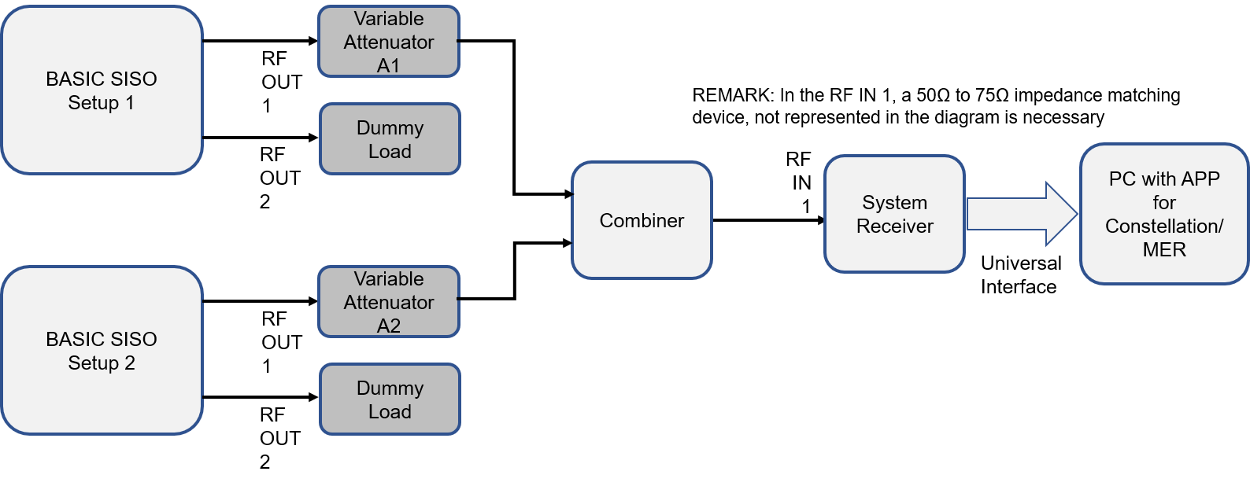
Figure 17: SISO configuration co-channel interference with own system test setup
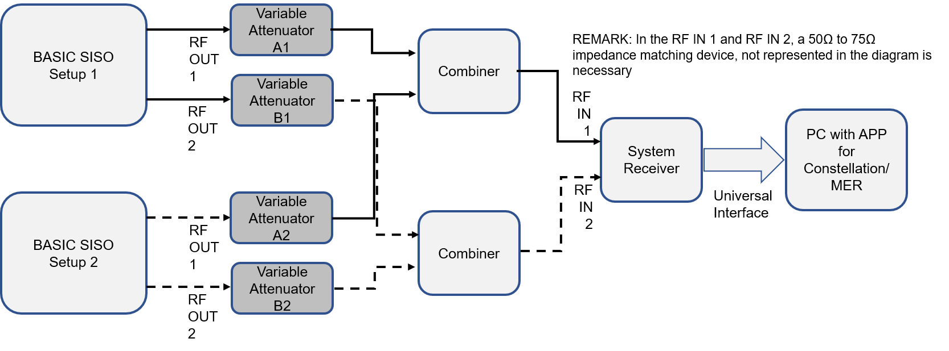
Figure 18: MIMO configuration co-channel interference with own system test setup
Test Procedure for SISO and MIMO:
  - Start the test with complete synchronization between the desired and undesired signals;
  - Configure the modulation parameters to one of the configurations that offers C/N ≤ 0 dB, and set both of Exciter to the maximum output level and to the VHF Ch 10;
  - Register the modulation parameters used and the corresponding net bitrate;
  - Consider the output of Exciter of “Basic SISO SETUP 1” as desired (D) signal and of the output of “Basic SISO SETUP 2” as undesired or interference (U) signal;
  - Set Variable Attenuator A1 (and A2) in order that the RF IN 1 (and RF IN 2) input level be -53 dBm. This is the Signal D level;
  - Start decreasing Variable Attenuator B1 (and synchronously B2), at 0.1 dB steps, until the receiver reaches the QEF.
  - Set the Variable Attenuator A1 (and A2) to the maximum attenuation and measure with a Spectrum Analyzer the level at RF IN 1 (and RF IN 2) of the U signal;
  - Compute the receiver D/U and register in the test result table. Use the template of Table 11;
  - Repeat the test for UHF Ch 33;
  - Repeat all the tests with the undesired signal without time synchronization.
Table 11: Template for test results of co-channel interference of own system
Channel Number | D/U (dB)
10
33

Co-channel and adjacent channel interference (at N±1 and N±2 channels) to ISDB-T
The co-channel interference test with ISDB-T shall be conducted with the proposed system in SISO configuration and for the desired ISDB-T signal (D) at VHF Ch 10 and UHF Ch 33, with desired ISDB-T receiver input level of -53 dBm.
The test set up is shown in Figure 19.
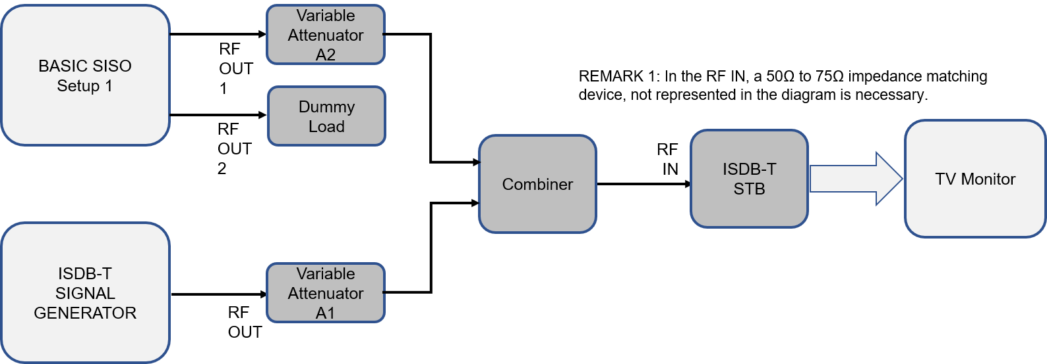
Figure 19: Test setup for co-channel and adjacent channel interference (at N±1 and N±2 channels) with ISDB-T
Test procedure:
  - The ISDB-T desired signal should be a dynamic zone plate and set to Ch 10;
  - Configure the ISDB-T signal generator for: Mode 3, 1 x Layer A = 13 segments, 64QAM, CR = 3/4, GI = 1/8, I = 0;
  - Configure the modulation parameters of the proposed TV 3.0 system to one of the configurations that offers C/N ≤ 0 dB, and set both of Exciter to the maximum output level and to the VHF Ch 10. This is the undesired or interfering signal (U);
  - Register the modulation parameters used and the corresponding net bitrate;
  - Adjust Variable Attenuator A2 to maximum attenuation;
  - Adjust Variable Attenuator A1 in order that the level of the D signal be -53 dBm in the input of the ISDB-T STB;
  - Adjust the Variable Attenuator A2, of the U signal, decreasing its attenuation until the Threshold of Visibility (TOV) condition is reached;
  - Adjust the Variable Attenuator A1, of the D signal, to the maximum attenuation and read the level of the interfering channel in the Signal Analyzer. This is the “U (dBm)” level;
  - Compute the D/U ratio for the co-channel interference for Ch 10 and register in the test result table. Use the template shown in Table 12.
  - For the adjacent channel interference tests, set the desired signal (D) to the channel 10, and the interfering signal (U) to the channel 9, for (N-1), or channel 8, for (N-2), for the lower adjacent channel interference test, or to the channel 11, for (N+1), or channel 12, for (N+2), for the upper adjacent channel interference tests;
  - Adjust Variable Attenuator A2 to maximum attenuation;
  - Adjust Variable Attenuator A1 and set the receiver input level of D signal to -53 dBm using a Signal Analyzer;
  - Adjust Variable Attenuator A2, corresponding to the U signal, decreasing its attenuation until the TOV condition is reached;
  - Adjust Variable Attenuator A1 to the maximum attenuation and read the level of the interfering channel in the Signal Analyzer. This is the “U (dBm)” level;
  - Compute the D/U ratio for the adjacent channel interference for Ch 10 and register in the test result table. Use the template shown in Table 12;
  - Repeat the test for the D signal set to Ch 33 and the U signal to Ch 31 to 35.
Table 12: Template for results of co-channel and adjacent channel interference to ISDB-T
Protection Ratio D/U (dB)
Desired Channel | Interferer Channel | Receiver D/U (dB)
VHF  (Digital CH in Test – CH 10) | CH8
VHF  (Digital CH in Test – CH 10) | CH9
VHF  (Digital CH in Test – CH 10) | CH10
VHF  (Digital CH in Test – CH 10) | CH11
VHF  (Digital CH in Test – CH 10) | CH12
UHF  (Digital CH in Test – CH33) | CH31
UHF  (Digital CH in Test – CH33) | CH32
UHF  (Digital CH in Test – CH33) | CH33
UHF  (Digital CH in Test – CH33) | CH34
UHF  (Digital CH in Test – CH33) | CH35

Impulse noise
The impulse noise interference test shall be performed with SISO configuration, in VHF Ch 10 and UHF Ch 33, and the desired signal level at RF IN 1 of the System Receiver at -53 dBm.
The test shall be conducted with an Impulse Noise Generator, which switches ON and OFF an AWGN noise creating periodic bursts of impulse noise. The interferent impulse noise has a variable pulse width P_{W} of 1 µs to 900 µs and the impulse noise repetition period T of 10 ms (100 Hz). The equivalent noise power Neq is obtained by measuring the power of the AWGN noise, at 6 MHz of bandwidth, before noise switching.
The test setup is shown in Figure 20.
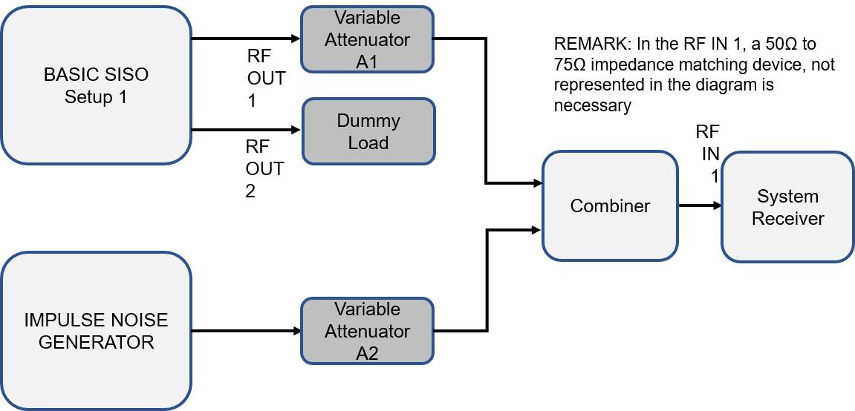
Figure 20: Impulse noise test setup
The impulse noise pulse patterns used are shown in Table 13.
Table 13: Impulse noise pulse patterns
Noise Type | Model | Pulse Spacing (µs) | Burst Duration (pulses per burst) | Burst Duration (µs) | Effective Burst Duration
N1 | Central Heating 2 | 25 ±10 | 6 | 75.25 – 175.25 | 1500 ns
N2 | Central Heating 3 | 2 ±0.5 | 2 | 1.75 – 2.75 | 500 ns
N3 | Gas Range Ignition | 1.5 ±0.5 | 20 | 19.25 – 38.25 | 5000 ns
N4 | Dishwasher | 12.5 ±2.5 | 10 | 90.25 – 135.25 | 2500 ns
N5 | Fluorescent lights | 25 ±20 | 2 | 5.25 – 45.25 | 500 ns
N6 | Traffic 3A | 7.5 ±2.5 | 2 | 5.25 – 10.25 | 500 ns
N7 | Traffic 3B | N/A | 1 | N/A | 250 ns
N8 | Variable Impulse Noise | 10 000 | 1 | N/A | 1 – 900 µs
Test procedure:
  - Configure the modulation parameters to one of the configurations that offers C/N ≤ 0 dB, and set the Exciter to the maximum output level and to the VHF Ch 10;
  - Register the modulation parameters used and the corresponding net bitrate;
  - Adjust the Variable Attenuator A2 to maximum attenuation;
  - Adjust the Variable Attenuator A1 in order that the desired signal level (D) in the RF IN 1 of the System Receiver be -53 dBm;
  - Set the Impulse Noise Generator to the maximum output power of AWGN, and then set the impulse noise pulse pattern noise type to N1;
  - Start decreasing the attenuation of Variable Attenuator A2, in steps of 0.1 dB, until the System Receiver reaches the QEF;
  - Set the Variable Attenuator A1 to maximum attenuation, stop the switching of the AWGN signal in the Impulse Signal Generator, and measure the Neq with a Spectrum Analyzer in channel power mode with 6 MHz bandwidth;
  - Register the C/Neq, which is the difference between -53 dBm – TV signal power and Neq, in the test result template as shown in Table 14;
  - Continue the test for other impulse noise pulse pattern noise types until N7;
  - For the impulse noise pulse pattern noise type N8, it is suggested to use the effective burst duration value of 1 µs, then 10 µs, 20 µs, in steps of 10 µs until 100 µs. Then in steps of 50 µs until 500 µs. After 500 µs, steps of 100 µs are suggested;
  - Repeat the test for UHF Ch 33.
Table 14: Template for impulse noise test result
VHF Ch 10 |  | UHF Ch 33
Noise Type | C/Neq (dB) | P_{W} (µs) | C/Neq (dB)
N1
N2
N3
N4
N5
N6
N7
N8 (1 µs)
N8 (10 µs)
N8 (20 µs)
...
N8 (100 µs)
N8 (150 µs)
...
N8 (500 µs)
N8 (600 µs)
...
N8 (900 µs)

Single echo static multipath interference
The single echo static multipath interference shall be conducted for SISO configuration, for VHF Ch 10 and UHF Ch 33, and receiving input level of -53 dBm. Measurement of Echo Attenuation for receiving threshold QEF shall be performed for Echo Delay between -1000 µs and +1000 µs.
To execute this test, access to the IF frequency of 44 MHz will be necessary. So, the U-Link connected between IF OUT 1 and IF IN 1, in the “Basic SISO setup” of Figure 5, should be removed, and the connection to the Fading Simulator established, as shown in the test set up of Figure 21.
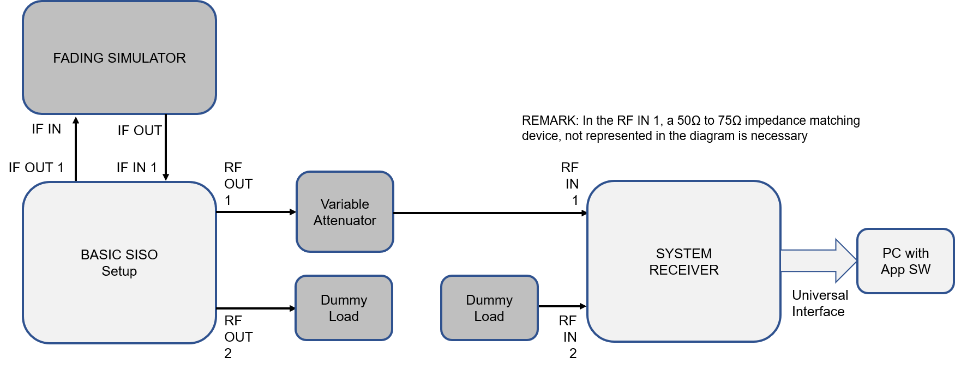
Figure 21: Single echo static multipath interference test setup
Test Procedure:
  - Configure the modulation parameters to one of the configurations that offers C/N ≤ 0 dB, and set the Exciter to the maximum output level and to the VHF Ch 10;
NOTE: Considering that the proposed system modulation is based on the OFDM modulation, the system should work without any error with a pre-echo or post-echo interference of the same level, for interference signal delay inside the guard interval. Some OFDM receivers implement equalizers to improve the performance in multipath environments.
  - Register the modulation parameters used and the corresponding net bitrate;
  - Set the Fading Simulator to work with the 2 paths: the first path should be considered as the main signal and the second path the interference signal, which delay and level should be varied in relation to the main signal. To start the test, set attenuation, delays, and phases of both signals to zero (0), without any impairment as fading, doppler, or noise;
  - Adjust the Variable Attenuator in order to obtain a receiving level of -53 dBm in the RF IN 1 input;
  - Just note that the receiver works properly without any error in such a situation;
  - Then, apply delays (post-echo or pre-echo), inferior to the guard interval (set in the modulator) to the interference path of the Fading Simulator, and verify that the receiver works without any error;
  - Register these results (0 dB Echo Attenuation) in the test result table. Use the template shown in Table 15;
  - Continue the test applying delays (pre-echo or post-echo) above the guard interval of the modulation. To start the measurements set maximum attenuation on the interference path of the Fading Simulator. Then start setting delays with 50 µs displacement over the guard interval time. Then, reduce the interference path attenuation in steps of 0.1 dB, until the receiver reaches the QEF. Register the attenuation value of the interference path as Echo Attenuation in the correspondent delay row, in the test result table;
  - For delays values exceeding the triple of the guard interval, it is recommended to set delays in 100 µs step;
  - Repeat the test for other modulation parameters recommended by the system proponent.
Table 15: Template for single echo static multipath interference test results
Pre-Echo |  | Post-Echo
Delay (µs) | Echo Attenuation (dB) | Delay (µs) | Echo Attenuation (dB)
0 | 0.0 | 0 | 0.0
-20 | 0.0 | 20 | 0.0
-40 | 0.0 | 40 | 0.0
-63 | 0.0 | 63 | 0.0
-65 |  | 65
-70 |  | 70
-100 |  | 100
--150 |  | 150
-200 |  | 200
-300 |  | 300
-400 |  | 400
-500 |  | 500
. |  | .
. |  | .
-1000 |  | 1000

Channel bonding
The channel bonding tests shall be performed in MIMO configuration with 2 Exciters, one operating in the VHF Ch 10 and other in UHF Ch 33, and the receiving input level of -53 dBm.
The test setup is shown in Figure 22.
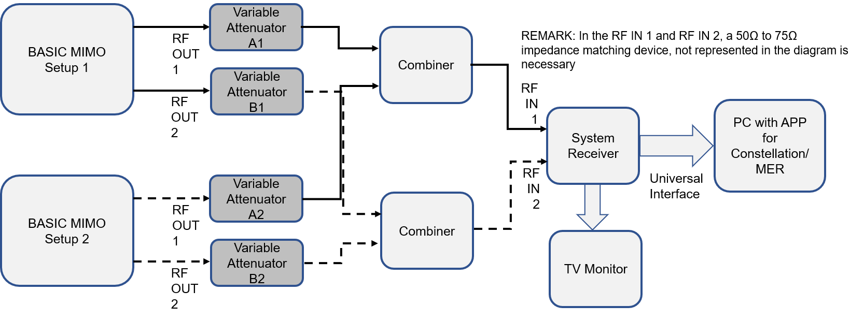
Figure 22: Test setup for channel bonding and channel identification stability
Test procedure:
  - Set the special stream provided by the proponent in the Content Storage of the “Basic MIMO setup” and the Multiplexer settings for channel bonding operation with the modulation parameters chosen for the test (provided that C/N ≤ 0 dB);
  - Configure the modulation parameters for the channel bonding operation, and set the Exciter of the “Basic MIMO setup 1” to the VHF Ch 10, and the Exciter of the “Basic MIMO setup 2” to the VHF Ch 33. Both Exciter power output shall be set to the maximum;
  - Register the modulation parameters used and the corresponding net bitrate;
  - Adjust the Variable Attenuators to have each of the 4 signal levels at each RF IN input of the System Receiver to -53 dBm;
  - Configure the System Receiver to operate in channel bonding with Ch 10 and Ch 33;
  - Confirm that the receiver operates normally, without any error, and observe that the video, audio, and data are reproduced perfectly;
  - In the PC with the application software provided by the proponent, check the video and audio bit rates.

Channel identification stability in frequency reuse-1 condition
The channel identification stability tests shall be conducted in MIMO configuration with 2 Exciters, both operating in the VHF Ch 10 (or UHF Ch 33), and the receiving input level of -53 dBm for each Exciter RF signals.
Use the test setup shown in Figure 22.
Test procedure:
  - Set the different content streams for the “Basic MIMO setup” and in the Multiplexer set one station identification as A, and other as B;
  - Configure the modulation parameters of both “Basic MIMO setup” to the same configuration that offers C/N ≤ 0 dB, and set the Exciters to the maximum output level and to the VHF Ch 10;
  - Register the modulation parameters used and the corresponding net bitrate;
  - Adjust the Variable Attenuators to have each of the 4 signal levels at each RF IN input of the System Receiver to -53 dBm;
  - Set the System Receiver to open the signal of the station identified as A, and verify in the TV Monitor that the video and audio corresponding to station A is reproduced adequately;
  - Verify that the reproduction of station A content is reproduced normally for 1 hour;
  - Set the System Receiver to open the signal of the station identified as B, and verify in the TV Monitor that the video and audio corresponding to station B is reproduced adequately;
  - Verify that the reproduction of station B content is reproduced normally for 1 hour.

FM Radio (88 to 108 MHz) Interference
The FM interference test shall be performed with the proposed TV 3.0 system in SISO configuration, and intends to measure the QEF level of the System Receiver for various power levels of DTV signal (-80, -70, -60, -50, -40, -30 and -20 dBm) for VHF channels 7, 13 and UHF channels 15, 33, and 50, as a function of FM interference signal strength.
In this test, an FM Signal Generator will be used. The Generator reproduces a composed FM Radio signal, consisting of 34 FM radio channels - between the channels 201 to 300 (88 to 108 MHz). Each FM signal is modulated by a 1 kHz single tone, with an FM deviation of 75 kHz RMS. Each one of the single tone signals modulating the FM carriers has a random phase. Figure 23 shows the FM Signal Generator output spectrum.
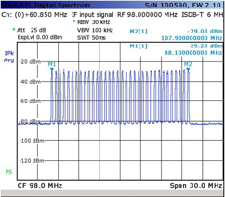
Figure 23: Generated FM Radio signal between 88 to 108 MHz
The test set up is shown in Figure 24.
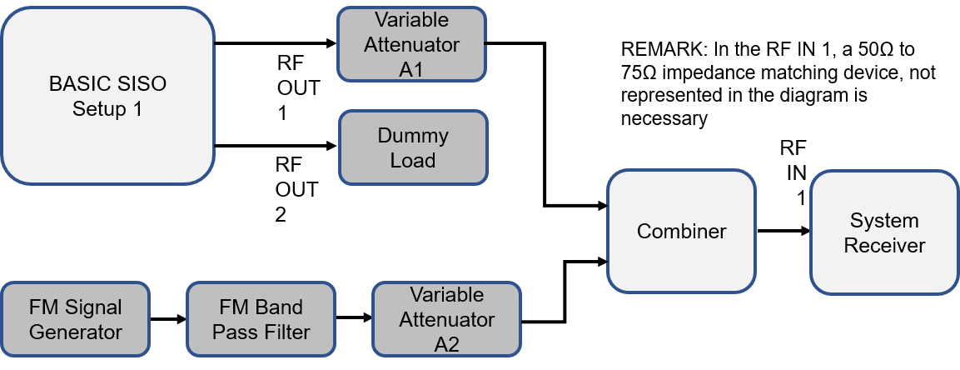
Figure 24: FM interference test setup
Test procedure:
  - Configure the modulation parameters to one of the configurations that offers C/N ≤ 0 dB, and set the Exciter to the maximum output level and to the VHF Ch 7;
  - Register the modulation parameters used and the corresponding net bitrate;
  - Adjust Variable Attenuator A2 to maximum attenuation;
  - Adjust Variable Attenuator A1, to obtain -80 dBm in the RF IN 1 input of the System Receiver;
  - Start reducing the attenuation of Variable Attenuator A2, in steps of 0.1 dB until the System Receiver reach QEF;
  - Register the QEF level in the corresponding cell of the template shown in Table 16;
  - Repeat the test for other TV levels of Table 16;
  - Repeat the test for other VHF and UHF channels.
Table 16: Template for FM interference test results
TV Level (dBm) | TV VHF |  | TV UHF
TV Level (dBm) | CH 7 | CH 13 | CH 15 | CH 33 | CH 50
TV Level (dBm) | QEF Level (dBm)
-20
-30
-40
-50
-60
-70
-80

Field Tests

Scope
There will be 4 types of evaluation to be conducted in the field, which are classified as:
  - Coverage Measurement
Conducted by using MIMO Indoor antennas, placed at approximately 2 m height above ground. Measurements made along radials, arcs, grids, and clusters and selected indoor environments. A sample containing a large number of measurements needs to be taken to develop statistically significant results. The indoor MIMO antenna provided by the technology proponent shall be used, but SBTVD Forum may use MIMO indoor antennas of other providers, as reference.
  - Service Measurement
Process of determining the conditions under which digital television signals can be received and decoded under various actual operating conditions. The MIMO Indoor antenna provided by the technology proponent and others should be used. Use recording equipment to obtain signal level, carrier-to-noise ratio, margin-to-threshold, error rate, and other information. The MIMO Indoor antenna provided by the technology proponent shall be used, but SBTVD Forum may use another MIMO Indoor antenna of other providers, as reference.
  - Drive Test
For the drive tests, the proponent shall provide a GPS receiver capable of delivering the position information to a notebook PC. Also, the proponent shall provide a receiver capable of delivering the relevant information to a notebook PC. The MIMO Omnidirectional antenna provided by the technology proponent shall be used, but SBTVD Forum may use MIMO Omnidirectional antennas of other providers, as reference.
  - RF Capturing
For determination of channel characterization. Accomplished by detailed measurements of signal characteristics including effects of channel impairments such as level variations, impulse noise, in-band interference, and multipath. The MIMO Indoor antenna provided by the technology proponent shall be used, but SBTVD Forum may use MIMO Indoor antennas of other providers, as reference.
The field tests shall be conducted in Multi-Frequency Network (MFN), Single-Frequency Network (SFN) – with the stations transmitting different contents, and MIMO configuration, in the Rio de Janeiro city, using the available channels 30 (566-572 MHz) and 36 (602-608 MHz). A test car will be prepared for the Coverage Measurements, Service Measurements, and RF Capturing. Rooms for indoor tests for such measurements shall also be prepared. A second test car shall conduct the Drive Test.
The test setups to be used in the field tests are shown in Figure 25, Figure 26, and Figure 27.
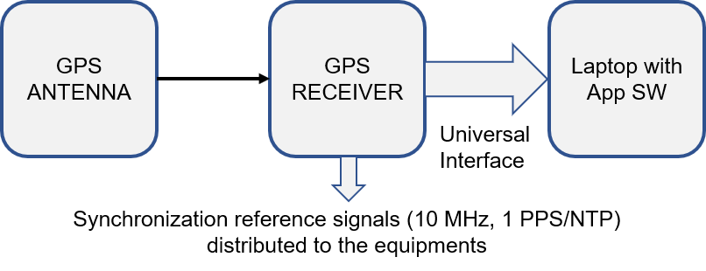
Figure 25: GPS signal receiving setup
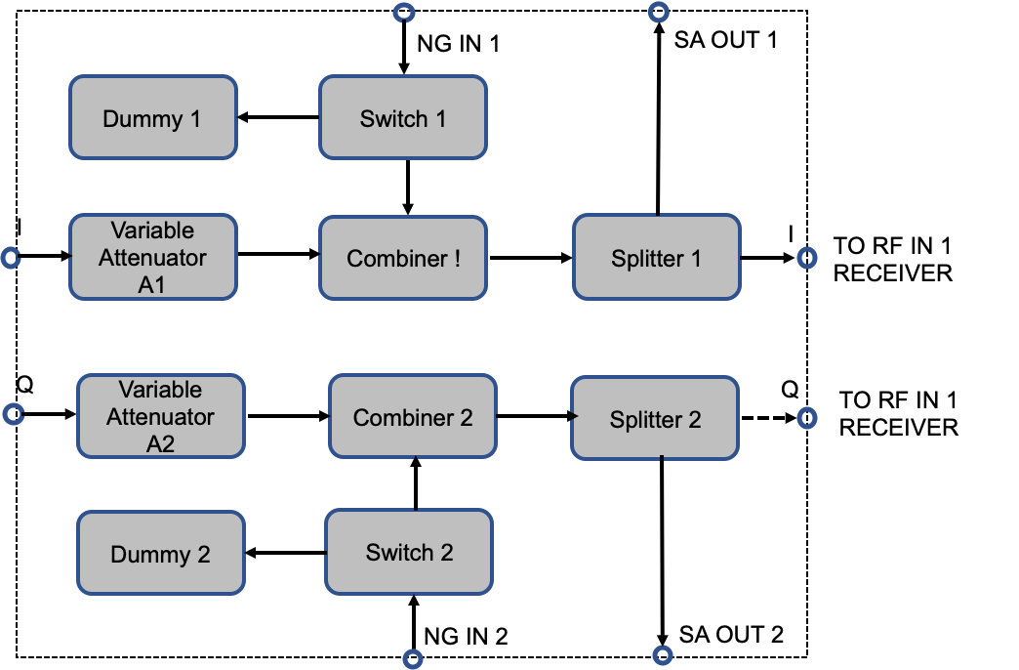
Figure 26: Field test sub-set
NOTE: The terms “I” and “Q” represents the MIMO antenna output cross-polarized signals, to be tested using both horizontal / vertical and +45° / -45° polarization.
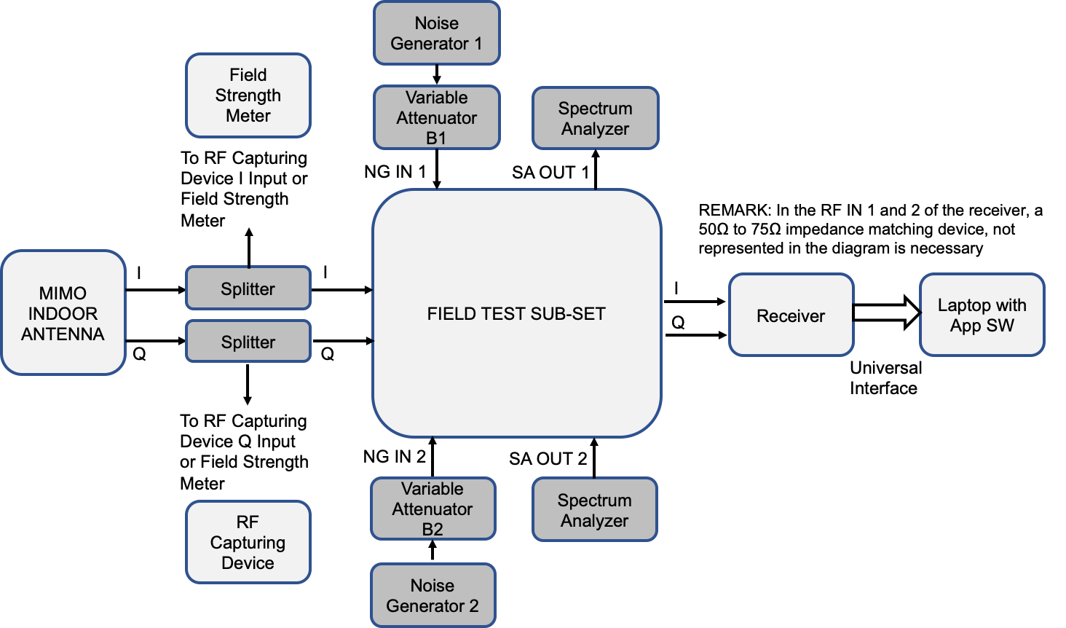
Figure 27: Field test setup
The field test setup of Figure 27 shall be applied to the Test Vehicle and the rooms arranged for indoor tests. In the Test Vehicle, the MIMO Indoor Antenna and the GPS Antennas will be securely mounted above the Test Vehicle and connected to the equipment inside the vehicle by coaxial cables. In the test rooms, the MIMO Indoor Antenna shall stay inside the room, and the GPS antenna in a position for best GPS signal reception, being outside the room if necessary.
The reference signal for synchronization, generated by the GPS signal receiving set up of Figure 25, is not shown in Figure 27, just for simplifying the figure.

Coverage Measurement
The coverage measurement tests shall be conducted with the test vehicle parked or inside a room.
For the coverage measurements, the Variable Attenuators A1 and A2 in Figure 26 (Field test sub-set) shall be set to minimum attenuation, except for system margin measurements. The Variable Attenuators B1 and B2 are set to the maximum attenuation, except for C/N measurements.
The test points should be selected in compliance with the ITU-R Report BT.2035-2.
The measurements to be conducted are:
  - Distance and bearing to transmitting antenna location;
  - Ground elevation at measuring location;
  - Date, time of the day, topography, traffic, and weather observations should be noted;
  - Spectrum analyzer data of the DTTB receiver signal spectrum (for each major measurement set, including for Variable Attenuators A1 and A2 in minimum attenuation);
  - Field Strength (minimum, maximum, and median value) (dBµV/m);
  - System margin. The input RF signal shall be attenuated in a controlled manner until TOV is reached;
  - C/N ratio at TOV for best reception and for maximum field strength (random noise added in a controlled manner by adjusting Variable Attenuators B1 and B2).

Service Measurement
The service measurement test shall be conducted in parallel to the coverage measurement. All the data collected for the coverage measurement is processed for the analysis of service measurements. Additional tests are specified as:
- Noise floor;
- If the reception conditions in the location are not good and errors occur, annotate the BER or FER;
- Delay profile. If the Application Software installed in the Laptop PC, provided by the technology proponent, is capable to provide such data;
- Measurement of video, audio, and data transmission bitrates at MIMO and MIMO plus Channel Bonding;
- Verification of stability of channel identification, with the receiver tuned to a station identified as A, in a location receiving the signal of station identified as B, transmitting in the same frequency as A, but with different content and with similar receiving level.
NOTE: To adjust the receiving levels of A station and B station, replace the MIMO Indoor Antenna by two directional antennas (one for each polarization), and adjust the receiving level of both stations by controlling the azimuth of each antenna and adjusting the Variable Attenuators A1 and A2 to minimum attenuation. When a similar reception level is achieved, fix the antenna positions. The observation interval time shall be one hour. The stability of reception shall be verified even in a condition of level variations of both signals in the Receiver input.

Drive Test
The drive tests shall be conducted with a test vehicle in movement, with the MIMO Omnidirectional antenna and GPS antenna fixed securely above the vehicle, and connected to the respective Receivers, inside the vehicle through coaxial cables.
The vehicle setup is shown in Figure 28.
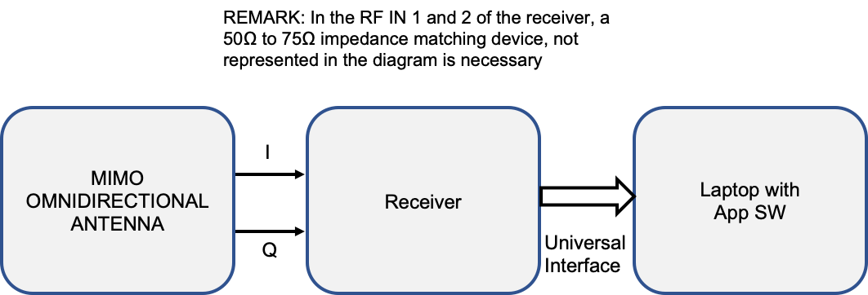
Figure 28: Drive test vehicle setup
NOTE: The setup of Figure 28 does not show the GPS receiving signal set up shown in Figure 25. The GPS reference signals shall be distributed to the Receivers and the Laptop PC with application software.
The vehicle moves around the city and collects Digital TV signal quality data and GPS information into the Laptop PC hard drive. The data are retrieved in the Laboratory, analyzed and maps with localization and Digital TV signal quality are registered.
The data registered by the Laptop PC are:
- For GPS information: date, hour, car speed, longitude, latitude, number of locked GPS satellites, GPS satellite signal quality, orientation, channel lock state, shall be collected and recorded, at each one-second interval;
- For receiving signal quality: modulation parameters - to be determined according to the modulation technology used by the proposed technology, errored bits, errored packets, total quantity of packets received in the one-second interval, C/N of the channel being received, received level, and others parameters according to the proposed technology. The data should be refreshed at each one-second interval.

RF Capturing
The RF capturing in the field will be only possible with the availability of an RF capturing device for the MIMO system.
One alternative is the use of 2 RF capturing devices, one for each antenna polarization output, that allows synchronized operation.
The SBTVD Forum will determine the locations for the RF capturing, which should be done with Test Vehicle stationed or inside in a room. Each capturing should have a duration of at least 20 seconds.

Transport Layer
The transport layer requirements set in the TV 3.0 Call for Proposals document, against which the proposals of candidate technologies will be tested and evaluated, are repeated here for the convenience of the reader. For further details, please refer to the TV 3.0 Call for Proposals document.
use case |  | minimum technical specification |  |  | over-the-air delivery | Internet delivery
TL1 | Enable frame-accurate synchronization of video, audio, and data, either carried on the same platform (e.g. over-the-air) or mixed on different distribution platforms (e.g. DTT, cable, IPTV, DTH satellite, fixed broadband, 4G/5G mobile broadband) for seamless dynamic content replacement or for using audio/video/data enhancement layers. | TL1.1 | single platform audio/video/data sync | frame-accurate | required | required
TL1 |  | TL1.2 | multi-platform audio/video/data sync | frame-accurate | required | required
TL2 | Facilitate content rebroadcasting over different distribution platforms (e.g. DTT, cable, IPTV, DTH satellite, fixed broadband, 4G/5G mobile broadband) and for the home network. Support non-real-time media (download/push). | TL2.1 | IPv4-based transport |  | required | required
TL2 |  | TL2.2 | IPv6-based transport |  | desirable | required
TL3 | Enable reliable and efficient multiplexing (low latency, error detection with low-overhead, avoiding unnecessary metadata duplication). | TL3.1 | latency | ms | lower is better | lower is better
TL3 |  | TL3.2 | error detection |  | required | required
TL3 |  | TL3.3 | overhead | % | lower is better | lower is better
TL3 |  | TL3.4 | avoid unnecessary metadata duplication |  | recommended | recommended
TL4 | Enable Internet content delivery with encryption. | TL4.1 | encryption support |  | not required | required
TL5 | Enable the identification of the TV network, the originating station, and the transmission station. | TL5.1 | identification of the TV network, the originating station, and the transmission station |  | required | N/A
TL6 | Provide appropriate signaling of whether the channel transports emergency warnings (over-the-air or by the Internet) or not. | TL6.1 | provide appropriate signaling of whether the channel transports emergency warnings (over-the-air or by the Internet) or not |  | required | required
TL7 | Provide Internet-based "wake-up" capability for compatible receivers in case of an emergency warning. | TL7.1 | Internet-based "wake-up" capability |  | N/A | desirable
TL8 | Support as much as possible the same Alerting Protocol used by the Brazilian Government, or a similar one. | TL8.1 | support OASIS Common Alerting Protocol 1.2 required elements |  | required | required
TL9 | Enable flexible geographic targeting for emergency warnings. | TL9.1 | countrywide alert (with country identification) |  | required | required
TL9 | Enable flexible geographic targeting for emergency warnings. | TL9.2 | list of up to 14 federative units within a country to be alerted (with country identification) (at least 27 federative unit codes) (federative unit codes list should be updatable over-the-air and by Internet) |  | required | required
TL9 | Enable flexible geographic targeting for emergency warnings. | TL9.3 | list of up to 14 federative units within a country not to be alerted (with country identification) (at least 27 federative unit codes) (federative unit codes list should be updatable over-the-air and by Internet) |  | required | required
TL9 | Enable flexible geographic targeting for emergency warnings. | TL9.4 | list of up to 427 municipalities within a federative unit to be alerted (with country and federative unit identification) (at least 5 570 municipality codes) (municipality codes list should be updatable over-the-air and by Internet) |  | required | required
TL9 | Enable flexible geographic targeting for emergency warnings. | TL9.5 | list of up to 427 municipalities within a federative unit not to be alerted (with country and federative unit identification) (at least 5 570 municipality codes) (municipality codes list should be updatable over-the-air and by Internet) |  | required | required
TL9 | Enable flexible geographic targeting for emergency warnings. | TL9.6 | list of up to 1 000 postal codes entries to be alerted (with country identification) (including individual entries and ranges) (supporting wildcard characters) (Brazilian postal code format: 8 numeric digits) |  | required | required
TL9 | Enable flexible geographic targeting for emergency warnings. | TL9.7 | list of up to 1 000 postal codes entries to be alerted  (with country identification) (including individual entries and ranges) (supporting wildcard characters) (other postal code formats, up to 10 alphanumeric digits) |  | not required for Brazil, but may be useful for other countries that may wish to adopt the same DTTB system
TL10 | Enable future extensions to the transport layer (e.g. to support transporting new audio, video, and data formats). | TL10.1 | extensibility |  | required | required
TL-AR1. Provide free of charge reference multiplexer and demultiplexer (software or hardware) with its corresponding documentation, strictly for temporary technical evaluation of the SBTVD Forum (non-commercial usage).
TL-AR2. Provide information about available implementations of the multiplexer and demultiplexer, the latter both for professional (broadcast) and consumer electronic applications.
TL-AR3. Provide some reference information about the demultiplexer for TV sets manufacturing.
The proponent's transport layer system will be evaluated in two steps. The “steps” referred here are “System Tests” (ST) and the “System Verifications” (SV). The proponent of the transport layer shall make available prototype or commercial equipment for the evaluation, as defined in the following subsections.

Conditions for tests

Equipment to be provided by the proponent
For testing purposes, the proponent shall deliver to the laboratory, at least 1 MUX, 1 DEMUX, 1 Transport Analyzer, and 1 A/V Decoder with 2 SDI output channels. Depending on the proponent’s system, it is possible that some of the equipment is integrated into a single module and this is acceptable as long as all tests can be accomplished. Also, if any of the equipment does not fulfill all requirements, additional HW/SW must be provided so that all tests can be executed. Thus, if any of the equipment does not have enough inputs or outputs, the proponent must provide more than 1 module, or if it does not have any of the requested features or is not able to make any measurement requested, the proponent must come up with another solution to make this measurement possible, providing extra HW/SW.
Features needed for each equipment are described in the topics below.
- MUX: Gigabit ethernet interface and access to its Operational System (OS) if available;
- DEMUX: Gigabit ethernet interface and access to its OS if available;
- Transport Analyzer: Gigabit ethernet interface, overhead percentage measurement;
- A/V Decoder: Gigabit ethernet interface and two SDI outputs. Capable of decoding 2 IP streams simultaneously.

Files to be provided by the proponent
- MUX configuration files for all tests;
- Packet Capture (PCap) files for all test cases;
- Video server files, SW, and/or executable programs needed.

Laboratory’s equipment
The Laboratory shall have the following equipment to perform the tests:
- 1 PCap Playout;
- 1 Video Server;
- 1 Time Source (Local NTP Server);
- 1 Network / OTA delay Emulator;
- 1 Gigabit Ethernet Switch / Router;
- 1 Controller Computer / Laptop;
- 2 Monitors;
- 1 A/V Recorder with 2 channels.
The Time Source is a Local NTP Server, but if a GPS is necessary it must be provided by the proponent.
The Network / OTA delay Emulator can delay the ethernet packets, limit bandwidth, and corrupt data at any ethernet connection (destination IP address and/or port).
The A/V Recorder must be able to record two SDI streams simultaneously.

General test conditions
- Every packet under test shall be monitored to measure the latency in each device;
- All signal generated shall be checked in the Transport Analyzer;
- Test content containing an HEVC video with burnt-in timecode and spatial resolution of 1 920 x 1 080 pixels (Full HD), temporal resolution of 59.94 frames per second, at 15 Mbps CBR (±5%), and a MPEG-4 AAC LC stereo audio, at 192 kbps CBR (±5%).

Testing cases
- Over-The-Air (OTA): A single test content stream, containing video and audio content, is delivered, simulating an OTA transmission, from the PCap Playout.
- Targeted advertising: The A/V decoder switches from OTA delivery to OTT delivery. The PCap file for the OTA delivery must contain a transition from a TV Show content to a General Advertising content, which is played in case of low internet bandwidth and the proponent must inform the timecode of the first frame for the Advertising (General and Targeted). The Targeted Advertising stream comes from a file or URL from the Video Server. Figure 29 shows the targeted advertising expected timeline depending on internet availability / bandwidth.
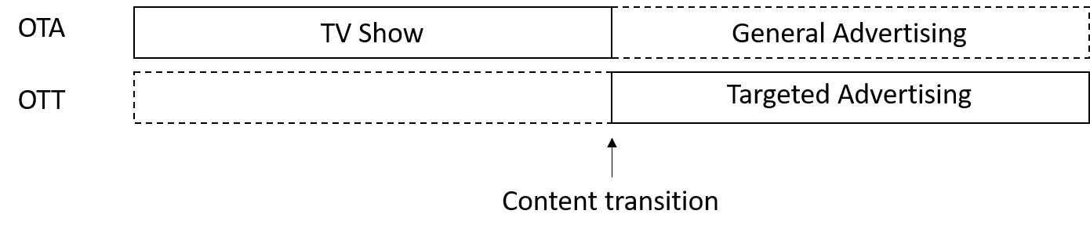
Figure 29: Target advertising timeline
- Live Streaming: The A/V decoder switches from OTA delivery to OTT delivery. The PCap file(s) must contain two streams, one with a low bit rate content for the OTA delivery and another with a high bit rate content for the OTT delivery. Content shall switch whenever the internet bandwidth is not limited. Figure 30 shows the expected timeline when internet bandwidth is not limited.
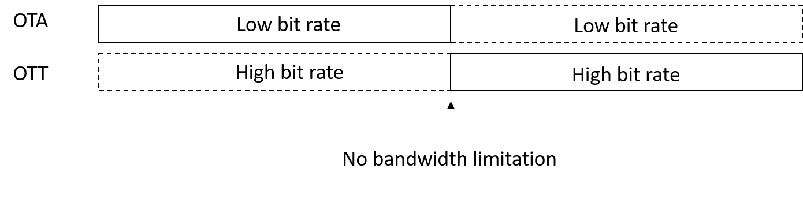
Figure 30: Live stream timeline
- OTT audio: A/V content is delivered OTA and audio content in another language is delivered by the OTT. All contents for this test shall come from one PCap file and the MUX shall generate the OTA and OTT streams. The file should be an A/V Lip-Sync Test Pattern and Audio 1 and Audio 2 shall have different levels. Audio selection should be done on the DEMUX. Figure 31 shows the timeline of additional audio delivered OTT.
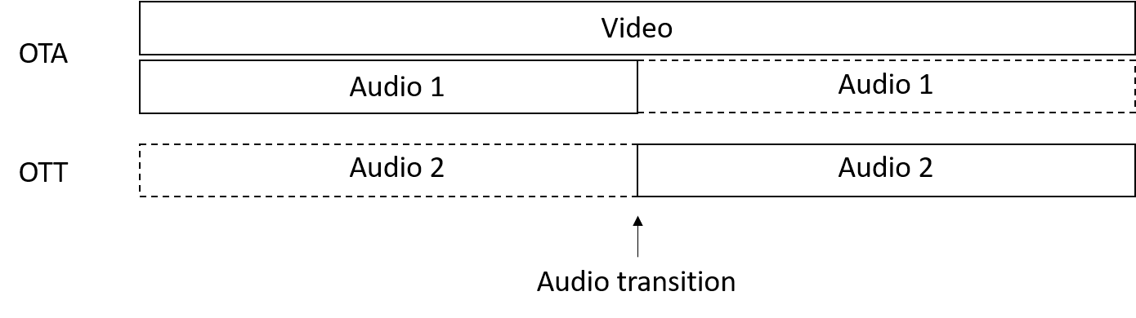
Figure 31: Additional audio over OTT timeline
- Multi-view: the same scene from different angles, where one of them is delivered OTA to a TV, and the other one is delivered by the internet (OTT) to a mobile device (e.g. a soccer game). Playout’s output feeds three streams to the MUX: one for OTA and the others for OTT. The DEMUX must have the functionality to switch between views 2 and 3 according to the user’s choice. For testing purposes, all 3 streams must be different from each other. Figure 32 shows the timeline for OTA and OTT deliveries, which should be displayed on different monitors.
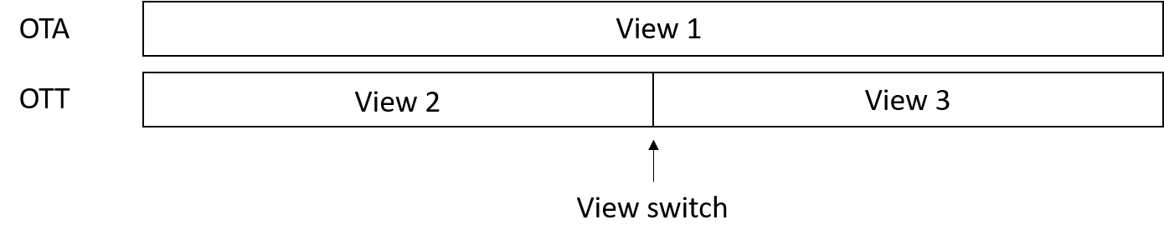
Figure 32: Timeline for two monitors: one OTA and one OTT

Setup for tests
Figure 33 presents a general setup that shall be used for all tests from this procedure. Please note that not necessarily all output equipment will be used at every test, each one of them will specify at their own sections which equipment will be used to provide the requested results. Also, additional equipment can be added to this setup, considering the provisions on 4.3.2.1.1. Figure 34 to Figure 36 show the Logical configurations used in the tests.
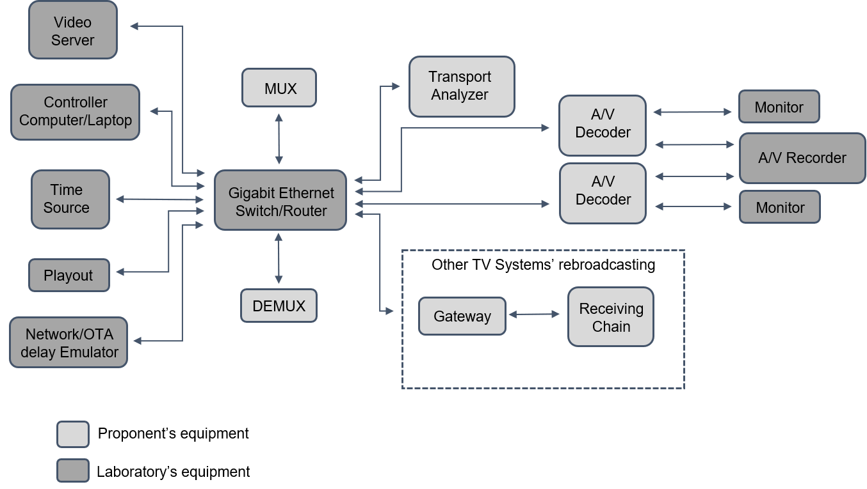
Figure 33: Physical diagram of the test setup
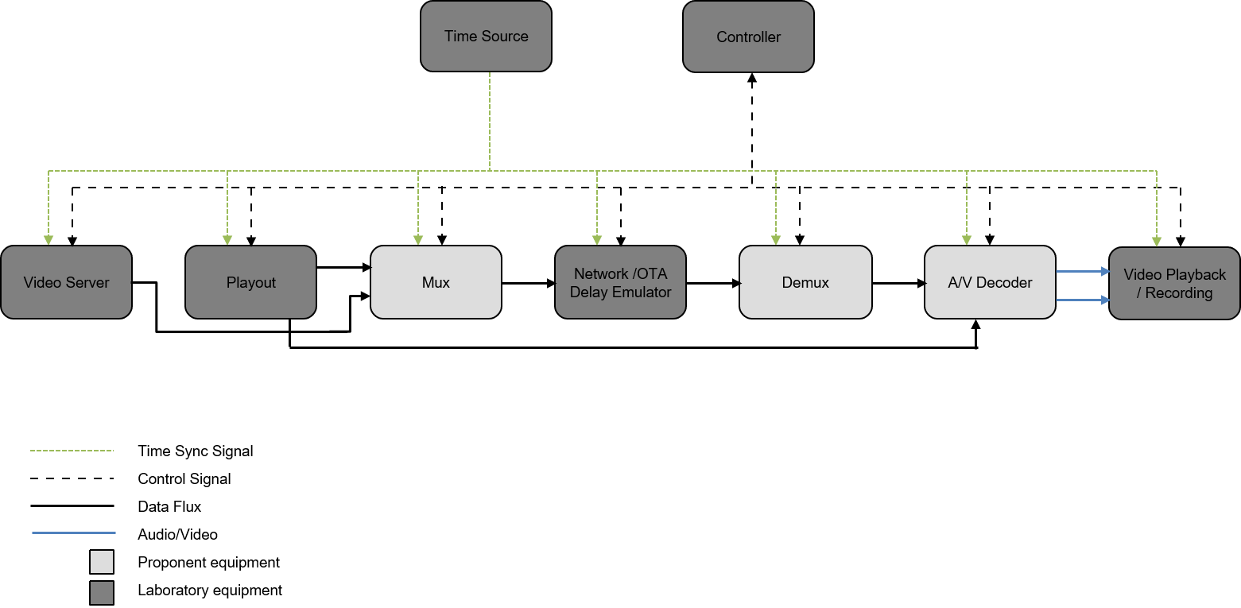
Figure 34: Logical configuration for video playback/recording
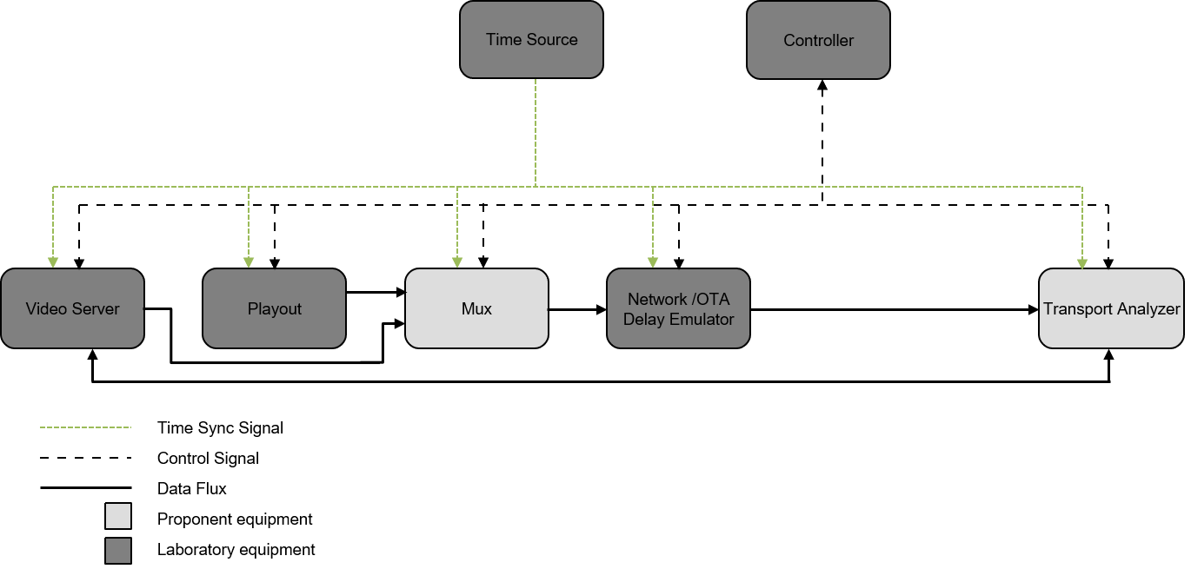
Figure 35: Logical configuration for the Transport Analyzer
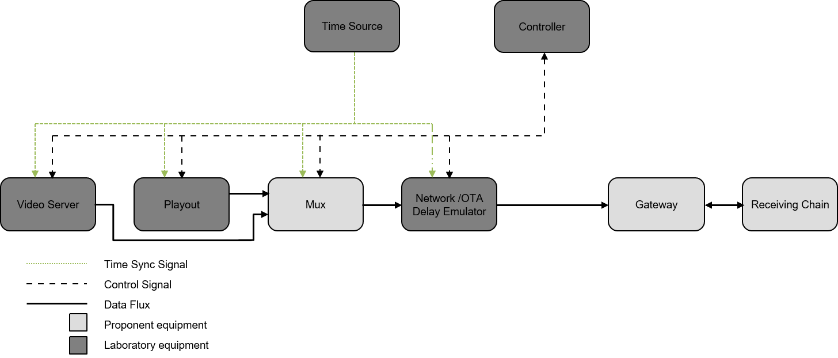
Figure 36: Logical configuration for rebroadcasting

Laboratory Tests

System Tests

Enable frame-accurate synchronization of video, audio, and data for single or multi-platform (TL1.1 and TL1.2)
Cases "b", "c", "d" and "e" shall be considered for this test.
For the single platform configurations, synchronization will be observed considering the moment when the OTT content replaces or enhances the OTA content.
For the multi-platform configuration, all media shall be synchronized from the beginning of the transmission.
The system will be stressed by delaying both OTA and OTT streams (one at a time) with the Network/OTA delay emulator and will be tested under different configurations. Also, the proponent must inform the maximum latency supported (or buffer size).
Each case shall be tested with no added delay and maximum delay informed by the proponent. If the system is not synchronized at maximum delay informed by the proponent, the laboratory shall conduct the test by reducing the delay until frame-accuracy can be observed. If in any of these configurations the result is not frame-accurate, the delay in frames shall be reported.
The A/V Decoder output(s) shall be recorded and analyzed using the timecode as a reference.
Test procedure:
  - Play the PCap file(s) test case in the playout system;
  - Configure all equipment;
  - Adjust the Network/OTA delay Emulator;
  - Check Transport Analyzer information (flags, alarms, signaling, etc.);
  - Start to record A/V Decoder output(s);
    - For the Targeted Advertising test case, check if OTA General Advertising is played when no bandwidth is available for OTT, then restart the test with no bandwidth limitation;
    - For the Live Streaming case, check if Full HD content is displayed until the end of the stream when no bandwidth is available, then restart the test with no bandwidth limitation;
    - For the OTT audio and the Multi-view cases, switch content being streamed at any moment during the stream.
  - Stop recording a few seconds after the transition occurs;
  - Repeat this procedure for all cases and conditions.
After running all tests, recordings shall be analyzed on an editing video software (recorded from SDI) to check for synchronization, as described in the topics below:
  - Targeted Advertising: Check if the OTT Targeted Advertising stream starts right after the last frame from the OTA stream or if any frame was lost;
  - Live Streaming: Check if any frame was lost when video switches to OTT;
  - OTT Audio: Check if A/V synchronism remains after transition by observing the lip-sync stream pattern;
  - Multi-view: Both OTA and OTT streams shall be compared, and synchronization shall be verified after and before the transition.
All results shall be recorded according to the template in Table 17.
Table 17: Template for synchronization test results
Case | Stream delayed | Latency (ms) | Result
b) Targeted Advertising | OTA | 0
b) Targeted Advertising | OTA | max
b) Targeted Advertising | OTT | 0
b) Targeted Advertising | OTT | max
c) Live Streaming | OTA | 0
c) Live Streaming | OTA | max
c) Live Streaming | OTT | 0
c) Live Streaming | OTT | max
d) OTT Audio | OTA | 0
d) OTT Audio | OTA | max
d) OTT Audio | OTT | 0
d) OTT Audio | OTT | max
e) Multi-view | OTA | 0
e) Multi-view | OTA | max
e) Multi-view | OTT | 0
e) Multi-view | OTT | max

Multiplexing latency (TL3.1)
The latency of both OTA and OTT deliveries shall be measured in milliseconds (ms), considering different content cases and the results will be recorded according to the template in Table 18.
The SDI A/V decoder outputs from the Playout and the DEMUX will be recorded so that the latency can be measured comparing the timecode of each file.
The IP streams under test are monitored to measure their latency since the input of the MUX until A/V decoder input.
The following test procedure shall be conducted for testing cases "a" and "e":
  - Play the PCap file(s) test case in the playout system;
  - Configure all equipment;
  - Check Transport Analyzer information (flags, alarms, signaling, etc.);
  - Record A/V Decoder outputs for a few seconds.
Recorded files shall be analyzed on a video editing software and the latency shall be measured by comparing their timecodes. Results shall be recorded according to the template in Table 18.
Table 18: Template for multiplexing latency results
Testing case | Delivery method | Latency (ms)
a) OTA | OTA
e) Multi-view | OTA
e) Multi-view | OTT

Measure % of Overhead (TL3.3)
Overhead percentage of both OTA and OTT deliveries shall be measured for cases "a", "b", "c", and "e" with the Transport Analyzer, and the results will be recorded according to the template in Table 19. If the Transport Analyzer is not able to provide this measurement, the proponent must provide an equivalent method for this test.
The following test procedure shall be conducted for testing cases "a", "b", "c" and "e":
  - Play the PCap file(s) test case in the playout system;
  - Configure all equipment;
  - Adjust the Network / OTA delay Emulator;
  - Check Transport Analyzer information (flags, alarms, signaling, etc.) and the Overhead.
Table 19: Template for overhead percentage measurements
Testing case | Delivery method | Overhead (%)
a) OTA | OTA
b) Target Advertisement | OTA
b) Target Advertisement | OTT
c) Live Streaming | OTA
c) Live Streaming | OTT
e) Multi-view | OTA
e) Multi-view | OTT

System Verification

Check ease to rebroadcast content over different distribution platforms (TL2.1 and TL2.2)
The proponent shall provide any available equipment or method that facilitates rebroadcasting, such as a UDP stream from the MUX or a converter.
The following test procedure shall be conducted for the testing case "a":
  - Play the PCap file(s) test case in the playout system;
  - Configure all equipment;
  - Adjust the Network / OTA delay Emulator;
  - Check Transport Analyzer information (flags, alarms, signaling, etc.).

Check error detection mechanism in over the air delivery as well as in the internet delivery (TL3.2)
Packet errors must be shown on the Transport Analyzer, or by any other HW / SW provided by the proponent. Packets will be corrupted for this test.
The following test procedure shall be conducted for the testing cases "a", "b", "c", and "e":
  - Play the PCap file(s) test case in the playout system;
  - Configure all equipment;
  - Adjust the Network / OTA delay Emulator and corrupt packets;
  - Check Transport Analyzer information (flags, alarms, signaling, etc.).

Check if it avoids unnecessary metadata duplication (TL3.4)
The proponent shall demonstrate how its system avoids unnecessary metadata duplication and provide a verification method.

Check internet content delivery with encryption (TL4.1)
The Transport Analyzer must show if the content is encrypted and the A/V Decoder must be able to decode the encrypted content. The proponent must provide a PCap file similar to the case “e”, but with view 3 being an encrypted content.
The following test procedure shall be conducted for the requested file:
  - Play the PCap file(s) test case in the playout system;
  - Configure all equipment;
  - Adjust the Network / OTA delay Emulator;
  - Check Transport Analyzer information (flags, alarms, signaling, etc.) if the internet content is encrypted;
  - Check if the encrypted content was decrypted and decoded.

Check the possibility of TV network, originating station, and transmission station identification (TL5.1)
The proponent must inform which fields in the tables are responsible for this information and it will be observed on the Transport Analyzer.
The following test procedure shall be conducted for the testing case "a":
  - Play the PCap file(s) test case in the playout system;
  - Configure all equipment;
  - Adjust the Network / OTA delay Emulator;
  - Check Transport Analyzer information (flags, alarms, signaling, etc.), including TV network, originating station, and the transmission station identification information as specified by the proponent.

Check the emergency warning message transmission signaling (TL6.1)
The emergency warning must be enabled/disabled on the MUX and the Transport Analyzer must show it.
The following test procedure shall be conducted for the testing case "a":
  - Play the PCap file(s) test case in the playout system;
  - Configure all equipment;
  - Adjust the Network / OTA delay Emulator;
  - Enable/Disable emergency warning message in the MUX;
  - Check Transport Analyzer information (flags, alarms, signaling, etc.), including the emergency warning message as specified by the proponent.

Check internet-based wake-up capability (TL7.1)
The wake-up must be enabled / disabled on the MUX and the Transport Analyzer must show it. The proponent must provide the MUX configuration file that signalizes the wake-up.
The following test procedure shall be conducted for the testing case "a":
  - Play the PCap file(s) test case in the playout system;
  - Configure all equipment;
  - Adjust the Network / OTA delay Emulator;
  - Enable / Disable Alert Protocol in the MUX;
  - Check Transport Analyzer information (flags, alarms, signaling, etc.), including wake-up flags and/or fields.

Check Support as much as possible the same Alerting Protocol used by the Brazilian Government, or a similar one (TL8.1)
The proponent must inform and detail which fields in the tables are responsible for this information and it will be observed on the Transport Analyzer. If it is a similar protocol, the proponent must detail the similarities and differences between the Alert Protocol used by the Brazilian Government and the proponent’s proposed one. The MUX configuration file must be provided.
The following test procedure shall be conducted for the testing case "a":
  - Play the PCap file(s) test case in the playout system;
  - Configure all equipment;
  - Adjust the Network / OTA delay Emulator;
  - Enable / Disable Alert Protocol in the MUX;
  - Check Transport Analyzer information (flags, alarms, signaling, etc.) and information of Alert Protocol.

Check flexible geographic targeting for emergency warnings (TL9.1 – TL9.7)
The proponent must inform which fields in the tables are responsible for this information and it will be observed on the Transport Analyzer.
The following test procedure shall be conducted for the testing case "a":
  - Play the PCap file(s) test case in the playout system;
  - Configure all equipment;
  - Adjust the Network / OTA delay Emulator;
  - Enable / Disable geographic targeting for emergency warnings in the MUX;
  - Check Transport Analyzer information (flags, alarms, signaling, etc.), including geographic targeting for emergency warnings.

Check future extensions to the transport layer (TL10.1)
The proponent must provide information about how current formats are signaled and if / how future upgrades can be signaled (number of bits used by the field and/or its syntax / format).

Video Coding
The video coding requirements set in the TV 3.0 Call for Proposals document, against which the proposals of candidate technologies will be tested and evaluated, are repeated here for the convenience of the reader. For further details, please refer to the TV 3.0 Call for Proposals document.
use case |  | minimum technical specification |  |  | over-the-air delivery | Internet delivery
VC1 | Provide improved video resolution, adequate to consumer electronics display evolution. | VC1.1.1 | resolution | 7 680 x 4 320 | not required | required
VC1 |  | VC1.1.2 | resolution | 5 120 x 2 880 | recommended | recommended
VC1 |  | VC1.1.3 | resolution | 3 840 x 2 160 | required | required
VC1 |  | VC1.1.4 | resolution | 2 560 x 1 440 | recommended | recommended
VC1 |  | VC1.1.5 | resolution | 1 920 x 1 080 | required | required
VC1 |  | VC1.1.6 | resolution | 1 280 x 720 | required | required
VC1 |  | VC1.2 | scanning | progressive | required | required
VC1 |  | VC1.3 | aspect ratio | 16:9 | required | required
VC1 |  | VC1.4 | sampling | YCbCr 4:2:0 | required | required
VC2 | Provide improved video dynamic range and color space, adequate to consumer electronics display evolution. | VC2.1 | bit depth | 10-bit/component | required | required
VC2 |  | VC2.2.1 | dynamic range | HDR | required | required
VC2 |  | VC2.2.2 | dynamic range | HDR Dynamic Mapping | desirable | required
VC2 |  | VC2.2.3 | dynamic range | SDR | not required | required
VC2 |  | VC2.3 | colorimetry | WCG (Rec. ITU-R BT.2020 / BT.2100) | required | required
VC3 | Provide sharp images (reducing motion blur), even on content with fast motion (e.g. sports, action movies). | VC3.1.1 | frame rate | 120 fps | recommended | required
VC3 |  | VC3.1.2 | frame rate | 119.88 fps (120/1.001) | recommended | required
VC3 |  | VC3.1.3 | frame rate | 60 fps | recommended | required
VC3 |  | VC3.1.4 | frame rate | 59.94 fps (60/1.001) | required | required
VC3 |  | VC3.1.5 | frame rate | 30 fps | not required | required
VC3 |  | VC3.1.6 | frame rate | 29.97 fps (30/1.001) | not required | required
VC3 |  | VC3.1.7 | frame rate | 24 fps | not required | required
VC3 |  | VC3.1.8 | frame rate | 23.976 fps (24/1.001) | not required | required
VC3 |  | VC3.1.9 | frame rate | 100 fps | not required for Brazil, but may be useful for 50Hz countries that may wish to adopt the same DTTB system
VC3 |  | VC3.1.10 | frame rate | 50 fps
VC3 |  | VC3.1.11 | frame rate | 25 fps
VC4 | Provide state-of-the-art coding efficiency, to allow better quality video in limited capacity channels (over-the-air or Internet). | VC4.1 | bit rate | Mbps @ MOS 4 or equivalent objective metric | lower is better | lower is better
VC5 | Provide live video with minimum end-to-end latency. | VC5.1 | real-time encoding |  | required | required
VC5 | Provide live video with minimum end-to-end latency. | VC5.2 | latency | ms | lower is better | lower is better
VC6 | Enable second video stream with a sign language interpreter to be optionally activated by the user (to be rendered at the side of the main video, that should be proportionally downscaled to fit the horizontal space left, with no overlap; an optional background still image can be defined by the broadcaster). | VC6.1.1 | resolution | 2 160 x 3 840 (when using 7 680 x 4 320 main video) | not required | required
VC6 |  | VC6.1.2 | resolution | 1 440 x 2 560 (when using 5 120 x 2 880 main video) | recommended | recommended
VC6 |  | VC6.1.3 | resolution | 1 080 x 1 920 (when using 3 840 x 2 160 main video) | required | required
VC6 |  | VC6.1.4 | resolution | 720 x 1 280 (when using 2 560 x 1 440 main video) | recommended | recommended
VC6 |  | VC6.1.5 | resolution | 540 x 960 (when using 1 920 x 1080 main video) | required | required
VC6 |  | VC6.1.6 | resolution | 360 x 640 (when using 1 280 x 720 main video) | required | required
VC6 |  | VC6.2 | scanning | progressive | required | required
VC6 |  | VC6.3 | aspect ratio | 9:16 | required | required
VC6 |  | VC6.4 | sampling | YCbCr 4:2:0 | required | required
VC6 |  | VC6.5 | alpha blending |  | required | required
VC6 |  | VC6.6 | bit depth | 10-bit/component | required | required
VC6 |  | VC6.7.1 | dynamic range | HDR | required | required
VC6 |  | VC6.7.2 | dynamic range | HDR Dynamic Mapping | desirable | required
VC6 |  | VC6.7.3 | dynamic range | SDR | not required | required
VC6 |  | VC6.8 | colorimetry | WCG (Rec. ITU-R BT.2020 / BT.2100) | required | required
VC6 |  | VC6.9.1 | frame rate | 30 fps | recommended | required
VC6 |  | VC6.9.2 | frame rate | 29.97 fps (30/1.001) | required | required
VC6 |  | VC6.9.3 | frame rate | 24 fps | not required | required
VC6 |  | VC6.9.4 | frame rate | 23.976 (24/1.001) | not required | required
VC6 |  | VC6.9.5 | frame rate | 25 fps | not required for Brazil, but may be useful for 50Hz countries that may wish to adopt the same DTTB system
VC6 |  | VC6.10 | bit rate | Mbps @ MOS 4 or equivalent objective metric | lower is better | lower is better
VC6 |  | VC6.11 | real-time encoding |  | required | required
VC6 |  | VC6.12 | latency | ms | lower is better | lower is better
VC7 | Enable emergency warning information delivery using sign language video. | VC7.1 | emergency warning information sign language video |  | desirable | desirable
VC8 | Enable new immersive video services. | VC8.1 | VR / AR / XR / 3DoF / 6DoF support |  | desirable | desirable
VC9 | Enable seamless decoding and A/V alignment. | VC9.1 | seamless and frame-accurate stream splicing or ad-insertion at any time instance, even if some of the streams come from different distribution platforms (e.g. switch between over-the-air and Internet delivery) |  | required | required
VC10 | Enable interoperability with different distribution platforms (e.g. DTT, cable, IPTV, DTH satellite, fixed broadband, 4G/5G mobile broadband, home network). | VC10.1 | interoperability with different distribution platforms |  | required | required
VC11 | Enable scalability (e.g. to improve over-the-air video quality with an Internet-delivered enhancement layer) and extensibility (support new settings and/or features in the future, in a backward-compatible way). | VC11.1.1. | scalability | spatial | required | required
VC11 |  | VC11.1.2. | scalability | temporal | recommended | recommended
VC11 |  | VC11.1.3. | scalability | quality (bit rate) | recommended | required
VC11 |  | VC11.2 | extensibility |  | required | required
VC-AR1. Provide free of charge test content (consecutively numbered TIFF files) with the required technical specification, strictly for technical evaluation of the SBTVD Forum (non-commercial usage). The content shall not contain commercial brands.
VC-AR2. Provide free of charge reference encoder and decoder (software or hardware) with its corresponding documentation, strictly for temporary technical evaluation of the SBTVD Forum (non-commercial usage).
VC-AR3. Provide information about available implementations of the encoder and decoder, the latter both for professional (broadcast) and consumer electronic applications.
VC-AR4. Provide some reference information about the decoder for TV sets manufacturing.
The assessment methodology for video systems is divided into three main evaluation steps: Documentation Analysis, Subjective Quality Assessment Reports, and Features and Objective Performance Evaluation.
In the subsequent subsections, the following definitions are adopted:
- real-time: this phrase indicates that encoding and/or decoding is executed concurrently as audio/video content is being delivered to a system under test by a playout system and, after the decoding process, is displayed in an audio or video monitor.
- non-real-time: this phrase, or the phrase “file-based”, indicates that encoding and/or decoding is executed after audio/video content is received (normally as a file). Non-real-time encoding and/or decoding shall be done only with single-pass encoding and/or decoding.
- source content: this phrase indicates uncompressed audio or video content that is used to feed the system under test.
- processed content: this phrase indicates uncompressed audio or video content after being processed by the system under test.

Documentation analysis
Each received proposal for the video system shall be analyzed in detail to map what the proponent's system can achieve in conformance with the TV 3.0 Call for Proposals requirements.
Proponents shall provide detailed documentation on how their system works and how it conforms with the specified requirements for the video system. Proponents are encouraged to submit additional information about features from the proposed video system that may enrich the overall video quality of experience and are not a current requirement in the TV 3.0 Call for Proposals document.
At the end of the documentation analysis, the Test Lab shall produce a report consolidating all the analyzed requirements for the video system classified as “Fulfilled”, “Partially Fulfilled” and “Not Fulfilled”. Test Lab analysts shall include in that report a detailed explanation of all requirements classified as “Fulfilled”, “Partially Fulfilled” and “Not Fulfilled”.
The evaluation report shall present the results per video sub-component (Video Codec, HDR Dynamic Mapping Codec, VR Codec, Display Manager for multiple videos, and Emergency Warning System manager).

Subjective quality assessment reports
The SBTVD Forum does not intend to perform any subjective video quality assessment. Each proponent shall send its own subjective quality assessment reports as described in this section.
Each proposal for video sub-components Video Codec, HDR Dynamic Mapping Codec, and VR Codec shall provide subjective qualitative and quantitative reports assessing codec’s performance results. Those reports shall include data from video subjective test procedures in compliance with directives from the Recommendations ITU-R BT.500, ITU-T P.910, or ITU-R BT.2095, submitted to or produced by international standardization organizations for the evaluation of the proponent’s video system. Reports from independent test labs or proponent test labs can also be submitted. In the latter case, SBTVD Forum members can request the description of the statistical tools used for the analysis and the content files used in the subjective test (both source and processed content) to allow cross-checking the results. The proponent shall grant, in a timely manner, a free of charge content license for its own content and provide information on how third-party content could be licensed (if applicable).
Subjective quality assessment reports are not required for the video sub-components Display Manager for multiple videos and Emergency Warning System manager.

Features and objective performance evaluation
Each proponent shall provide the required equipment and test content to allow the Test Lab to verify the compliance of the proponent's system regarding the requirements set in the TV 3.0 Call for Proposals and its performance, through the test procedures described in this section.
At the end of this step, the appointed Test Lab shall produce a report consolidating all the results obtained from the analyzed requirements for the video system classified as “Fulfilled”, “Partially Fulfilled” and “Not Fulfilled”. Test Lab analysts shall include in that report a detailed explanation of all requirements classified as “Fulfilled”, “Partially Fulfilled” and “Not Fulfilled”.
The evaluation report shall present the results per video sub-component (Video Codec, HDR Dynamic Mapping Codec, VR Codec, Display Manager for multiple videos, and Emergency Warning System manager).
For the evaluation of the proposed video sub-components Video Codec and HDR Dynamic Mapping Codec, a common set of test content shall be used by the Test Lab. The test content items shall be provided free of charge by the proponents as a raw material using consecutively numbered TIFF files or as a single YUV file per test content. All raw material shall contain a text file summarizing its characteristics. SBTVD Forum members are also encouraged to provide additional free of charge video test content in the same format. Content licenses shall be free of charge but may describe usage conditions. The Test Lab and the SBTVD Forum will select the appropriate content from the submitted pool of content. Proponents shall be allowed to have selected at least one of their own test content items. The result of that work is a number of critical test data sets: one for SDR, one for static HLG HDR, one for static PQ HDR, and one for HDR Dynamic Mapping. Test Lab and the SBTVD Forum will then fix bitrates individually for each content item and each test condition using HEVC fixed QP per picture type. QP values to be used are 22, 27, 32, and 37. The QPs are chosen in a manner that HEVC produces results from high quality (QP = 22) to poor quality (QP = 37), allowing to evaluate the performance of the new codecs. The result of that work is a spreadsheet with individual bitrates as the basis for all tests, further named bitrate spreadsheet. The subsequent test descriptions will reference the QPs. All test data sets will be made available to proponents for encoding.
For video sub-components Virtual Reality (VR) Codec, Display Manager for multiple videos, and Emergency Warning System manager, proponents shall demonstrate the proposed system capabilities using only their own test content and setup.
Video test content shall not make any reference to commercial brands and should contain a diverse set of ordinary broadcast program characteristics. Video test contents should contain scenes with diverse light (indoor/outdoor/mixed, sunny and cloudy), colorful sharp scenes, rapid camera motion scenes (pan, tilt, and zoom), scenes under natural or unnatural illumination, scenes partially or not using computer graphics (like graphics or text overlays), scenes with movement elements (people and/or objects), detailed and diverse scene elements (like people and/or objects) and scenes with facial closed-up with or without rich detail background. The duration of each video test content item shall be:
- For the sub-component Video Codec:
  - SDR: 10 seconds;
  - Static HLG HDR: 10 seconds; and
  - Static PQ HDR: 10 seconds.
- For the sub-component HDR Dynamic Mapping Codec:
  - HDR Dynamic Mapping: between 30 seconds and 3 minutes.
- For the sub-component VR Codec: between 10 seconds and 3 minutes.
- For the sub-component Display Manager for multiple videos: 10 seconds.
- For the sub-component Emergency Warning System manager: between 2 and 3 minutes.
Test content items with 10 seconds duration shall contain only one scene. Video test content items matching all the characteristics specified in the relevant tests for each video sub-component shall be provided by the proponents and other SBTVD members. For each configuration, the test set must contain at least 3 different test items.
All proposed video systems shall be evaluated using the same Test Lab room environment. This room shall have adequate illumination and shall reproduce ordinary living room characteristics as much as possible, taking into account the general viewing conditions guidance of the Recommendation ITU-R BT.500.
For the video sub-components Video Codec and HDR Dynamic Mapping Codec evaluation, one of the six video test setups (illustrated from Figure 37 to Figure 42 with their respective mandatory elements) shall be used, according to the test. Instructions about setup selection are provided in each video test description. Additional monitoring elements may be added to those setups by the Test Lab or by the SBTVD Forum. Nevertheless, those additional elements information shall be informed to all proponents before the test execution.
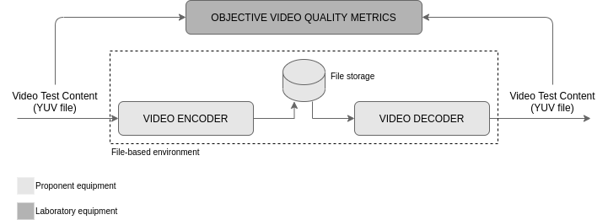
Figure 37: Video Codec test setup for non-real-time encoding / decoding
For Video Codec evaluations using the non-real-time encoding / decoding setup, all equipment (hardware and software) are the proponent’s responsibility, except the objective video quality metrics software (HDRMetrics utility from HDRTools version 0.19.1, available at https://gitlab.com/standards/HDRTools) and its related hardware, that shall be Test Lab’s responsibility. Video Encoder and Video Decoder can each consist of more than one device, implementing functions such as format converters, and compression/decompression functions. The transport layer between the video encoder and the video decoder can be selected by the proponent as long as the interoperability between the encoder and the decoder is ensured. The video encoder shall accept uncompressed video content as a single YUV file per test content item and in accordance with test content characteristics specified in each Test Case where the non-real-time video test setup is required. The video decoder shall provide processed video content as a single YUV file per test content item. Any test content item provided as consecutive numbered TIFF files format shall be converted to a single YUV file format before encoding using the HDRConvert utility from HDRTools.
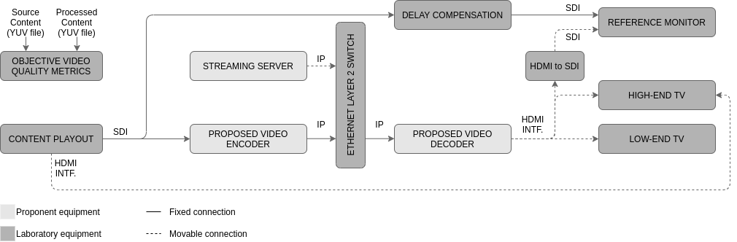
Figure 38: Video Codec test setup for real-time encoding / decoding
For Video Codec evaluations using real-time encoding/decoding, an SDI interface shall be used to feed the video encoder. The video encoder output interface shall use IP version 4 over Ethernet (IEEE 802.3). The IP-based transport layer protocol shall be chosen by the proponent. In the normal operation of this setup, the Streaming Server shall remain disconnected from the Ethernet Layer 2 Switch. When necessary, particular Test Cases provide instructions about the Streaming Server connection. For the video decoder, the input interface shall accept IP version 4 over Ethernet (IEEE 802.3) and the video output interface shall use HDMI. Content playout in this setup shall be capable of playing uncompressed video content over the SDI interface. In this setup, the reference monitor shall support resolutions from 1 920 x 720 pixels up to 3 840 x 2 160 pixels, temporal resolution up to 60 frames per second, WCG (Rec. ITU-R BT.2020 / BT.2100, with color space reproduction greater than or equal to DCI-P3), dynamic range SDR, HLG10 and PQ10, and have an SDI input interface and a peak luminance greater than or equal to 1 000 cd/m². A professional reference monitor is recommended. The consumer TVs (low-end and high-end) shall be consumer televisions sets, supporting the same resolutions, frame rates, and dynamic ranges, and they shall have an HDMI input interface. The low-end TV shall have a peak luminance less than or equal to 400 cd/m². The high-end TV shall have a peak luminance greater than or equal to 750 cd/m². All two consumer TVs shall support HLG10 and PQ10 over the HDMI input. The Test Lab shall evaluate their peak luminance, as this information is required for setting the HDR Dynamic Mapping tests.
On both Video Codec setups, Test Lab analysts shall evaluate the Source and Processed video (YUV files, in the non-real-time setup, SDI signal, in the real-time setup) using objective video quality metrics: PSNR (Peak Signal to Noise Ratio), wPSNR (Weighted PSNR) and MS-SSIM (Multi-Scale Structural Similarity Index Measure). From this point on of the document, the expression “video quality metrics" will be used to refer to these three objective video quality metrics. The values for Y-PSNR, U-PSNR, V-PSNR, Y-wPSNR, U-wPSNR, V-wPSNR, Y-MS-SSIM, U-MS-SSIM, and V-MS-SSIM shall be measured per frame and as well as the mean values for each test content item. For SDR sequences and Static HLG HDR sequences, the PSNR and MS-SSIM metrics will be used and for Static PQ HDR sequences, the PSNR, wPSNR, and MS-SSIM metrics will be used. Those video quality metrics shall be implemented by Test Lab using the HDRMetrics utility from HDRTools and computer resources of their own. Further instructions regarding the execution of those metrics are provided in the Test Procedure field for each Test Case.
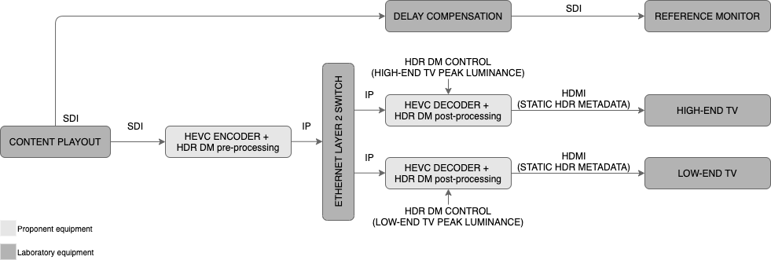
Figure 39: HDR Dynamic Mapping Codec real-time test setup 1
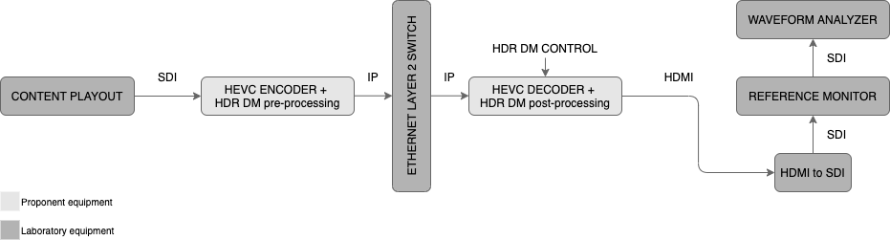
Figure 40: HDR Dynamic Mapping Codec real-time test setup 2
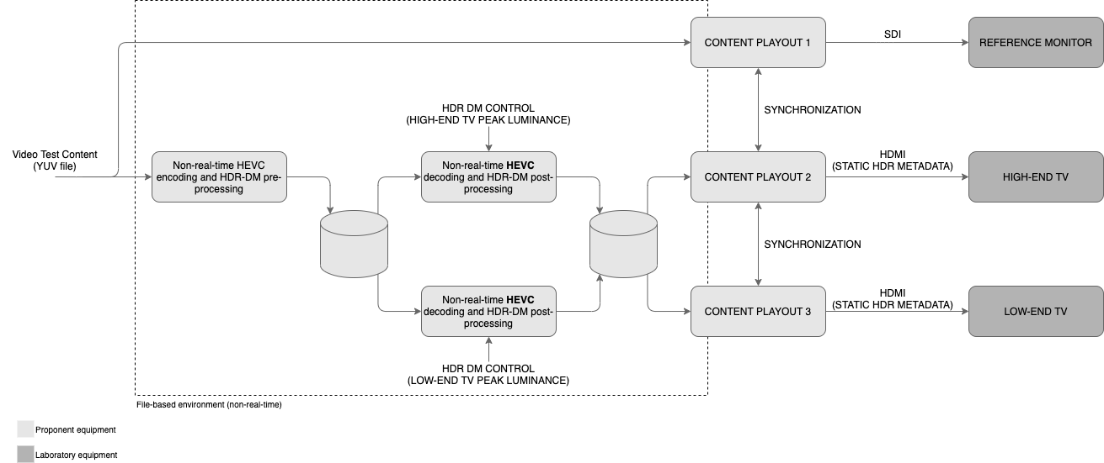
Figure 41: HDR Dynamic Mapping Codec non-real-time test setup 1
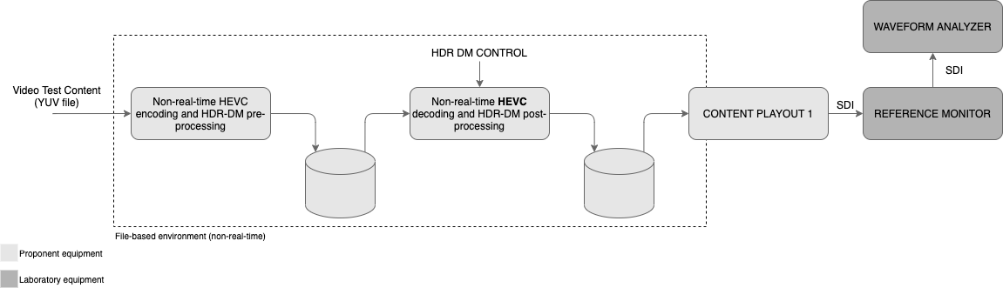
Figure 42: HDR Dynamic Mapping Codec non-real-time test setup 2
Table 20 shows the mapping between video sub-components and Test Case ID.
Table 20: Video sub-components and related Test Cases
Test Number | Video Codec | HDR DM Codec | VR Codec | Display Manager | EWS
Test 1 | TC1.1 and TC1.2 | --- | --- | --- | ---
Test 2 | TC2.1 to TC2.3 | TC2.4 to TC2.6 | --- | --- | ---
Test 3 | TC3.1 | --- | --- | --- | ---
Test 4 | TC1.1 and TC1.2 | --- | --- | --- | ---
Test 5 | TC5.1 and TC5.2 | --- | --- | --- | ---
Test 6 | --- | --- | --- | TC6.1 | ---
Test 7 | --- | --- | --- | --- | TC7.1
Test 8 | --- | --- | TC8.1 | --- | ---
Test 9 | TC9.1 | --- | --- | --- | ---
Test 10 | TC9.1 | --- | --- | --- | ---
Test 11 | TC11.1 and TC11.2 | --- | --- | --- | ---
Evaluation reports from the Test Lab shall present results of sub-components based on the mapping in Table 20.
HEVC reference software (HM version 16.22, available at https://vcgit.hhi.fraunhofer.de/jct-vc/HM) will be used as the anchor codec (baseline for comparison) to calculate the PSNR-based, wPSNR-based, and MS-SSIM-based Bjøntegaard Delta rates (BD-rates) for the proposed Video Codecs.
Proponents shall deliver, where applicable, all objective test results to the SBTVD Forum, i.e., all file-based encoded sequences, md5 checksums for decoded sequences, and metrics results in the form of spreadsheets and rate distortions diagrams. The SBTVD Forum will make available a filename scheme and appropriate file storage space for upload.
For the video codec sub-component, HEVC will be used as the anchor codec and the Test Lab will produce all anchor results for reference.

Test 1 (Video resolution)
Each proponent’s system performance shall be evaluated for the following capabilities:
Test Case ID | TC1.1
Test Type | Objective
Test Description | Requirements VC1.1.1, VC1.1.2, VC1.1.3, VC1.1.4, VC1.1.5, VC1.1.6, VC1.2, VC1.3, VC1.4, and VC4.1:  - Shall demonstrate the system’s ability to encode and decode the source video contents for each specific spatial resolution and target bitrates.  - Each pair of source/processed video content in this test shall be evaluated by video quality metrics. The results shall be registered by Test Lab analysts.  This test shall produce baseline data for comparison between HEVC performance and proposed video codecs. Test Lab shall execute TC1.1 using HEVC codec (i.e., HEVC reference software, HM version 16.22).
Test Setup | Non-real-time setup as shown in Figure 37.
Test Content | Test items common characteristics:  - Progressive scanning;  - Aspect ratio 16:9;  - Sampling YCbCr 4:2:0;  - Bit depth 10 bit per component;  - Colorimetry Wide Color Gamut Recommendation ITU-R BT.2100;  - Dynamic range HLG HDR from HLG HDR test set;  - Temporal resolution 59.94 frames per second.
Test Bitrate | To determine the four target bitrates for each test content item, the item is to be encoded using HM 16.22 with fixed Quantization Parameter (QP) values of 22, 27, 32, and 37. The correspondent maximum bitrates (see bitrate spreadsheet) shall be used in fixed bitrate mode, with a tolerance of ±5%, with HM 16.22 as the anchor. Specified spatial resolutions are:  - 1 280 x 720 pixels  - 1 920 x 1 080 pixels  - 2 560 x 1 440 pixels  - 3 840 x 2 160 pixels  - 5 120 x 2 880 pixels  - 7 680 x 4 320 pixels
Test Procedure | Codec configuration:  - RAP period: 64 frames;  - RAP picture type: CRA;  - Hierarchical GOP size: 16;  - All other parameters to be set shall be informed by the proponent and registered by Test Lab.  For each Test Item conduct the following steps:  - Take the Test Item presented as a YUV file, encode it at the desired QP or bitrate (see the Test Bitrate description) and store the output stream.  - Decode the stored output stream and deliver the result, processed content, as a YUV file.  - Analyze processed content and related Test Item form using video quality metrics. Register video quality metrics scores.  Summarize registered video quality metrics scores in spreadsheets and graphics. Provide Y, U, V PSNR-based, and MS-SSIM-based rate distortions diagrams of codec under test compared to the HEVC anchor codec.

Test Case ID | TC1.2
Test Type | Objective
Test Description | Requirements VC1.1.1, VC1.1.2, VC1.1.3, VC1.1.4, VC1.1.5, VC1.1.6, VC1.2, VC1.3, VC1.4, and VC4.1:  - Shall demonstrate the system’s ability to encode and decode the source video contents for each specific spatial resolution and target bitrates.  - Each pair of source/processed video content in this test shall be evaluated by video quality metrics. The results shall be registered by Test Lab analysts.  This test shall produce baseline data for comparison between HEVC performance and proposed video codecs. Test Lab shall execute TC1.1 using HEVC codec (i.e., HEVC reference software, HM version 16.22).
Test Setup | Non-real-time setup as shown in Figure 37.
Test Content | Test items common characteristics:  - Progressive scanning;  - Aspect ratio 16:9;  - Sampling YCbCr 4:2:0;  - Bit depth 10 bit per component;  - Colorimetry Wide Color Gamut Recommendation ITU-R BT.2100;  - Dynamic range PQ HDR from PQ HDR test set;  - Temporal resolution 59.94 frames per second.
Test Bitrate | To determine the four target bitrates for each test content item, the item is to be encoded using HM 16.22 with fixed Quantization Parameter (QP) values of 22, 27, 32, and 37. The correspondent maximum bitrates (see bitrate spreadsheet) shall be used in fixed bitrate mode, with a tolerance of ±5%, with HM 16.22 as the anchor. Specified spatial resolutions are:  - 1 280 x 720 pixels  - 1 920 x 1 080 pixels  - 2 560 x 1 440 pixels  - 3 840 x 2 160 pixels  - 5 120 x 2 880 pixels  - 7 680 x 4 320 pixels
Test Procedure | Codec configuration:  - RAP period: 64 frames;  - RAP picture type: CRA;  - Hierarchical GOP size: 16;  - All other parameters to be set shall be informed by the proponent and registered by Test Lab.  For each Test Item conduct the following steps:  - Take the Test Item presented as a YUV file, encode it at the desired QP or bitrate (see the Test Bitrate description) and store the output stream.  - Decode the stored output stream and deliver the result, processed content, as a YUV file.  - Analyze processed content and related Test Item form using video quality metrics. Register video quality metrics scores.  Summarize registered video quality metrics scores in spreadsheets and graphics. Provide Y, U, V PSNR-based, wPSNR-based and MS-SSIM-based rate distortion diagrams of codec under test compared to the HEVC anchor codec.

Test 2 (Dynamic range)
Each proponent’s system performance shall be evaluated for the following capabilities:
Test Case ID | TC2.1
Test Type | Feature
Test Description | Requirements VC2.1, VC2.2.3 and VC2.3: SDR content  - Shall demonstrate the system’s ability to display the SDR test set with spatial resolution equal to 1 920 x 1 080 pixels.  - The purpose of this test is to demonstrate the SDR feature on low-end and high-end TVs.  - The evaluator compares the reference picture on the Reference monitor with the low-end and high-end TVs.
Test Setup | Real-time setup as shown in Figure 38.
Test Content | Test items common characteristics:  - Spatial resolution is 1 920 x 1 080 pixels;  - Progressive scanning;  - Aspect ratio 16:9;  - Sampling YCbCr 4:2:0;  - Bit depth 10 bit per component;  - Colorimetry Wide Color Gamut Recommendation ITU-R BT.2020;  - Dynamic range SDR from SDR test set;  - Temporal resolution 59.94 frames per second.  The SDR test set consists of camera-generated content items.
Test Bitrate | To determine the target bitrate, with a tolerance of ±5%, for each test content item, the item is encoded using HM 16.22 with fixed Quantization Parameter (QP) value of 27 (see bitrate spreadsheet).
Test Procedure | Codec configuration:  - RAP period: 64 frames;  - RAP picture type: CRA;  - Hierarchical GOP size: 16;  - All other parameters to be set shall be informed by the proponent and registered by Test Lab.  For each Test Item conduct the following steps:  - The evaluator selects and plays SDR test content items and compares adjacently the image quality on the reference monitor with the quality on the low-end and high-end TVs.  The test is passed if SDR content is displayed without video coding artifacts.

Test Case ID | TC2.2
Test Type | Feature
Test Description | Requirements VC2.1, VC2.2.2, and VC2.3: static HLG HDR content.  - Shall demonstrate the system’s ability to display static HLG HDR test set with spatial resolution equal to 1 920 x 1 080 pixels.  - The purpose of this test is to demonstrate the static HLG HDR feature on low-end and high-end TVs.  - The evaluator compares the reference picture on the reference monitor with the low-end and high-end TV.
Test Setup | Real-time setup as shown in Figure 38.
Test Content | Test items common characteristics:  - Spatial resolution is 1 920 x 1 080 pixels;  - Progressive scanning;  - Aspect ratio 16:9;  - Sampling YCbCr 4:2:0;  - Bit depth 10 bit per component;  - Colorimetry Wide Color Gamut Recommendation ITU-R BT.2100;  - Dynamic range HLG from static HLG HDR test set;  - Temporal resolution 59.94 frames per second.  The static HLG HDR test set consists of camera-generated content items.
Test Bitrate | To determine the target bitrate for each test content item, with a tolerance of ±5%, the item is encoded using HM 16.22 with fixed Quantization Parameter (QP) value of 27 (see bitrate spreadsheet).
Test Procedure | Codec configuration:  - RAP period: 64 frames;  - RAP picture type: CRA;  - Hierarchical GOP size: 16;  - All other parameters to be set shall be informed by the proponent and registered by Test Lab.  For each Test Item conduct the following steps:  - The evaluator selects and plays static HLG HDR test content items and compares adjacently the image quality on the reference monitor with the quality on the low-end and high-end TVs.  The test is passed if static HLG HDR content is displayed without video coding artifacts.

Test Case ID | TC2.3
Test Type | Feature
Test Description | Requirements VC2.1, VC2.2.1, and VC2.3: static PQ HDR content.  - Shall demonstrate the system’s ability to display static PQ HDR test set with spatial resolution equal to 1 920 x 1 080 pixels.  - The purpose of this test is to demonstrate the static PQ HDR feature on low-end and high-end TVs.  - The evaluator compares the reference picture on the reference monitor with the high-end TV.
Test Setup | Real-time setup as shown in Figure 38.
Test Content | Test items common characteristics:  - Spatial resolution is 1 920 x 1 080 pixels;  - Progressive scanning;  - Aspect ratio 16:9;  - Sampling YCbCr 4:2:0;  - Bit depth 10 bit per component;  - Colorimetry Wide Color Gamut Recommendation ITU-R BT.2100;  - Dynamic range PQ from static PQ HDR test set;  - Temporal resolution 59.94 frames per second.  The static PQ HDR test set consists of camera-generated content items.
Test Bitrate | To determine the target bitrate for each test content item, with a tolerance of ±5%, the item is encoded using HM 16.22 with fixed Quantization Parameter (QP) value of 27 (see bitrate spreadsheet).
Test Procedure | Codec configuration:  - RAP period: 64 frames;  - RAP picture type: CRA;  - Hierarchical GOP size: 16;  - All other parameters to be set shall be informed by the proponent and registered by Test Lab.  For each Test Item conduct the following steps:  - The evaluator selects and plays static PQ HDR test content items and compares adjacently the image quality on the reference monitor with the quality on the high-end TV.  Evaluators should look at artifacts such as clipping, burnouts, and loss of details and document the observations as comments per content item and TV type.  The test is passed if static PQ HDR content is displayed without video coding artifacts.

Test Case ID | TC2.4
Test Type | Feature
Test Description | Requirements VC2.1, VC2.2.2, and VC2.3: HDR Dynamic Mapping camera content.  - Shall demonstrate the system’s ability to display HDR with Dynamic Mapping functionality with spatial resolution equal to 1 920 x 1 080 pixels.  - The purpose of this test is to demonstrate the HDR Dynamic Mapping feature on low-end and high-end TVs.  - The evaluator compares the reference picture on the reference monitor with dynamic mapping on low-end and high-end TVs.
Test Setup | Real-time setup as shown in Figure 39 or non-real-time setup as shown in Figure 41.
Test Content | Test items common characteristics:  - Spatial resolution is 1 920 x 1 080 pixels;  - Progressive scanning;  - Aspect ratio 16:9;  - Sampling YCbCr 4:2:0;  - Bit depth 10 bit per component;  - Colorimetry Wide Color Gamut Recommendation ITU-R BT.2100;  - Dynamic range PQ from HDR DM camera test set;  - The temporal resolution depends on the test content item.  Test TC2.4 uses the camera-generated content items of the HDR Dynamic Mapping test set.
Test Bitrate | The target bitrate for each test content item is HEVC with the Quantization Parameter (QP) value of 27 with a tolerance of ±5%. The encoding shall be done with HM 16.22, HEVC Main 10 profile, and fixed bitrate mode.
Test Procedure | All other parameters to be set shall be informed by the proponent and registered by Test Lab.  For each Test Item conduct the following steps:  - The HDR Dynamic Mapping shall be configured manually (e.g., monitor peak luminance) to make it compatible with the respective TV.  - The evaluator selects and plays HDR Dynamic Mapping test content items and compares adjacently the image quality on the reference monitor with the quality on the low-end and high-end TVs.  - The evaluator should also be able to switch off and on the dynamic mapping functionality to see the difference.  Evaluators should look at dynamic mapping artifacts such as clipping, burnouts, and loss of details and document the observations as comments per content item and TV type. The test is passed if HDR Dynamic Mapping switched on preserves details in the highlights compared to HDR Dynamic Mapping switched off.

Test Case ID | TC2.5
Test Type | Objective
Test Description | Requirements VC2.1, VC2.2.2, and VC2.3: HDR Dynamic Mapping luminance test pattern content.  - Shall verify the behavior of the HDR Dynamic Mapping solution by using the luminance HDR test pattern.  - Test bitstreams are generated with the HDR Dynamic Mapping solution and encoded with HEVC at a high bitrate to avoid video coding artifacts. The evaluator selects 10 peak luminances and produces bitstreams from 100 up to 4 000 cd/m². Example values are 4 000, 2 000, 1 000, 800, 700, 600, 500, 400, 300, 100 cd/m². To avoid fine-tuning by the proponent, the tested peak luminances should not be known in advance.  - Measurements of the signal displayed on the reference monitor are collected using a waveform analyzer.
Test Setup | Real-time setup as shown in Figure 40 or non-real-time setup as shown in Figure 42.
Test Content | Test items common characteristics:  - Spatial resolution is 1 920 x 1 080 pixels;  - Progressive scanning;  - Aspect ratio 16:9;  - Sampling YCbCr 4:2:0;  - Bit depth 10 bit per component;  - Colorimetry Wide Color Gamut Recommendation ITU-R BT.2100;  - Dynamic range PQ from HDR DM luminance test pattern;  - Temporal resolution 59.94 frames per second.  Test TC2.5 uses the HDR luminance test patterns.
Test Bitrate | The target bitrate for each test content item is HEVC with the Quantization Parameter (QP) value of 27 with a tolerance of ±5%. The encoding shall be done with HM 16.22, HEVC Main 10 profile, and fixed bitrate mode.
Test Procedure | All other parameters to be set shall be informed by the proponent and registered by Test Lab.  For each Test Item conduct the following step:  - The HDR Dynamic Mapping shall be configured manually to the selected peak luminance.  - The evaluator plays the sequence, probes with the analyzer the level corresponding to the highest peak luminance in the sequence, and records the result per sequence.  The evaluator produces one luminance record for each test pattern for each HDR-DM solution. The records allow him to judge how exact luminances are mapped.

Test Case ID | TC2.6
Test Type | Objective
Test Description | Requirements VC2.1, VC2.2.2, and VC2.3: HDR Dynamic Mapping chrominance test pattern content.  - Shall verify the behavior of the HDR DM solution by using the chrominance HDR test pattern(s).  - Test bitstreams are generated with the HDR DM solution and encoded with HEVC at a high bitrate to avoid video coding artifacts. The evaluator selects 10 peak luminances and produces bitstreams from 100 up to 4 000 cd/m². Example values are 4 000, 2 000, 1 000, 800, 700, 600, 500, 400, 300, 100 cd/m². To avoid fine-tuning by the proponent, the tested peak luminances should not be known in advance.  - Measurements of the signal displayed on the reference monitor are collected using a waveform analyzer.
Test Setup | Real-time setup as shown in Figure 40 or non-real-time setup as shown in Figure 42.
Test Content | Test items common characteristics:  - Spatial resolution is 1 920 x 1 080 pixels;  - Progressive scanning;  - Aspect ratio 16:9;  - Sampling YCbCr 4:2:0;  - Bit depth 10 bit per component;  - Colorimetry Wide Color Gamut Recommendation ITU-R BT.2100;  - Dynamic range PQ from HDR DM chrominance test pattern;  - Temporal resolution 59.94 frames per second.
Test Bitrate | The target bitrate for each test content item is HEVC with the Quantization Parameter (QP) value of 27 with a tolerance of ±5%. The encoding shall be done with HM 16.22, HEVC Main 10 profile, and fixed bitrate mode.
Test Procedure | All other parameters to be set shall be informed by the proponent and registered by Test Lab.  For each Test Item conduct the following step:  - The HDR-DM shall be configured manually to the selected peak luminance.  - The evaluator plays the sequence, analyzes the chroma components with the waveform analyzer (vectorscope, CIE color chart, etc.), and records the result per test sequence.  The evaluator produces one chrominance record for each test pattern for each HDR-DM solution. The records allow him to judge how the display mapping solutions preserve the relative proportions of the color components for different display mapping settings.

Test 3 (Temporal resolution)
Each proponent’s system performance shall be evaluated for the following capabilities:
Test Case ID | TC3.1
Test Type | Objective
Test Description | Requirements VC3.1.1, VC3.1.2, VC3.1.3, VC3.1.4, VC3.1.5, VC3.1.6, VC3.1.7 and VC3.1.8:  - Shall demonstrate the system’s ability to encode and decode the source video contents for each specific temporal resolution.  - Each pair of source/processed video content in this test shall be evaluated by video quality metrics. The results shall be registered by Test Lab analysts.
Test Setup | Non-real-time setup as shown in Figure 37.
Test Content | Test items common characteristics:  - Spatial resolution is 1 920 x 1 080 pixels;  - Progressive scanning;  - Aspect ratio 16:9;  - Sampling YCbCr 4:2:0;  - Bit depth 10 bit per component;  - Colorimetry Wide Color Gamut Recommendation ITU-R BT.2020;  - Dynamic range SDR from the SDR test set;
Test Bitrate | To determine the four target bitrates for each test content item, the item is to be encoded using HM 16.22 with fixed Quantization Parameter (QP) values of 22, 27, 32, and 37. The correspondent maximum bitrates shall be used in fixed bitrate mode, with a tolerance of ±5%, with HM 16.22 as the anchor (see bitrate spreadsheet). Specified frame rates are:  - 120 fps: RAP period: 128 frames;  - (120/1.001) fps: RAP period: 128 frames;  - 60 fps: RAP period: 64 frames;  - (60/1.001) fps: RAP period: 64 frames;  - 30 fps: RAP period: 32 frames;  - (30/1.001) fps: RAP period: 32 frames;  - 24 fps: RAP period: 32 frames;  - (24/1.001) fps: RAP period: 32 frames.
Test Procedure | Codec configuration:  - RAP picture type: CRA;  - Hierarchical GOP size: 16;  - All other parameters to be set shall be informed by the proponent and registered by Test Lab.  For each Test Item conduct the following steps:  - Take the Test Item presented as a YUV file, encode it at the desired bitrate and store the output stream.  - Decode the stored output stream and deliver the result, processed content, as a YUV file.  - Analyze processed content and related Test Item form using video quality metrics. Register video quality metrics scores.  Summarize registered video quality metrics scores in Tables and graphics. Provide Y, U, V PSNR-based, and MS-SSIM-based rate distortion diagrams of codec under test compared to the HEVC anchor codec.
Specifications VC3.1.9 to VC3.1.11 are not required, therefore will not be verified.

Test 4 (Video coding quality)
Requirement VC4.1: This requirement is verified during the execution of Test Cases TC1.1 and TC1.2.

Test 5 (Video end to end latency)
Each proponent’s system performance shall be evaluated for the following capabilities:
Test Case ID | TC5.1
Test Type | Feature
Test Description | Requirements VC5.1 and VC5.2: Latency  - Shall demonstrate the system’s ability for real-time encoding and decoding in a live broadcast environment. Video contents shall have a burn-in timecode counter in the active video area displaying values for hours, minutes, seconds, and frames.
Test Setup | Real-time setup as shown in Figure 38. For this setup, the Delay compensation element between content playout and reference monitor shall be removed.
Test Content | Test items common characteristics:  - Progressive scanning;  - Aspect ratio 16:9;  - Sampling YCbCr 4:2:0;  - Bit depth 10 bit per component;  - Colorimetry Wide Color Gamut Recommendation ITU-R BT.2100;  - Dynamic range HLG HDR from HLG HDR test set;  - Temporal resolution 59.94 frames per second;  - Spatial resolution 1 920 x 1 080 pixels;  Test Contents to be used in this test shall be provided by proponents or SBTVD Forum members with a burn-in timecode counter in the active video area.
Test Bitrate | To determine the target bitrate for each test content item, with a tolerance of ±5%, the item is to be encoded using HM 16.22 with fixed Quantization Parameter (QP) value of 27 (see bitrate spreadsheet).
Test Procedure | Codec configuration:  - RAP period: 64 frames;  - RAP picture type: CRA;  - Hierarchical GOP size: 16;  - All other parameters to be set shall be informed by the proponent and registered by Test Lab.  For each Test Item conduct the following steps:  - Take the Test Item presented as a YUV file or consecutive numbered TIFF files and format it to the supported format by content playout.  - Play the Test Item from the content playout system through the real-time test setup.  - Connect one playout SDI output interface to permanently feed the reference monitor.  - Connect one playout HDMI output interface to feed the high-end TV.  - Take a photo framing reference monitor and high-end TV.  - Verify if both timecode counters are readable in the photo and register the values. If not, take another photo.  - Connect a second playout SDI output interface to feed the encoder/decoder chain.  - Replace playout HDMI output from high-end TV HDMI input by connecting video decoder HDMI output to the same high-end TV HDMI input.  - Take a photo framing reference monitor and high-end TV.  - Verify if both timecode counters are readable in the photo and register the values. If not, take another photo.  The measured end to end latency will be the timecode from the high-end TV subtracted from the reference monitor and, if necessary, compensated by any offset registered in step 6. The configuration parameters from the encoder / decoder must be registered.

Test 6 (Sign language)
Each proponent’s system performance shall be evaluated for the following capabilities:
Test Case ID | TC6.1
Test Type | Feature
Test Description | Requirements VC6.1.1 to VC6.12:  - Shall perform a video application containing the proposed codec and shall conform with the specified requirements.
Test Setup | Proponents can provide their own setup.
Test Content | Proponents can provide their own test content.
Test Bitrate | The bitrate for this test shall be chosen by the proponent's system.
Test Procedure | Perform a playback of a video application enabling a second video stream with a sign language interpreter to be activated by the user (to be rendered at the side of the main video, that should be proportionally downscaled to fit the horizontal space left, with no overlap; an optional background still image can be defined by the broadcaster). Application technologies to be used in this test shall be chosen by the proponents. However, proponents shall demonstrate how the application works in detail and how the TV 3.0 application coding layer could manipulate the video codec stream to perform the same results.  Incorrect display of the available audio/video content, erroneous audio / video playback of the content leads to failure of the test.

Test 7 (Video emergency warning information)
Each proponent’s system performance shall be evaluated for the following capabilities:
Test Case ID | TC7.1
Test Type | Feature
Test Description | Requirements VC7.1:  - Shall perform a video application demonstrating emergency warning information sign language video.
Test Setup | Proponents can provide their own setup.
Test Content | Proponents can provide their own test content.
Test Bitrate | The bitrate for this test shall be chosen by the proponent's system.
Test Procedure | Perform a playback of a video application demonstrating how the video system can enable emergency warning information delivery using sign language video, particularly showing what metadata is carried in the video bitstream and how the TV 3.0 application coding layer could access or process this metadata to perform the same results.  Incorrect display of the available audio/video content, erroneous audio / video playback of the content leads to failure of the test.

Test 8 (New immersive video services)
Each proponent’s system performance shall be evaluated for the following capabilities:
Test Case ID | TC8.1
Test Type | Feature and Objective
Test Description | Requirements VC8.1:  - Shall perform playback of content demonstrating one or more of those applications: VR / AR / XR / 3DoF / 6DoF. If necessary, the audio codec to be used in this test shall be chosen by the proponent.
Test Setup | Proponents can provide their own setup.
Test Content | Proponents can provide their own test content.
Test Bitrate | The bitrate for this test shall be chosen by the proponent's system.
Test Procedure | Provide a comprehensive demonstration of the proposed format, allowing the evaluation of:  - features of the codec;  - the quality of the codec;  - the real-time decoding capability;  - the readiness of delivery of the format over broadcast and broadband networks;  - how the applications work in details;  - how the TV 3.0 application coding layer could manipulate the content stream to perform the same results exhibited in the demonstration.  Non-compliance with one or more of the above steps leads to failure of the test.

Test 9 (Seamless decoding and A/V alignment)
Each proponent’s system performance shall be evaluated for the following capabilities:
Test Case ID | TC9.1
Test Type | Feature
Test Description | Requirements: VC9.1, VC10.1:  - Shall perform a video application demonstrating the desired capabilities. The audio codec and transport technology to be used in this test shall be chosen by the proponents.
Test Setup | Real-time setup as shown in Figure 38. The Streaming Server shall be connected to an Ethernet Layer 2 switch. The content to be provided by the Streaming Server can be encoded using the non-real-time setup as shown in Figure 37 Alternatively, the proponent can provide a special setup for this test.
Test Content | Proponents can provide their own test content.
Test Bitrate | The bitrate for this test shall be chosen by the proponent's system.
Test Procedure | Codec configuration:  - RAP period: 64 frames;  - RAP picture type: CRA;  - Hierarchical GOP size: 16;  - All other parameters to be set shall be informed by the proponent and registered by Test Lab.  Perform a playback of a video application demonstrating how the video system can switch (back and forth) between the live encoding and the Streaming Server content, seamlessly, and keeping the alignment between audio and video. Include an explanation of how the application works in detail and how the TV 3.0 application coding layer could manipulate the video system to achieve the same results.  Reproduction discontinuities and A/V sync (lip-sync) issues when switching (back and forth) between the live encoding and the Streaming Server content leads to failure of the test.

Test 10 (Interoperability with different distribution platforms)
Requirement VC10.1: This requirement is verified during the execution of Test Case TC9.1.

Test 11 (Video scalability and extensibility)
Each proponent’s system performance shall be evaluated for the following capabilities:
Test Case ID | TC11.1
Test Type | Feature
Test Description | Requirement VC11.1.1: Spatial scalability  - Shall demonstrate the system’s spatial scalability capabilities by enhancing the video experience, increasing the video content spatial resolution.
Test Setup | Proponents can provide their own setup.
Test Content | Test item common characteristic:  - Progressive scanning;  - Aspect ratio 16:9;  - Sampling YCbCr 4:2:0;  - Bit depth 10 bit per component;  - Colorimetry Wide Color Gamut Recommendation ITU-R BT.2100;  - Dynamic range HLG HDR from HLG HDR test set;  - Temporal resolution 59.94 frames per second.
Test Bitrate | To determine the target bitrate for each test content item, with a tolerance of ±5%, the item is to be encoded using HM 16.22 with fixed Quantization Parameter (QP) value of 27 (see bitrate spreadsheet).
Test Procedure | Codec configuration:  - RAP period: 64 frames;  - RAP picture type: CRA;  - Hierarchical GOP size: 16;  - All other parameters to be set shall be informed by the proponent and registered by Test Lab.  For available Test Item conduct the following steps:  - Perform non-real-time scalable coding of a 2160p video content, with a 1080p base layer.  - Perform non-real-time decoding of the scalable bitstream, switching on and off the enhancement layer every two seconds. The output YUV file should keep a constant 2160p resolution. When decoding only the base layer (1080p) every pixel should be duplicated vertically and horizontally (no interpolation or smoothing)  - Encode the processed YUV file with HEVC reference software (HM 16.22) with fixed Quantization Parameter (QP) value of 22.  - Evaluate, by monitoring the resulting HEVC decoding on the reference monitor, the capability of the system to continuously and seamlessly playback the content during all switching, back and forth, between the base layer and the enhancement layer.  Incorrect display of the available content or lack of continuous and seamless playback during all switching leads to failure of the test.

Test Case ID | TC11.2
Test Type | Feature
Test Description | Requirement VC11.1.2: Temporal scalability  - Shall demonstrate the system’s temporal scalability capabilities by enhancing the video experience, increasing the video content temporal resolution.
Test Setup | Proponents can provide their own setup.
Test Content | Test item common characteristic:  - Progressive scanning;  - Aspect ratio 16:9;  - Sampling YCbCr 4:2:0;  - Bit depth 10 bit per component;  - Colorimetry Wide Color Gamut Recommendation ITU-R BT.2100;  - Dynamic range HLG HDR from HLG HDR test set;  - Spatial resolution 1 920 x 1 080 pixels.
Test Bitrate | To determine the target bitrate for each test content item, with a tolerance of ±5%, the item is to be encoded using HM 16.22 with fixed Quantization Parameter (QP) value of 27 (see bitrate spreadsheet).
Test Procedure | Codec configuration:  - RAP period: 64 frames (for 59.94 fps) or 32 frames (for 29.97 fps);  - RAP picture type: CRA;  - Hierarchical GOP size: 16;  - All other parameters to be set shall be informed by the proponent and registered by Test Lab.  For available Test Item conduct the following steps:  - Perform non-real-time scalable coding of a 59.94 fps video content, with a 29.97 fps base layer.  - Perform non-real-time decoding of the scalable bitstream, switching on and off the enhancement layer every two seconds. The output YUV file should keep a constant 59.94 fps temporal resolution. When decoding only the base layer (29.97 fps) every frame should be duplicated (no interpolation or smoothing).  - Encode the processed YUV file with HEVC reference software (HM 16.22) with fixed Quantization Parameter (QP) value of 22.  - Evaluate, by monitoring the resulting HEVC decoding on the reference monitor, the capability of the system to continuously and seamlessly playback the content during all switching, back and forth, between the base layer and the enhancement layer.  Incorrect display of the available content or lack of continuous and seamless playback during all switching leads to failure of the test.

Test Case ID | TC11.3
Test Type | Feature
Test Description | Requirement VC11.1.3: Quality scalability  - Shall demonstrate the system’s quality scalability capabilities by enhancing the video experience, increasing the video content quality bitrate.
Test Setup | Proponents can provide their own setup.
Test Content | Test item common characteristic:  - Progressive scanning;  - Aspect ratio 16:9;  - Sampling YCbCr 4:2:0;  - Bit depth 10 bit per component;  - Colorimetry Wide Color Gamut Recommendation ITU-R BT.2100;  - Dynamic range HLG HDR from HLG HDR test set;  - Spatial resolution 1 920 x 1 080 pixels.  - Temporal resolution 59.94 frames per second.
Test Bitrate | See Test Procedure.
Test Procedure | Codec configuration:  - RAP period: 64 frames;  - RAP picture type: CRA;  - Hierarchical GOP size: 16;  - All other parameters to be set shall be informed by the proponent and registered by Test Lab.  For available Test Item conduct the following steps:  - Perform non-real-time scalable coding of a QP=37 base layer, enhancement layer QP=27 (both QP values of candidate codec).  - Perform non-real-time decoding of the scalable bitstream, switching on and off the enhancement layer every two seconds.  - Encode the processed YUV file with HEVC reference software (HM 16.22) with fixed Quantization Parameter (QP) value of 22.  - Evaluate, by monitoring the resulting HEVC decoding on the reference monitor, the capability of the system to continuously and seamlessly playback the content during all switching, back and forth, between the base layer and the enhancement layer.  Incorrect display of the available content or lack of continuous and seamless playback during all switching leads to failure of the test.
Requirement VC11.2: This requirement will not be analyzed with a feature test. The proponent’s documentation provided in the Document Analysis phase shall address this requirement.

Audio Coding
The audio coding requirements set in the TV 3.0 Call for Proposals document, against which the proposals of candidate technologies will be tested and evaluated, are repeated here for the convenience of the reader. For further details, please refer to the TV 3.0 Call for Proposals document.
use case |  | minimum technical specification |  |  | over-the-air delivery | Internet delivery
AC1 | Enable immersive (3D) audio. | AC1.1.1 | channel-based | 2.0 | required | required
AC1 | Enable immersive (3D) audio. | AC1.1.2 | channel-based | 5.1 | required | required
AC1 | Enable immersive (3D) audio. | AC1.1.3 | channel-based | 5.1 + 4H | required | required
AC1 | Enable immersive (3D) audio. | AC1.2 | object-based |  | required | required
AC1 | Enable immersive (3D) audio. | AC1.3 | scene-based (HOA) |  | desirable | desirable
AC2 | Enable end-user interactivity/personalization when allowed by the broadcaster (e.g. switch among different languages, sports commentators, adjust the commentator loudness level and position). | AC2.1 | switch components (audio objects and alternative full mix substreams) |  | required | required
AC2 |  | AC2.2 | adjust object loudness |  | required | required
AC2 |  | AC2.3 | adjust object position |  | required | required
AC2 |  | AC2.4 | enable interactivity when using external sound reproduction devices |  | required | required
AC3 | Enable audio description delivery in the same stream as the main audio, as an alternative full mix or as an additional audio object with associated metadata. | AC3.1 | audio description delivery in the same stream as the main audio |  | required | required
AC3 |  | AC3.2 | audio description delivery as an alternative full mix |  | required | required
AC3 |  | AC3.3 | audio description delivery as an additional audio object  with associated metadata |  | required | required
AC4 | Enable emergency warning information delivery using audio description. | AC4.1 | emergency warning information audio description |  | desirable | desirable
AC5 | Enable a single delivery format for multiple audio playback configurations (TV loudspeakers, soundbars, home theaters, binaural). | AC5.1 | flexible loudspeaker configuration render |  | required | required
AC5 |  | AC5.2 | binaural render |  | required | required
AC6 | Enable consistent loudness across programs and inside the same program. | AC6.1 | consistent loudness across programs |  | required | required
AC6 |  | AC6.2 | consistent loudness after user interaction |  | required | required
AC7 | Enable seamless configuration changes and A/V alignment. | AC7.1 | seamless playback during configuration changes  (e.g. from 5.1+4H to stereo) |  | required | required
AC7 | Enable seamless configuration changes and A/V alignment. | AC7.2 | seamless playback during user interaction  (e.g. enable/disable several audio elements) |  | required | required
AC7 | Enable seamless configuration changes and A/V alignment. | AC7.3 | seamless playback during changes in production  (e.g. broadcaster removes one object) |  | required | required
AC7 | Enable seamless configuration changes and A/V alignment. | AC7.4 | seamless and sample-accurate stream splicing or ad-insertion at any time instance, even if some of the streams come from different distribution platforms (e.g. switch between over-the-air and Internet delivery) |  | required | required
AC8 | Provide state-of-the-art coding efficiency, to allow better quality audio in limited capacity channels (over-the-air or Internet). | AC8.1 | bit rate | kbps @ MOS 4 / MUSHRA > 80 or equivalent objective metric | lower is better | lower is better
AC9 | Provide live audio with minimum end-to-end latency. | AC9.1 | real-time encoding |  | required | required
AC9 | Provide live audio with minimum end-to-end latency. | AC9.2 | latency | ms | lower is better | lower is better
AC10 | Provide audio/video synchronization. | AC10.1 | A/V sync | frame-accurate | required | required
AC11 | Enable new immersive audio services. | AC11.1 | VR / AR / XR / 3DoF / 6DoF support |  | desirable | desirable
AC12 | Enable interoperability with different distribution platforms (e.g. DTT, cable, IPTV, DTH satellite, fixed broadband, 4G/5G mobile broadband, home network). | AC12.1 | interoperability with different distribution platforms |  | required | required
AC13 | Enable scalability (e.g. to enhance the over-the-air audio experience with additional Internet-delivered audio content, such as new sports commentator options) and extensibility (support new settings and/or features in the future, in a backward-compatible way). | AC13.1 | scalability |  | required | required
AC13 |  | AC13.2 | extensibility |  | required | required
AC-AR1. Provide free of charge test content (BW64 file with ADM metadata) with the required technical specification, strictly for technical evaluation of the SBTVD Forum (non-commercial usage). The content shall not make any reference to commercial brands.
AC-AR2. Provide free of charge reference encoder and decoder (software or hardware) with its corresponding documentation, strictly for temporary technical evaluation of the SBTVD Forum (non-commercial usage).
AC-AR3. Provide information about available implementations of the encoder and decoder, the latter both for professional (broadcast) and consumer electronic applications.
AC-AR4. Provide information about available implementations of production tools: authoring and monitoring for live and post-production.
AC-AR5. Provide some reference information about the decoder for TV sets manufacturing.
Audio system proponents are also encouraged to submit an Application Coding proposal on an API to fulfill the minimum technical specification AP14.4 (3D object-based immersive audio interaction) with their proposed candidate technology. Please refer to 4.7 for further information on Application Coding.
The assessment methodology for audio systems is divided into three main evaluation steps: Documentation Analysis, Quality Assessment Reports, and Features Evaluation.
In the subsequent subsections, the following definitions are adopted:
- real-time: this phrase indicates that encoding and/or decoding is executed concurrently as audio/video content is being delivered to a system under test by a playout system and, after the decoding process, is displayed in an audio or video monitor.
- non-real-time: this phrase, or the phrase “file-based”, indicates that encoding and/or decoding is executed after audio/video content is received (normally as a file). Non-real-time encoding and/or decoding shall be done only with single-pass encoding and/or decoding.
- source content: this phrase indicates uncompressed audio or video content that is used to feed the system under test.
- processed content: this phrase indicates uncompressed audio or video content after being processed by the system under test.

Documentation analysis
Each received proposal for the audio system shall be analyzed in detail to map what the proponent's system can achieve in conformance with the TV 3.0 Call for Proposals requirements.
Proponents shall provide detailed documentation on how their system works and how it conforms with the specified requirements for the audio system. Proponents are encouraged to submit additional information about features from the proposed audio system that may enrich the overall audio quality of experience and are not a current requirement in the TV 3.0 Call for Proposals document.
At the end of the documentation analysis, the Test Lab shall produce a report consolidating all the analyzed requirements for the audio system classified as “Fulfilled”, “Partially Fulfilled” and “Not Fulfilled”. Test Lab analysts shall include in that report a detailed explanation of all requirements classified as “Fulfilled”, “Partially Fulfilled” and “Not Fulfilled”.

Subjective quality assessment reports
The SBTVD Forum does not intend to perform any subjective audio quality assessment. Each proponent shall send its own subjective quality assessment reports as described in this section.
Each proposal for audio systems shall provide qualitative and quantitative reports assessing the codec’s performance results. Those reports shall include data from audio subjective test procedures in compliance with directives from the Recommendations ITU-R BS.1116 or ITU-R BS.1534, submitted to or produced by international standardization organizations for the evaluation of the proponent's audio system. Reports from independent test labs or proponent test labs can be submitted. In the latter case, SBTVD Forum members can request the description of the statistical tools used for the analysis and the content files used in the subjective test (both source and processed content) to allow cross-checking the results. The proponent shall grant, in a timely manner, a free of charge content license for its own content and provide information on how third-party content could be licensed (if applicable).

Features evaluation
Each proponent shall provide the required equipment and test content to allow the Test Lab to verify the compliance of the proponent's system regarding the requirements set in the TV 3.0 Call for Proposals document and its performance, through the test procedures described in this section.
At the end of this step, the appointed Test Lab shall produce a report consolidating all the results obtained from the analyzed requirements for the audio system classified as “Fulfilled”, “Partially Fulfilled” and “Not Fulfilled”. Test Lab analysts shall include in that report a detailed explanation of all requirements classified as “Fulfilled”, “Partially Fulfilled” and “Not Fulfilled”.
For the evaluation of proposed audio systems, a common set of test content shall be used by the Test Lab. The test content items shall be provided free of charge by the proponents as a raw material using BW64/RF64 file with ADM metadata. SBTVD Forum members are also encouraged to provide additional free of charge audio test content in the same format. The audio content shall be provided together with the corresponding uncompressed video file. Content licenses shall be free of charge but may describe usage conditions. The Test Lab and the SBTVD Forum will select the appropriate content from the submitted pool of content. Proponents shall be allowed to have selected at least one of their own test content items.
Audio test contents shall not make any reference to commercial brands and should contain a diverse set of ordinary broadcast program characteristics. It should contain pure speech, speech together with music or background noise, high dynamic orchestra music, and piano solo. The minimum length of the sequences shall be 15 seconds and the maximum length should not exceed 10 minutes. This test shall use twelve audio test contents, as described in Table 21.
Table 21: Audio test contents characteristics
Audio content | Content characteristics
1 | Stereo mix (Language 1)
2 | Stereo mix (Language 1) + Stereo mix (Language 2) + Stereo Audio Description (Language 1)
3 | Channel Bed 2.0 + 2 languages (Language 1, Language 2) + 1 Audio Description (Language 1) + 1 Object (Emergency Warning Information)
4 | Channel Bed 5.1
5 | Channel Bed 5.1 + 2 languages (Language 1, Language 2)
6 | Channel Bed 5.1+4H
7 | Channel Bed 5.1+4H + 2 languages (Language 1, Language 2)
8 | Channel Bed 5.1+4H + 2 languages (Lang. 1, Lang. 2) + 1 Audio Description (Lang. 1) + 1 Object (Stadium Announcer)
9 | Channel Bed 5.1+4H + 1 Object (Mono Commentator 1) + 1 Object (Mono Commentator 2)
10 | Channel Bed 5.1+4H + 2 languages (Language 1, Language 2) + 1 Dynamic Object
11 | Channel Bed 5.1+4H + 2 Mono languages (Language 1, Language 2) + Stereo mix (Language 1) + Mono mix (Language 2)
12 | Higher-Order Ambisonics
Note: For Audio content 3: The Emergency Warning Information audio object shall be active only in cases when the support for emergency warning information is tested. For all other test cases, the Emergency Warning Information audio object shall be removed.
All proposed audio systems shall be evaluated by a common set of audio test content and shall use the same Test Lab room environment. This room shall have adequate audio listening and shall reproduce ordinary living room characteristics as much as possible (e.g., recommended dimensions for the room are width: 4 m to 6 m, height: 2.5 m to 3.5 m, length: 3.5 m to 5 m; and it should allow placement of the TV set and soundbar in the room 50 to 100 cm above the floor and 2 to 3 m away from the listening position).
For the audio feature evaluation, one of the two audio test setups (illustrated in Figure 43 and Figure 44 with their respective mandatory elements) shall be used, according to the test. Instructions about setup selection are provided in each audio test description. Additional monitoring elements may be added to those setups by the Test Lab or by the SBTVD Forum. Nevertheless, those additional elements shall be informed to all proponents before the test execution.
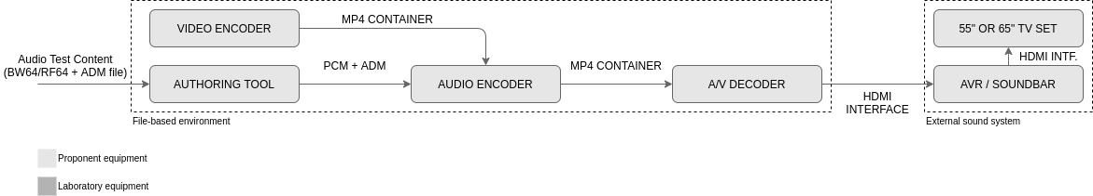
Figure 43: Audio test setup for non-real-time encoding / decoding
For evaluations using the non-real-time encoding / decoding setup, all elements (hardware and software) are the proponent’s responsibility. The transport layer between the audio encoder and the A/V decoder shall use an MP4 container format. All MP4 files will be stored. A/V decoder shall use an HDMI interface to feed the external sound system and demonstrate the audio system capabilities. The video content, if necessary, shall be provided by the proponent and shall be encoded using HEVC video codec (H.265), spatial resolution 1 920 x 1 080 pixels, 59.94 frames per second, progressive scanning, 10-bit per component, SDR Rec. ITU-R BT.2020 and aspect ratio 16:9.
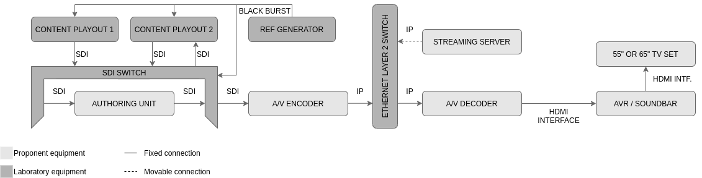
Figure 44: Audio test setup for real-time encoding / decoding
For evaluations using real-time encoding / decoding, the authoring tool shall use the SDI interface for its input and output. The A/V encoder shall accept SDI interface input and, for the output interface, it shall use IP version 4 protocol over Ethernet (IEEE 802.3). The IP-based transport layer protocol shall be chosen by the proponent. The A/V decoder input interface shall accept IP version 4 over Ethernet (IEEE 802.3) and its A/V output interface shall use HDMI. Both content playouts in this setup shall be capable of playing uncompressed A/V content over the SDI interface. Any content authored by the Authoring Unit should be recorded by Content Playout 2 for later use in other audio tests. Content Playouts 1, 2, and SDI Switch shall be referenced to the genlock signal provided by the reference generator, to always obtain a clean switch operation with SDI Switch equipment. In the normal operation of this setup, the Streaming Server shall remain disconnected from Ethernet Layer 2 Switch. When necessary, particular Test Cases provide instructions about the Streaming Server connection.

Test 1 (Immersive audio)
Each proponent’s system performance shall be evaluated for the following capabilities:
Test Case ID | TC1.1
Test Description | Requirement AC1.1.1, AC1.1.2, AC1.1.3, and AC1.2:  - Shall demonstrate the system’s ability to present audio in the specified channel mode and in accordance with the target bitrate for this Test Case.  - Shall demonstrate the system’s ability to present audio in the specified channel mode and audio objects rendered together to various output setups (e.g., 2.0, 5.1, and 5.1+4H channels). The demonstration shall use the target bitrates for this Test Case.
Test Setup | Real-time setup as shown in Figure 44.
Test Content | Test items:  - Audio content 3;  - Audio content 5;  - Audio content 7;  - Audio content 9.
Test Bitrate | Specified bitrates are:  - Mono or Stereo (2.0) = 48 kbps;  - Surround 5.1 = 144 kbps;  - Immersive 5.1+4H = 256 kbps;  - Audio object = 48 kbps per object.  The total bitrate to be used for each Test Item is computed by summing the specified bitrate for each component of the Test Item with a tolerance of ±2%.
Test Procedure | For each Test Item conduct the following steps:  - Play the Test Item form the content playout system through the real-time test setup.  - In the authoring system, author the metadata.  - Playback the live test stream received over IP continuously and keep the volume of playback to a suitable level.  - Evaluate the overall 3D experience when played back over the connected external sound device (AVR/Soundbar). Sound sources panned in production above the listener should be perceived during reproduction over the external sound system also above the listener.  - Evaluate the overall spatial reproduction when the content is played back over a 5.1 setup and a stereo setup, up to the capabilities of the reproduction system.  Perceiving spatial sound events at wrong positions leads to failure of the test.

Test Case ID | TC1.2
Test Description | Requirement AC1.3:  - Shall demonstrate the system’s ability to present scene-based (HOA, Higher-Order Ambisonics) content in accordance with the target bitrate for this Test Case.
Test Setup | Non-real-time setup as shown in Figure 43.
Test Content | Test item:  - Audio content 12.
Test Bitrate | HOA content is characterized by a certain order, N. Shall be used the order N equal to 3, which gives the number of corresponding “HOA-channels” equal to 16 (as, per definition, ch=(N+1)²). Shall be used 20 kbps per “HOA-channel”, therefore the HOA bitrate shall be equal to 320 kbps.
Test Procedure | For each Test Item conduct the following steps:  - Encode the HOA content with the video content to an MP4 file.  - Playback the MP4 file on the proponent video player and keep the volume of playback to a suitable level.  - Evaluate the overall 3D experience when played back over the connected external sound device (AVR/Soundbar). Sound events located left/right to or above the listener should be perceived during reproduction over the external sound system also left/right to or above the listener.  - Evaluate the overall spatial reproduction when the content is played back over a 5.1 setup and a stereo setup, up to the capabilities of the reproduction system.  Perceiving spatial sound events at wrong positions leads to failure of the test.

Test 2 (Interactivity and personalization)
Each proponent’s performance shall be evaluated for the following capabilities:
Test Case ID | TC2.1
Test Description | Requirement AC2.1: Language Selection.  - Shall demonstrate the system’s ability to allow end-users to select between multiple audio languages based on user interaction or automatic language selection (e.g., the receiver’s preferred audio settings).
Test Setup | Real-time setup as shown in Figure 44.
Test Content | Test items:  - Audio content 3;  - Audio content 5;  - Audio content 8.
Test Bitrate | Specified bitrates are:  - Mono or Stereo (2.0) = 48 kbps;  - Surround 5.1 = 144 kbps;  - Immersive 5.1+4H = 256 kbps;  - Audio object = 48 kbps per object.  The total bitrate to be used for each Test Item is computed by summing the specified bitrate for each component of the Test Item with a tolerance of ±2%.
Test Procedure | For each Test Item conduct the following steps:  - Play the Test Item from the content playout system through the real-time test setup.  - In the authoring system, author the metadata enabling the desired personalization options to be tested. The authored signal will be sent over SDI to the A/V encoder.  - Playback the live test stream received over IP continuously and keep the volume of playback to a suitable level.  - Evaluate the capability of the audio system to display on the receiver side all available languages authored in production.  - Evaluate the capability of the audio system to enable the user to manually and seamlessly switch between different languages on the receiver side during live playback.  - Set the preferred language of the receiving device to a different language and evaluate the capability of the audio system to:  - Start the playback at receiver tune-in with the preferred language active, given that the preferred language is available in the authored and received stream.  - Start the playback at receiver tune-in with the default language active, given that the preferred language is not available in the authored and received stream.  - Remove the last two languages on the production side and evaluate the capability of the audio system to correctly adapt, display, and reproduce the available languages on the receiver side.  Incorrect display of the available languages, playback of the wrong audio language or lack of fallback to commentator available in the stream, disruption of the live playback (e.g., the audio stops during a user selection, the audio/stream stops during a change of the available languages in production) leads to failure of the test.

Test Case ID | TC2.2
Test Description | Requirement AC2.1: Selection of different preselections.  - Shall demonstrate the system’s ability to allow end-users to select between different preselections created in production.
Test Setup | Real-time setup as shown in Figure 44.
Test Content | Test items:  - Audio content 8;  - Audio content 11.
Test Bitrate | Specified bitrates are:  - Mono or Stereo (2.0) = 48 kbps;  - Surround 5.1 = 144 kbps;  - Immersive 5.1+4H = 256 kbps;  - Audio object = 48 kbps per object.  The total bitrate to be used for each Test Item is computed by summing the specified bitrate for each component of the Test Item with a tolerance of ±2%.
Test Procedure | For each Test Item conduct the following steps:  - Play the Test Item from the content playout system through the real-time test setup.  - In the authoring system, author the metadata enabling the desired personalization options to be tested. The authored signal will be sent over SDI to the A/V encoder.  - Playback the live test stream received over IP continuously and keep the volume of playback to a suitable level.  - Evaluate the capability of the audio system to display on the receiver side all preselections authored in production.  - Evaluate the capability of the audio system to enable the end-user to manually and seamlessly switch between different preselections on the receiver side during live playback.  - Add or remove several preselections on the production side and evaluate the capability of the audio system to correctly adapt and display the available preselections on the receiver side.  - Remove one audio element inside one preselection on the production side and evaluate the capability of the audio system to correctly adapt and reproduce the modified preselection on the receiver side during live playback (e.g., if the stadium announcer audio object is removed from the preselection in production, the audio object shall not be audible any longer in that preset).  - Evaluate the capability of the audio system to correctly render all the preselections on the receiver side.  Incorrect display of the available preselections, playback of the wrong preselection, playback of the wrong audio elements inside a preselection, or disruption of the live playback (e.g., the audio stops during a user selection, the audio/stream stops during a change in production) leads to failure of the test.

Test Case ID | TC2.3
Test Description | Requirement AC2.1: Switch between multiple commentators.  - Shall demonstrate the system’s ability to allow end-users to select between multiple commentators (e.g., during a sports event the user at home could switch between the usual commentator and the premium commentator or local team commentator).
Test Setup | Real-time setup as shown in Figure 44.
Test Content | Test items:  - Audio content 9.
Test Bitrate | Specified bitrates are:  - Mono or Stereo (2.0) = 48 kbps;  - Surround 5.1 = 144 kbps;  - Immersive 5.1+4H = 256 kbps;  - Audio object = 48 kbps per object.  The total bitrate to be used for each Test Item is computed by summing the specified bitrate for each component of the Test Item with a tolerance of ±2%.
Test Procedure | For each Test Item conduct the following steps:  - Play the Test Item from the content playout system through the real-time test setup.  - In the authoring system, author the metadata enabling the desired personalization options to be tested. The authored signal will be sent over SDI to the A/V encoder.  - Playback the live test stream received over IP continuously and keep the volume of playback to a suitable level.  - Evaluate the capability of the audio system to display on the receiver side all available commentators authored in the production.  - Evaluate the capability of the audio system to enable the end-user to manually and seamlessly switch between different commentators on the receiver side during live playback.  - Remove the last commentator on the production side and evaluate the capability of the audio system to:  - Correctly adapt and display the available commentators on the receiver side.  - Correctly playback one of the still available commentators.  Incorrect display of the available commentators, playback of the wrong commentators, or disruption of the live playback (e.g., the audio stops during a user selection, the audio/stream stops during a change in production) leads to failure of the test.

Test Case ID | TC2.4
Test Description | Requirement AC2.1: Display of textual labels.  - Shall demonstrate the system’s ability to display to the end-users correct textual labels for all audio objects that allow interactivity options and preselections as created in production.
Test Setup | Real-time setup as shown in Figure 44.
Test Content | Test items:  - Audio content 8;  - Audio content 9;  - Audio content 11.
Test Bitrate | Specified bitrates are:  - Mono or Stereo (2.0) = 48 kbps;  - Surround 5.1 = 144 kbps;  - Immersive 5.1+4H = 256 kbps;  - Audio object = 48 kbps per object.  The total bitrate to be used for each Test Item is computed by summing the specified bitrate for each component of the Test Item with a tolerance of ±2%.
Test Procedure | For each Test Item conduct the following steps:  - Play the Test Item from the content playout system through the real-time test setup.  - In the authoring system, author the metadata. Author personalized labels for several audio elements (e.g., Dialogs, Commentators, Stadium Announcers, etc.) and several preselections (e.g., Main mix, Dialog+, Stadium, etc.). The authored signal will be sent over SDI to the A/V encoder.  - Playback the live test stream received over IP continuously and keep the volume of playback to a suitable level.  - Evaluate the capability of the audio system to display on the receiver side the textual labels for all preselections and audio objects allowing user interactivity as authored in production.  - Modify any of the labels available in production and evaluate the capability of the audio system to correctly adapt and display the updated textual labels on the receiver side during live playback without interruption of audio playback.  - Evaluate the capability of the audio system to correctly render all the preselections on the receiver side during live playback and modifications in production.  Incorrect display of the textual labels, playback of the wrong preselection, or disruption of the live playback (e.g., the audio/stream stops during a change in production) leads to failure of the test.

Test Case ID | TC2.5
Test Description | Requirement AC2.2: Audio object loudness interactivity, changing the level relative to the background.  - Shall demonstrate the system’s ability to enable the end-users to interact with any audio object and adjust the object level at the end-user’s device according to broadcaster settings in production. The user shall be able to increase or decrease the object level (relative to the background) only inside a range specified by the broadcaster (e.g., min/max gain interactivity values) and this range might differ for each object
Test Setup | Real-time setup as shown in Figure 44.
Test Content | Test items:  - Audio content 8;  - Audio content 9.
Test Bitrate | Specified bitrates are:  - Mono or Stereo (2.0) = 48 kbps;  - Surround 5.1 = 144 kbps;  - Immersive 5.1+4H = 256 kbps;  - Audio object = 48 kbps per object.  The total bitrate to be used for each Test Item is computed by summing the specified bitrate for each component of the Test Item with a tolerance of ±2%.
Test Procedure | For each Test Item conduct the following steps:  - Play the Test Item from the content playout system through the real-time test setup.  - In the authoring system, author the metadata enabling the desired personalization options to be tested (e.g., testing various gain interactivity ranges for each object). The authored signal will be sent over SDI to the A/V encoder.  - Playback the live test stream received over IP continuously and keep the volume of playback to a suitable level.  - Evaluate the capability of the audio system to display on the receiver side the object gain interactivity options and limits as authored in the production (e.g., some objects may allow interactivity while others do not allow it, as desired by the content).  - Evaluate the capability of the audio system to enable the end-user to manually and seamlessly increase or decrease the level of the individual objects which allow interactivity on the receiver side during live playback.  - Enable or disable gain interactivity options for individual objects in the authoring system and evaluate the capability of the audio system to correctly adapt and display the available interactivity options on the receiver side.  Incorrect display of the available interactivity options and interactivity limits, playback of the wrong audio objects, or disruption of the live playback (e.g., the audio stops during user interaction, the audio/stream stops during a change in production) leads to failure of the test.

Test Case ID | TC2.6
Test Description | Requirement AC2.3: Audio object interactivity, changing the object position.  - Shall demonstrate the system’s ability to enable the end-users to interact with any object and adjust the object position at the end-user’s device according to broadcaster settings in production. The end-user shall be able to move audio elements at the end-user’s device inside an area specified by the broadcaster (e.g., min/max position interactivity values) and this area might differ for each object.
Test Setup | Real-time setup as shown in Figure 44.
Test Content | Test items:  - Audio content 8;  - Audio content 10.
Test Bitrate | Specified bitrates are:  - Mono or Stereo (2.0) = 48 kbps;  - Surround 5.1 = 144 kbps;  - Immersive 5.1+4H = 256 kbps;  - Audio object = 48 kbps per object.  The total bitrate to be used for each Test Item is computed by summing the specified bitrate for each component of the Test Item with a tolerance of ±2%.
Test Procedure | For each Test Item conduct the following steps:  - Play the Test Item from the content playout system through the real-time test setup.  - In the authoring system, author the metadata enabling the desired personalization options to be tested (e.g., testing various position interactivity ranges for each object). The authored signal will be sent over SDI to the A/V encoder.  - Playback the live test stream received over IP continuously and keep the volume of playback to a suitable level.  - Evaluate the capability of the audio system to display on the receiver side the object position interactivity options and limits as authored in the production (e.g., some objects may allow position interactivity while others do not allow it, as desired by the content creator).  - Evaluate the capability of the audio system to enable the end-user to manually and seamlessly move the individual objects which allow position interactivity on the receiver side during live playback.  - Enable or disable position interactivity options for individual objects in the authoring system and evaluate the capability of the audio system to correctly adapt and display the available position interactivity options on the receiver side.  Incorrect display of the available position interactivity options and interactivity limits, playback of the wrong audio objects, or disruption of the live playback (e.g., the audio stops during user interaction, the audio/stream stops during a change in production) leads to failure of the test.

Test Case ID | TC2.7
Test Description | Requirement AC2.4: Enable Interactivity when using external sound reproduction systems.  - Shall demonstrate the system’s ability to enable interactivity when using external sound reproduction devices. All interactivity options described shall be demonstrated also using an external sound reproduction device (e.g., Soundbar/AVR). The tests shall demonstrate the system’s ability to enable the interactivity options on the main receiving device (e.g., TV/STB) while the immersive sound is reproduced by the external sound reproduction device.
Test Setup | Real-time setup as shown in Figure 44.
Test Content | Test items:  - Audio content 8;  - Audio content 9;  - Audio content 10.
Test Bitrate | Specified bitrates are:  - Mono or Stereo (2.0) = 48 kbps;  - Surround 5.1 = 144 kbps;  - Immersive 5.1+4H = 256 kbps;  - Audio object = 48 kbps per object.  The total bitrate to be used for each Test Item is computed by summing the specified bitrate for each component of the Test Item with a tolerance of ±2%.
Test Procedure | For each Test Item conduct the following steps:  - Play the Test Item from the content playout system through the real-time test setup.  - In the authoring system, author the metadata enabling the desired personalization options to be tested. The authored signal will be sent over SDI to the A/V encoder.  - Playback the live test stream received over IP continuously and keep the volume of playback to a suitable level.  - Evaluate the capability of the audio system to display on the receiver side a user interface with all interactivity options and limits as authored in the production (e.g., some objects may allow position or level interactivity while others do not allow it, as desired by the content creator).  - Evaluate the capability of the audio system to enable the end-user to manually and seamlessly interact with the audio scene (e.g., change an object level or position, change the preset) on the receiver side during live playback and evaluate the immersive experience reproduced on the external sound device (e.g., objects moved in the 3D space should be perceived at specific positions according to the user interaction).  Incorrect display of the available position interactivity options and interactivity limits, playback of the wrong audio objects, or disruption of the live playback (e.g., the audio stops during user interaction, the audio/stream stops during a change in production) leads to failure of the test.

Test 3 (Audio description)
Each proponent’s performance shall be evaluated for the following capabilities:
Test Case ID | TC3.1
Test Description | Requirement AC3.1 and AC3.2: Audio description in the same stream as the main audio.  - Shall demonstrate the system’s ability to enable audio description delivered in the same stream as the main audio (e.g., a single stream containing the main audio mix and alternative mix with audio description).
Test Setup | Real-time setup as shown in Figure 44.
Test Content | Test items:  - Audio content 2.
Test Bitrate | Specified bitrates are:  - Mono or Stereo (2.0) = 48 kbps;  - Surround 5.1 = 144 kbps;  - Immersive 5.1+4H = 256 kbps;  - Audio object = 48 kbps per object.  The total bitrate to be used for each Test Item is computed by summing the specified bitrate for each component of the Test Item with a tolerance of ±2%.
Test Procedure | For each Test Item conduct the following steps:  - Play the Test Item from the content playout system through the real-time test setup.  - In the authoring system, author the metadata enabling the desired personalization options to be tested. The authored signal will be sent over SDI to the A/V encoder.  - Playback the live test stream received over IP continuously and keep the volume of playback to a suitable level.  - Evaluate the capability of the audio system to display on the receiver the available Audio Description options in multiple languages as authored in production.  - Evaluate the capability of the audio system to enable the end-user to manually and seamlessly switch between different Audio Description elements on the receiver side during live playback.  - On the receive enable Audio Description and set the preferred language in the preferred settings of the device and evaluate the capability of the audio system to start the playback at receiver tune-in with Audio Description in the preferred language, given that the Audio Description in the preferred language is in the authored stream.  - Remove the Audio Description in the second language on the production side and evaluate the capability of the audio system to correctly adapt and display the available Audio description on the receiver side.  Incorrect display of the available Audio Description, playback of the Audio Description in the wrong language, or disruption of the live playback (e.g., the audio stops during a user change, the audio/stream stops during a change of the available Audio Description options in production) leads to failure of the test.

Test Case ID | TC3.2
Test Description | Requirement AC3.3 Part 1: Audio description delivered as an additional audio object.  - Shall demonstrate the system’s ability to enable audio description delivered as an additional audio object with associated metadata.
Test Setup | Real-time setup as shown in Figure 44.
Test Content | Test items:  - Audio content 3;  - Audio content 8.
Test Bitrate | Specified bitrates are:  - Mono or Stereo (2.0) = 48 kbps;  - Surround 5.1 = 144 kbps;  - Immersive 5.1+4H = 256 kbps;  - Audio object = 48 kbps per object.  The total bitrate to be used for each Test Item is computed by summing the specified bitrate for each component of the Test Item with a tolerance of ±2%.
Test Procedure | For each Test Item conduct the following steps:  - Play the Test Item from the content playout system through the real-time test setup.  - In the authoring system, author the metadata enabling the desired personalization options to be tested. The authored signal will be sent over SDI to the A/V encoder.  - Playback the live test stream received over IP continuously and keep the volume of playback to a suitable level.  - Evaluate the capability of the audio system to display on the receiver the available Audio Description options as authored in production.  - Evaluate the capability of the audio system to enable the end-user to manually and seamlessly enable and disable Audio Description on the receiver side during live playback.  - Enable or disable gain and position interactivity options for the Audio Description objects in the authoring system and evaluate the capability of the audio system to correctly adapt and display the available interactivity options on the receiver side.  - On the receiver side, evaluate the audio system capability to move the individual Audio Description objects which allow position interactivity during live playback.  Incorrect display of the available Audio Description options, playback without Audio Description after user selection of Audio Description, or disruption of the live playback (e.g., the audio stops during a user change, the audio/stream stops during a change of the available Audio Description options in production) leads to failure of the test.

Test Case ID | TC3.3
Test Description | Requirement AC3.3 Part 2: Audio description delivered as additional audio objects and language selection.  - Shall demonstrate the system’s ability to enable/disable audio description in multiple languages, delivered as an additional audio object with associated metadata.
Test Setup | Real-time setup as shown in Figure 44.
Test Content | Test items:  - Audio content 3;  - Audio content 8.
Test Bitrate | Specified bitrates are:  - Mono or Stereo (2.0) = 48 kbps;  - Surround 5.1 = 144 kbps;  - Immersive 5.1+4H = 256 kbps;  - Audio object = 48 kbps per object.  The total bitrate to be used for each Test Item is computed by summing the specified bitrate for each component of the Test Item with a tolerance of ±2%.
Test Procedure | For each Test Item conduct the following steps:  - Play the Test Item from the content playout system through the real-time test setup.  - In the authoring system, author the metadata enabling the desired personalization options to be tested. The authored signal will be sent over SDI to the A/V encoder.  - Playback the live test stream received over IP continuously and keep the volume of playback to a suitable level.  - Evaluate the capability of the audio system to display on the receiver the available Audio Description options and available languages as authored in production.  - On the receiving device enable Audio Description and set the preferred language in the preferred settings of the device and evaluate the capability of the audio system to start the playback at receiver tune-in with active Audio Description in the preferred language, given that the Audio Description in the preferred language is in the authored stream.  - Remove the Audio Description on the production side and evaluate the capability of the audio system to correctly adapt the playback of the content in the preferred language without Audio Description.  Incorrect display of the available Audio Description options, playback of the content without Audio Description when Audio Description is enabled or disruption of the live playback (e.g., the audio stops during a user change, the audio/stream stops during a change of the available Audio Description options in production) leads to failure of the test.

Test Case ID | TC3.4
Test Description | Requirement AC3.3 Part 3: Audio description delivered as additional audio objects and spatial separation of main dialog and audio description.  - Shall demonstrate the system’s ability to enable/disable audio description and spatially separate the main dialog and the audio description for better speech intelligibility.
Test Setup | Real-time setup as shown in Figure 44.
Test Content | Test items:  - Audio content 3;  - Audio content 8.
Test Bitrate | Specified bitrates are:  - Mono or Stereo (2.0) = 48 kbps;  - Surround 5.1 = 144 kbps;  - Immersive 5.1+4H = 256 kbps;  - Audio object = 48 kbps per object.  The total bitrate to be used for each Test Item is computed by summing the specified bitrate for each component of the Test Item with a tolerance of ±2%.
Test Procedure | For each Test Item conduct the following steps:  - Play the Test Item from the content playout system through the real-time test setup.  - In the authoring system, author the metadata enabling the desired personalization options to be tested. A dedicated preselection for the Audio Description shall be created where the main dialog is placed at one specific position (e.g., front left speaker) and the Audio Description object is placed at a different position (e.g., front right speaker). The authored signal will be sent over SDI to the A/V encoder.  - Playback the live test stream received over IP continuously and keep the volume of playback to a suitable level.  - Evaluate the capability of the audio system to enable the end-user to manually and seamlessly switch between different preselections on the receiver side during live playback.  - Evaluate the capability of the audio system to correctly reproduce at the receiver side the main dialog and the Audio Description at the desired locations in each preselection during live playback according to the metadata authored in production.  Reproduction of the main dialog and Audio Description at different locations than set in production leads to failure of the test.

Test 4 (Audio emergency warning information)
Each proponent’s performance shall be evaluated for the following capabilities:
Test Case ID | TC4.1
Test Description | Requirement AC4.1:  - Shall demonstrate how the audio system can deliver emergency warning information audio description, particularly showing what metadata is carried in the audio bitstream and how the TV 3.0 application coding layer could access or process this metadata to achieve the same result.
Test Setup | Real-time setup as shown in Figure 44.
Test Content | Test items:  - Audio content 3 including the Emergency Warning Information (EWI) audio object.
Test Bitrate | Specified bitrates are:  - Mono or Stereo (2.0) = 48 kbps;  - Surround 5.1 = 144 kbps;  - Immersive 5.1+4H = 256 kbps;  - Audio object = 48 kbps per object.  The total bitrate to be used for each Test Item is computed by summing the specified bitrate for each component of the Test Item with a tolerance of ±2%.
Test Procedure | The EWI audio object shall be active only for a limited period during the playback of the normal Test Item and could be active at any moment in time.  With the Test Item conduct the following steps:  - Play the Test Item from the content playout system through the real-time test setup.  - In the authoring system, author the metadata enabling the desired personalization options to be tested, with the Emergency Warning Information audio object disabled. The authored signal will be sent over SDI to the A/V encoder.  - Playback the live test stream received over IP continuously and keep the volume of playback to a suitable level.  - In the authoring system. Enable Emergency Warning Information (EWI) audio object.  - Evaluate the overall experience of playing emergency warning information audio description during reproduction over the external sound system:  - Before the Emergency Warning Information is triggered;  - During the Emergency Warning Information;  - After the emergency Warning Information has finished.  - Evaluate the continuous playback of the content before, during, and after the Emergency Warning Information.  - Evaluate the capability of the audio system to signal the Emergency Warning Information in the authoring system and the flexibility to control the Emergency Warning Information (i.e., if the audio object should be active in all preselections or a dedicated preselection, should mute the main dialog or playback over the main dialog, etc.).  Incorrect display of the Emergency Warning Information Audio Description, playback without Emergency Warning Information Audio Description, or disruption of the live playback (e.g., the audio stops during the presentation) leads to failure of the test.

Test 5 (Flexible audio playback configuration)
Each proponent’s performance shall be evaluated for the following capabilities:
Test Case ID | TC5.1
Test Description | Requirement AC5.1 and AC5.2:  - Shall demonstrate the system’s ability to decode and render the same content to multiple audio playback configurations including TV loudspeakers, soundbars, home theaters (immersive and 5.1 AVRs), and binaural
Test Setup | Real-time setup as shown in Figure 44.
Test Content | Test items:  - Audio content 8;  - Audio content 11.
Test Bitrate | Specified bitrates are:  - Mono or Stereo (2.0) = 48 kbps;  - Surround 5.1 = 144 kbps;  - Immersive 5.1+4H = 256 kbps;  - Audio object = 48 kbps per object.  The total bitrate to be used for each Test Item is computed by summing the specified bitrate for each component of the Test Item with a tolerance of ±2%.
Test Procedure | For each Test Item conduct the following steps:  - Play the Test Item from the content playout system through the real-time test setup.  - In the authoring system monitor the metadata. The authored signal will be sent over SDI to the A/V encoder.  - Playback the live test stream received over IP continuously and keep the volume of playback to a suitable level.  - Evaluate the capability of the audio system to playback the test item on TV loudspeakers with the correct spatial impression (within the limits of the TV loudspeakers).  - Evaluate the capability of the audio system to playback the identical test item on a soundbar with the correct spatial impression (within the limits of the soundbar).  - Evaluate the capability of the audio system to playback the identical test item (same encoded version) on an AVR connected to a 5.1 loudspeaker setup with the correct spatial impression (within the limits of the 5.1 loudspeaker setup).  - Evaluate the capability of the audio system to playback the identical test item (same encoded version) on an AVR connected to a 5.1+4H loudspeaker setup with the correct spatial impression (within the limits of the 5.1+4H loudspeaker setup).  - Evaluate the capability of the audio system to playback the identical test item (same encoded version) as binaural rendering over headphones with the correct spatial impression (within the limits of headphone reproduction).  Failure to render the correct spatial sound image within the limits of the reproduction device/setup (e.g. sound directions swapped left/right or collapse of the spatial image) leads to failure of the test. Other obvious rendering deficiencies (e.g., drop-outs, distortion) also lead to failure of the test.

Test 6 (Consistent loudness)
Each proponent’s performance shall be evaluated for the following capabilities:
Test Case ID | TC6.1
Test Description | Requirement AC6.1: Loudness Normalization Test - Programs.  - Shall demonstrate the system's ability to achieve the target loudness level across multiple programs.
Test Setup | Non-real-time setup as shown in Figure 43.
Test Content | Test items:  - Audio content 8;  - Audio content 11.
Test Bitrate | Specified bitrates are:  - Mono or Stereo (2.0) = 48 kbps;  - Surround 5.1 = 144 kbps;  - Immersive 5.1+4H = 256 kbps;  - Audio object = 48 kbps per object.  The total bitrate to be used for each Test Item is computed by summing the specified bitrate for each component of the Test Item with a tolerance of ±2%.
Test Procedure | For each Test Item conduct the following steps:  - Verify the ADM metadata correctness in the proponent authoring tool.  - Encode the audio content using the proponent software audio encoder.  - Decode the audio content using the proponent software audio decoder to the target loudness levels: -31, -24, and -16 LKFS.  - Evaluate the loudness consistency across multiple Test Items. The program loudness shall be measured according to ITU-R BS.1770-4 with a tolerance of +/-3 dB, using the FFMPEG tool.  - From the the FFMPEG tool output results, the loudness measurement is the value of the parameter labeled as “Integrated Loudness” (I), which unit is “LUFS” (LUFS is equal to LKFS as defined in Rec. ITU-R BS.1770).  Detection of a loudness jump leads to failure of the test.

Test Case ID | TC6.2
Test Description | Requirement AC6.2: Loudness Normalization Test - Preselections.  - Shall demonstrate the system’s ability to preserve the target loudness level across multiple preselections inside the same program.
Test Setup | Non-real-time setup as shown in Figure 43.
Test Content | Test items:  - Audio content 8;  - Audio content 11.
Test Bitrate | Specified bitrates are:  - Mono or Stereo (2.0) = 48 kbps;  - Surround 5.1 = 144 kbps;  - Immersive 5.1+4H = 256 kbps;  - Audio object = 48 kbps per object.  The total bitrate to be used for each Test Item is computed by summing the specified bitrate for each component of the Test Item with a tolerance of ±2%.
Test Procedure | For each Test Item conduct the following steps:  - Verify the ADM metadata correctness in the proponent authoring tool.  - Re-author the content using the proponent authoring tool and add more preselections.  - Encode the audio content using the proponent software audio encoder.  - Decode the audio content using the proponent software audio decoder to the target loudness levels: -31, -24, and -16 LKFS. Enable one by one all available audio preselections.  - Evaluate the loudness consistency across all available preselections. The program loudness shall be measured according to ITU-R BS.1770-4 with a tolerance of +/-3 dB, using FFMPEG tool.  - From the FFMPEG tool output results, the loudness measurement is the value of the parameter labeled as “Integrated Loudness” (I), which unit is “LUFS” (LUFS is equal to LKFS as defined in Rec. ITU-R BS.1770).  Detection of a loudness jump leads to failure of the test. Preselections with intentionally low loudness may be skipped.

Test Case ID | TC6.3
Test Description | Requirement AC6.2: Loudness Compensation Test.  - Shall demonstrate the system’s ability to preserve the target loudness level after user interaction, e.g., if the user increases the level of the dialog the overall loudness shall not increase.
Test Setup | Non-real-time setup as shown in Figure 43.
Test Content | Test items:  - Audio content 8;  - Audio content 11.
Test Bitrate | Specified bitrates are:  - Mono or Stereo (2.0) = 48 kbps;  - Surround 5.1 = 144 kbps;  - Immersive 5.1+4H = 256 kbps;  - Audio object = 48 kbps per object.  The total bitrate to be used for each Test Item is computed by summing the specified bitrate for each component of the Test Item with a tolerance of ±2%.
Test Procedure | For each Test Item conduct the following steps:  - Verify the ADM metadata correctness in the proponent authoring tool.  - Re-author the content using the proponent authoring tool and change the minimum and maximum gain interactivity options for several dialog objects to at least +/- 10 dB.  - Encode the audio content using the proponent software audio encoder and create an MP4 file muxing encoded audio and video streams together.  - Playback the MP4 file using the proponent video player and interact with the content by manually increasing the level of dialog objects.  - Evaluate the overall perceived loudness before and after the user interaction.  Detection of an overall loudness level increase leads to failure of the test.

Test 7 (Seamless configuration changes and A/V alignment)
Shall include a detailed description of the alignment of audio and video streams that can be achieved for enabling seamless stream splicing and the impacts on the bitrate of the solution used for alignment of the audio and video streams.
Each proponent’s performance shall be evaluated for the following capabilities:
Test Case ID | TC7.1
Test Description | Requirement AC7.1: Seamless configuration changes  - Shall demonstrate the system’s ability to seamless playback content during configuration changes. Configuration changes between any of the available configurations available in the test content shall be tested (e.g., combinations between 2.0, 5.1, and 5.1+4H).
Test Setup | Real-time setup as shown in Figure 44.
Test Content | Test items:  - Audio content 1;  - Audio content 4;  - Audio content 6;  - Audio content 8.
Test Bitrate | The total bitrate to be used for the concatenated Test Item shall be set to 448 kbps, with a tolerance of ±2%.
Test Procedure | For this test, a test item can be created containing a concatenation of many different Test Items with different configurations (previously recorded after the authoring step, containing the authored metadata).  For each Test Item conduct the following steps:  - Play the Test Item from the content playout system through the real-time test setup.  - In the authoring system monitor the metadata. The authored signal will be sent over SDI to the A/V encoder.  - In the authoring system monitor the correctness of the metadata. The test item contains a concatenation of many different Test Items with different configurations and the metadata shall be correctly displayed in the authoring system after each configuration change. The authored signal will be sent over SDI to the A/V encoder.  - Playback the live test stream received over IP continuously and keep the volume of playback to a suitable level.  - Evaluate the capability of the audio system to:  - Display on the receiver side the various interactivity options corresponding to each configuration and seamlessly update the user interface at each configuration.  - Continuously and seamlessly playback the content during all configuration changes.  Incorrect display of the available interactivity options, an erroneous audio playback, or disruption of the live playback during a configuration change leads to failure of the test.

Test Case ID | TC7.2
Test Description | Requirement AC7.2: Seamless content playback during user interaction.  - Shall demonstrate the system’s ability to seamless playback content during user interaction. Shall include changes between different audio languages or preselections, increasing or decreasing the level of various audio objects, without any audio drop-outs or glitches.
Test Setup | Real-time setup as shown in Figure 44.
Test Content | Test items:  - Audio content 8;  - Audio content 11.
Test Bitrate | Specified bitrates are:  - Mono or Stereo (2.0) = 48 kbps;  - Surround 5.1 = 144 kbps;  - Immersive 5.1+4H = 256 kbps;  - Audio object = 48 kbps per object.  The total bitrate to be used for each Test Item is computed by summing the specified bitrate for each component of the Test Item with a tolerance of ±2%.
Test Procedure | For each Test Item conduct the following steps:  - Play the Test Item from the content playout system through the real-time test setup.  - In the authoring system, author the metadata enabling the desired personalization options to be tested. The authored signal will be sent over SDI to the A/V encoder.  - Playback the live test stream received over IP continuously and keep the volume of playback to a suitable level.  - Evaluate the capability of the audio system to display on the receiver side a user interface indicating all interactivity options and limits as authored in production.  - Evaluate the capability of the audio system to enable the end-user to manually and seamlessly interact with the audio content on the receiver side during live playback (e.g., change preselection, increase dialog level, enable audio description, move objects to left/right or up/down, etc.).  Incorrect display of the available interactivity options and interactivity limits or disruption of the live playback during user interaction (e.g., the audio stops during user interaction, the audio/stream stops during a change in production) leads to failure of the test.

Test Case ID | TC7.3
Test Description | Requirement AC7.3 Part 1: Seamless content playback during changes in production.  - Shall demonstrate the system’s ability to seamless playback content during changes in production during a live broadcast. All typical changes in a live broadcast shall be tested, including:  - Change the audio scene (objects, preselections, etc.);  - Enable/disable dialogs in multiple languages;  - Enable/disable Audio Description in multiple languages;  - Enable/disable interactivity options for one or more preselections;  - Change the interactivity options (min/max gain and position values) for one or more objects;  - Change the textual labels for one or more objects or preselections.
Test Setup | Real-time setup as shown in Figure 44.
Test Content | Test items:  - Audio content 8;  - Audio content 11.
Test Bitrate | Specified bitrates are:  - Mono or Stereo (2.0) = 48 kbps;  - Surround 5.1 = 144 kbps;  - Immersive 5.1+4H = 256 kbps;  - Audio object = 48 kbps per object.  The total bitrate to be used for each Test Item is computed by summing the specified bitrate for each component of the Test Item with a tolerance of ±2%.
Test Procedure | For each Test Item conduct the following steps:  - Play the Test Item from the content playout system through the real-time test setup.  - In the authoring system, author the metadata enabling the desired personalization options to be tested. The authored signal will be sent over SDI to the A/V encoder.  - Playback the live test stream received over IP continuously and keep the volume of playback to a suitable level.  - Evaluate the capability of the audio system to display seamlessly playback the content and correctly display the user interaction options while making the following changes in the live production:  - Change the audio scene (objects, preselections, etc.);  - Enable/disable dialogs in multiple languages;  - Enable/disable Audio Description in multiple languages;  - Enable/disable interactivity options for one or more preselections and one or more audio objects;  - Change the interactivity options (min/max gain and position values) for one or more objects;  - Change the textual labels for one or more objects or preselections;  Audio drop out during production configuration changes leads to failure of the test.

Test Case ID | TC7.4
Test Description | Requirement AC7.3 Part 2: Seamless content playback during changes in production using a contribution feed.  - Shall demonstrate the system's ability to seamlessly playback during changes in production in a live broadcast scenario.  This test case emulates the typical broadcast scenario where the broadcast feed is authored in one location (e.g., event location) and provided over a contribution link to the broadcast center where it is monitored and re-authored if needed.
Test Setup | Real-time setup as shown in Figure 44.
Test Content | Test items:  - Audio content 8;  - Audio content 11.
Test Bitrate | Specified bitrates are:  - Mono or Stereo (2.0) = 48 kbps;  - Surround 5.1 = 144 kbps;  - Immersive 5.1+4H = 256 kbps;  - Audio object = 48 kbps per object.  The total bitrate to be used for each Test Item is computed by summing the specified bitrate for each component of the Test Item with a tolerance of ±2%.
Test Procedure | For each Test Item conduct the following steps:  - The pre-recorded output of the proponent authoring system for the test item will be used as the remote location production content.  - Play the pre-recorded output of the proponent authoring system for the test item from the content playout system through the live chain.  - Playback the live test stream received over IP continuously and keep the volume of playback to a suitable level.  - In the authoring system, re-author the metadata and correct potential errors in the original authoring as the last quality control check in the broadcast center:  - Enable/disable interactivity options for one or more preselections and one or more audio objects;  - Change the interactivity options (min/max gain and position values) for one or more objects;  - Change the textual labels for one or more objects or preselections;  - Evaluate the capability of the audio system to display seamlessly playback the content and correctly display the user interaction options while making the following changes in live production.  Audio drop out during production configuration changes leads to failure of the test.

Test Case ID | TC7.5
Test Description | Requirement AC7.4 Part 1: Seamless Ad-Insertion.  - Shall demonstrate the system’s ability to enable seamless ad-insertion at any time instance, e.g., switch between the main feed authored live (Content playout 1) and an additional feed containing the pre-authored advertisement break (Content playout 2).
Test Setup | Real-time setup as shown in Figure 44.
Test Content | Test items:  - Audio content 1;  - Audio content 11.
Test Bitrate | The total bitrate to be used for the Test Item shall be set to 448 kbps, with a tolerance of ±2%.
Test Procedure | This test is aiming at evaluation the audio system capabilities to handle ad-insertion in live broadcast, therefore two types of test items are used:  - Test Items emulating the live broadcast with typical immersive and interactive options available. For these test items, the metadata is authored live in the authoring system.  - Test Items emulating the ad-breaks which are pre-authored and contain limited capabilities (e.g., only stereo and 5.1 content).  For evaluation conduct the following steps:  - Play the Test Items emulating the live broadcast from the Content Playout 1 through the real-time test setup.  - In the authoring system, author the metadata enabling the desired personalization options to be tested. The authored signal will be sent over SDI to the A/V encoder.  - From the Content Playout 2 play any of the Test Items emulating the ad-breaks.  - Playback the live test stream received over IP continuously and keep the volume of playback to a suitable level.  - Using a clean SDI switch, switch between the content authored live and the pre-authored ad-breaks.  - Evaluate the capability of the audio system to:  - Display on the receiver side the various interactivity options corresponding to each configuration and seamlessly update the user interface at each ad-insertion.  - Continuously and seamlessly playback the content during the ad-insertion.  The seamless playout shall be achieved based on the capability of the clean switch to sample accurately switch between the different feeds.  Incorrect display of the available interactivity options, an erroneous audio playback of the or disruption of the live playback during ad-insertion leads to failure of the test.

Test Case ID | TC7.6
Test Description | Requirement AC7.4 Part 2: User selection persistency after the Ad-break.  - Shall demonstrate the system’s ability to preserve the user interaction settings after the ad-break, e.g., if the user selects, before the ad-break, the English language (EN) and increases the dialog level with 7 dB, after the ad-break the content will start with the exact same settings.
Test Setup | Real-time setup as shown in Figure 44.
Test Content | Test items:  - Audio content 1;  - Audio content 11.
Test Bitrate | The total bitrate to be used for the Test Item shall be set to 448 kbps, with a tolerance of ±2%.
Test Procedure | This test is aiming at evaluation the audio system capabilities to handle ad-insertion in live broadcast, therefore two types of test items are used:  - Test Items emulating the live broadcast with typical immersive and interactive options available. For these test items, the metadata is authored live in the authoring system.  - Test Items emulating the ad-breaks which are pre-authored and contain limited capabilities (e.g., only stereo and 5.1 content).  For evaluation conduct the following steps:  - Play the Test Items emulating the live broadcast from the Content Playout 1 through the real-time test setup. The authored signal will be sent over SDI to the A/V encoder.  - In the authoring system, author the metadata enabling the desired personalization options to be tested.  - From the Content Playout 2 play any of the Test Items emulating the ad-breaks.  - Playback the live test stream received over IP continuously and keep the volume of playback to a suitable level.  - On the receiver side, interact with the audio scene by selecting a different preselection, changing the language, and changing the dialog level.  - Using a clean SDI switch, switch from the content authored live to the pre-authored ad-breaks. After 1 minute, switch from the pre-authored ad-breaks back to the content authored live.  - Evaluate the capability of the audio system to preserve the user selections on the receiver side after the ad-break.  Starting playback after the ad-break with different settings than the changes done by the user on the receiver side before the ad-break leads to failure of the test.

Test Case ID | TC7.7
Test Description | Requirement AC7.4 Part 3: Hybrid Delivery.  - Shall demonstrate the system’s ability to synchronize and combine extra sound elements delivered via broadband with the main soundtrack delivered via broadcast (e.g., alternate language dialog delivered via broadband replacing the main dialog in the broadcast soundtrack).
Test Setup | Non-real-time setup as shown in Figure 43.
Test Content | Test items:  - Audio content 1;  - Audio content 8.
Test Bitrate | Specified bitrates are:  - Mono or Stereo (2.0) = 48 kbps;  - Surround 5.1 = 144 kbps;  - Immersive 5.1+4H = 256 kbps;  - Audio object = 48 kbps per object.  The total bitrate to be used for each Test Item is computed by summing the specified bitrate for each component of the Test Item with a tolerance of ±2%.
Test Procedure | For each Test Item conduct the following steps:  - In the authoring system, author the metadata enabling the desired personalization options to be tested.  - Encode the content in such a way that one audio stream is delivered on the main broadcast while additional audio streams (e.g., one additional language per audio stream) are delivered independently on OTT.  - Playback the live test stream received over IP continuously and keep the volume of playback to a suitable level.  - Evaluate the capability of the audio system to request additional audio elements delivered on OTT.  - Evaluate the capability of the audio system to enable based on user selection additional audio elements delivered on OTT.  - Evaluate the capability of the audio system to switch back to the main broadcast stream if the additional IP connection is lost and there are no audio elements available on OTT.  Incorrect handling of the audio elements delivered on OTT leads to failure of the test.

Test 8 (Audio coding efficiency)
The proponent’s documentation provided on the Quality Assessment Reports shall provide the data to analyze the audio coding efficiency.

Test 9 (Audio End to end latency)
Requirement AC9.1:
This requirement is tested during the execution of Test Case TC1.1. The classification for requirement AC9.1 shall be equal to:
- “Fulfilled”, if the proponent's system was able to encode and decode requirements AC1.1.1, AC1.1.2, and AC1.1.3;
- “Partially Fulfilled”, if the proponent's system fails to encode and decode at least one of requirements AC1.1.1, AC1.1.2, and AC1.1.3;
- “Not Fulfilled”, if the proponent's system fails to encode and decoding two or more of requirements AC1.1.1, AC1.1.2, and AC1.1.3;
Requirement AC9.2:
This requirement will not be analyzed with a feature test. The proponent’s documentation provided in the Document Analysis phase shall address this requirement. The delay of each module of the real-time test setup shall be documented, including the audio and video encoding delay, additional video buffering (if any) before the video encoder, audio decoding and rendering delay, transcoding to a different format delay, and final decoding delay in the external sound reproduction system.

Test 10 (A/V synchronization)
Each proponent’s system shall be tested using the real-time setup and the performance shall be evaluated for the following capability:
Test Case ID | TC10.1
Test Description | Requirements AC10.1:  - Shall demonstrate the system’s ability to perform adequate A/V synchronization
Test Setup | Real-time setup as shown in Figure 44.
Test Content | Test items:  - Audio content 3;  - Audio content 5;  - Audio content 7;  - Audio content 9.
Test Bitrate | Specified bitrates are:  - Mono or Stereo (2.0) = 48 kbps;  - Surround 5.1 = 144 kbps;  - Immersive 5.1+4H = 256 kbps;  - Audio object = 48 kbps per object.  The total bitrate to be used for each Test Item is computed by summing the specified bitrate for each component of the Test Item with a tolerance of ±2%.
Test Procedure | For video codec, proponents shall use HEVC, 10 bit per component, 1 920 x 1 080 pixels, SDR, 59.94 frames per second, WCG Rec ITU-R BT.2020, aspect ratio 16:9, progressive scanning, and video bitrate equal to 30 000 kbps.  For each Test Item conduct the following steps:  - Play the Test Item from the content playout system through the real-time test setup.  - In the authoring system, author the metadata.  - Playback the live test stream received over IP continuously and keep the volume of playback to a suitable level.  - Evaluate the downmix and rendering when the content is played back over a 5.1 setup and a stereo setup.  - Evaluate the overall 3D experience when the content is played back over an external sound system.  Perceiving lip-sync anomalies during the presentation with and without an external sound system leads to failure of the test.

Test 11 (New immersive audio services)
Each proponent’s system performance shall be evaluated for the following capabilities:
Test Case ID | TC11.1
Test Description | Requirements AC11.1:  - Shall perform playback of audio demonstrating one or more of those applications: VR / AR / XR / 3DoF / 6DoF. If necessary, a video codec to be used in this test shall be chosen by the proponent.
Test Setup | Proponents can provide their own setup.
Test Content | Proponents can provide their own test content.
Test Bitrate | The bitrate for this test shall be chosen by the proponent's system.
Test Procedure | Provide a comprehensive demonstration of the proposed format, allowing:  - to evaluate features of the codec  - the readiness for real-time coding/decoding;  - the readiness of delivery of the format over broadcast and broadband networks.  - how the applications work in details;  - how the TV 3.0 application coding layer could manipulate the audio codec stream to perform the same results exhibited in the demonstration.  Non-compliance with one or more of the above steps leads to failure of the test.

Test 12 (Interoperability with different distribution platforms)
Each proponent’s system performance shall be evaluated for the following capabilities:
Test Case ID | TC12.1
Test Description | Requirements VC12.1:  - Shall demonstrate the system’s ability to send multiple audio contents over two or more communications channels.
Test Setup | Real-time setup as shown in Figure 44. The Streaming Server shall be connected to an Ethernet Layer 2 switch.
Test Content | Test items:  - Audio content 3;  - Audio content 8.
Test Bitrate | Specified bitrates, with a tolerance of ±2%, are:  - Mono or Stereo (2.0) = 48 kbps;  - Surround 5.1 = 144 kbps;  - Immersive 5.1+4H = 256 kbps;  - Audio object = 48 kbps per object.
Test Procedure | For available Test Item conduct the following steps:  - Play the Test Item from the content playout system through the real-time test setup.  - In the authoring system, author the metadata and record the output of the authoring system.  - Encode offline the content, using a real-time encoder (which might run in the real-time setup or offline), and prepare it as multiple ISOBMFF streams ready for DASH streaming from the Streaming Server:  - stream 1 (main broadcast stream) containing Channel Bed 2.0 + 1 Object containing language 1;  - stream 2 (1 Object containing language 2);  - stream 3 (1 Object containing language 3).  - Make the Streaming Server ready to provide all 3 streams over IP connection (using different ports for the main broadcast stream and the additional streams).  - Playback the live test Stream 1 received over IP continuously and keep the volume of playback to a suitable level.  - On the receiver side, verify:  - the ability to synchronize the multiple streams received live;  - the ability to display the options available, the playing starts always with stream 1 but options from stream 2 and 3 shall be displayed as available;  - the ability to switch to additional languages coming from IP chain 2 (Streaming Server);  - the ability to switch back to the main language if the IP chain 2 is unplugged.  Incorrect display of the available languages, playback of the wrong audio language or lack of fallback to language available in the stream 1, disruption of the live playback (e.g., the audio stops during a user selection, the audio/stream stops during a change of the available languages in production) leads to failure of the test.

Test 13 (Audio scalability and extensibility)
Requirement AC13.1:
This requirement is verified during the execution of Test Case TC12.1.
Requirement AC13.2:
This requirement will not be analyzed with a feature test. The proponent’s documentation provided in the Document Analysis phase shall address this requirement.

Captions
The captions requirements set in the TV 3.0 Call for Proposals document, against which the proposals of candidate technologies will be tested and evaluated, are repeated here for the convenience of the reader. For further details, please refer to the TV 3.0 Call for Proposals document.
use case |  | minimum technical specification |  |  | over-the-air delivery | Internet delivery
CC1 | Enable frame-accurate synchronization with video. | CC1.1 | video/caption sync | frame-accurate | required | required
CC2 | Support the complete character set currently used for closed captioning in Brazil. | CC2.1 | support the complete character set currently used for closed captioning in Brazil (as specified in ABNT NBR 15610-1) |  | required | required
CC2 |  | CC2.2 | support other languages character sets  (Latin and non-Latin) |  | not required for Brazil, but may be useful for other countries that may wish to adopt the same DTTB system
CC3 | Enable live and offline closed-captioning. | CC3.1 | live closed-captioning |  | required | required
CC3 | Enable live and offline closed-captioning. | CC3.2 | offline closed-captioning |  | required | required
CC4 | Enable text styling control. | CC4.1 | control text horizontal and vertical position |  | required | required
CC4 | Enable text styling control. | CC4.2 | control text horizontal and vertical alignment |  | required | required
CC4 | Enable text styling control. | CC4.3 | select text font |  | required | required
CC4 | Enable text styling control. | CC4.4 | control text size |  | required | required
CC4 | Enable text styling control. | CC4.5 | select font style (normal, bold, italic and underline) |  | required | required
CC4 | Enable text styling control. | CC4.6 | select text color |  | required | required
CC4 | Enable text styling control. | CC4.7 | select background-color |  | required | required
CC5 | Support images (e.g. PNG) to enable displaying non-textual information. | CC5.1 | support images (e.g. PNG) to enable displaying non-textual information |  | desirable | desirable
CC6 | Enable sending sign language gloss as a separate caption stream to be synthesized as sign language video by an appropriate app. | CC6.1 | enable sending sign language gloss as a separate caption stream |  | required | required
CC7 | Enable emergency warning information delivery using captions. | CC7.1.1 | emergency information media format | captions (text) | required | required
CC7 |  | CC7.1.2 | emergency information media format | captions (image) | desirable | desirable
CC7 |  | CC7.1.3 | emergency information media format | sign language (gloss) | desirable | desirable
CC8 | Enable interoperability with different distribution platforms (e.g. DTT, cable, IPTV, DTH satellite, fixed broadband, 4G/5G mobile broadband, home network). | CC8.1 | interoperability with different distribution platforms |  | required | required
CC8 |  | CC8.2 | convertibility between the new caption format and the format specified in ABNT NBR 15610-1 |  | required | required
CC-AR1. Provide free of charge reference caption encoder and decoder/renderer (hardware or software) with its corresponding documentation, strictly for temporary technical evaluation of the SBTVD Forum (non-commercial usage).
CC-AR2. Provide information about available implementations of the encoder and decoder/renderer, the latter both for professional (broadcast) and consumer electronic applications.
CC-AR3. Provide some reference information about the decoder/renderer for TV sets manufacturing.
The assessment methodology for captions systems is divided into two main evaluation steps: Documentation Analysis, and Features and Subjective Performance Evaluation.

Documentation analysis
Each received proposal for the captions system shall be analyzed in detail to map what the proponent's system can achieve in conformance with the TV 3.0 Call for Proposals requirements.
Proponents shall provide detailed documentation on how their system works and how it conforms with the specified requirements for the captions system. Proponents are encouraged to submit additional information about features from the proposed captions system that may enrich the overall captioning quality of experience and are not a current requirement in the TV 3.0 Call for Proposals document.
At the end of the documentation analysis, the Test Lab shall produce a report consolidating all the analyzed requirements for the captions system classified as “Fulfilled”, “Partially Fulfilled” and “Not Fulfilled”. Test Lab analysts shall include in that report a detailed explanation of all requirements classified as “Fulfilled”, “Partially Fulfilled” and “Not Fulfilled”.

Features and subjective performance evaluation
Each proponent shall provide the required equipment and test content to allow the Test Lab to verify the compliance of the proponent's system regarding the requirements set in the TV 3.0 Call for Proposals and its performance, through the test procedures described in this section.
At the end of this step, the appointed Test Lab shall produce a report consolidating all the results obtained from the analyzed requirements for the captions system classified as “Fulfilled”, “Partially Fulfilled” and “Not Fulfilled”. Test Lab analysts shall include in that report a detailed explanation of all requirements classified as “Fulfilled”, “Partially Fulfilled” and “Not Fulfilled”.
For the evaluation of proposed captions systems, a common definition for the test contents shall be used by all proponents. The character set to be used in the test is based on Tables 11 and 12 from ABNT NBR 15610-1. Test content shall be composed by:
- A video content encoded using HEVC codec (H.265), profile Main 10, spatial resolution 1 920 x 1 080 pixels, 59.94 frames per second, progressive scanning, 10-bit per component, WCG SDR (Rec. ITU-R BT.2020), aspect ratio 16:9, at the bitrate of 15 Mbps, containing a timecode counter (SS:FF, starting at 00:00) burnt-in, aligned with the top left graphics safe margin (5%, as defined in the Rec. ITU-R BT.1848), with a monospaced serif font, white color, black outline, using 10% of the screen height, and encapsulated in an MP4 container. Video content duration shall be equal to 60 seconds.
- An audio content related to video content, encoded using MPEG-4 AAC (Advanced Audio Codec) LC (Low Complexity) at the bitrate of 192 kbps, stereo, encapsulated in the same MP4 container as the video container. The audio content duration shall be equal to 60 seconds.
- Closed caption contents are described in detail in each test description section for each Test Case.
For the captions' feature evaluation, the test setup illustrated in Figure 45 with its respective mandatory elements shall be used. Additional monitoring elements may be added to this setup by the Test Lab or by the SBTVD Forum. Nevertheless, those additional elements information shall be informed to all proponents before the test execution.
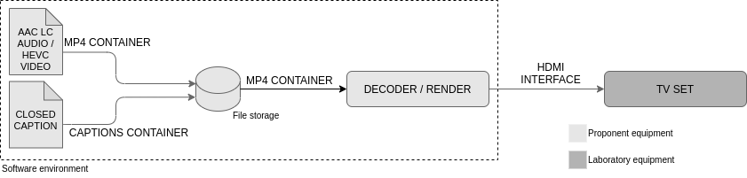
Figure 45: Captions test setup for decoding and rendering
For evaluations using the captions test setup, the elements in Figure 45 labeled as Software environment (hardware and software) are the proponent’s responsibility. The proponent’s decoder/render shall decode audio content and video content encapsulated in an MP4 container format. Proponent’s decoder/render shall use an HDMI interface to feed the TV set and demonstrate the captions system capabilities. The proponent software environment shall contain a mouse and a keyboard. It shall allow Test Lab analysts to switch captions on or off, toggle between multiple captions, and capture screenshots from what is being displayed on the TV set screen. Those screenshots shall be analyzed and saved by Test Lab analysts to verify the conformance of proponent technology in accordance with instructions to be provided in each Test Case.

Test 1 (Frame-accurate synchronization)
Each proponent’s system performance shall be evaluated for the following capability:
Test Case ID | TC1.1
Test Status | Mandatory
Test Description | Requirements CC1.1 and CC3.2:  - Shall demonstrate the system’s ability to present captions synchronized with the video content.  - Shall demonstrate the system’s ability to perform offline closed-captioning.
Test Setup | Setup as shown in Figure 45.
Test Content | Test items:  - Video content as specified in 4.6.2.  - Closed caption content containing text information that represents the timecode counter value (SS:FF) for each video frame. Closed caption rendering shall be aligned with the top right graphics safe margin, with a monospaced serif font, white color, black outline, using 10% of the screen height.
Test Procedure | For this test, conduct the following steps:  - Decode audio, video, and captions contents using the decoder/render. Present the result in the TV set.  - Evaluate if the closed caption content, containing the timecode values for seconds and frames, is correctly displayed on the TV set.  - Evaluate if the closed caption content, containing the timecode values for seconds and frames, presents those timecode values synchronized with the timecode counter burnt-in in the active video (aligned with the top left graphics safe margin). To verify the frame-accuracy in this step, take three screenshots from the content being exhibited on the TV set screen. Save the screenshots and register the frame difference between the timecode embedded in the active video and the timecode values exhibited as captioning.  Perceiving a difference greater than one frame during step 3 execution of this test procedure leads to failure of the test.

Test 2 (Character set)
Each proponent’s performance shall be evaluated for the following capabilities:
Test Case ID | TC2.1
Test Status | Mandatory
Test Description | Requirements CC2.1 and CC2.2:  - Shall demonstrate the system’s ability to present the correct complete character set currently used for closed captioning in Brazil (as specified in ABNT NBR 15610-1) and support to other languages character sets (Latin and non-Latin).
Test Setup | Setup as shown in Figure 45.
Test Content | Test items:  - Video content as specified in 4.6.2.  - Closed caption rendering shall be center-aligned with the bottom graphics safe margin, with a proportional sans-serif font, white color, black outline, using 5% of the screen height. Closed caption content shall be the following:  - From timecode 05:00 to 10:00 exhibit the caption “abcdefghijklmnopqrstuvwxyz”;  - From timecode 10:00 to 15:00 exhibit the caption “ABCDEFGHIJKLMNOPQRSTUVWXYZ”;  - From timecode 15:00 to 20:00 exhibit the caption “0123456789@!”#$%&’:(;)*+,-`/<|>\=?[.]_{^}~”;  - From timecode 20:00 to 25:00 exhibit the caption “áéíóúÁÉÍÓÚâêîôûÂÊÎÔÛãõÃÕàèìòùÀÈÌÒÙäëïöüÄËÏÖÜåÅ”;  - From timecode 25:00 to 30:00 exhibit the caption “çÇšŠœŒæÆñÑýÝÿŸžŽøØþÞßÐ±×÷⁰¹²³”;  - From timecode 30:00 to 35:00 exhibit the caption “© ® µ ¥ £ € ȼ § ͣ «»ㄱᄀ¿¯ ͦ ”;  - From timecode 35:00 to 40:00 exhibit the caption “♪¼½¾⅛⅜⅝⅞”;  - It is optional for the proponent to use the remaining video time to demonstrate the support of other languages' character sets (Latin and non-Latin).
Test Procedure | For this test, conduct the following steps:  - Decode audio, video, and captions contents using the decoder/render. Present the result in the TV set.  - Evaluate if the closed caption content is displayed correctly and matches the desired text sequence. To verify the match in this step, take screenshots of each character sequence exhibited on the TV set screen. Save the screenshots and compare the characters sequence registered in each of these screenshots with the desired characters sequence described in Test Content.  Perceiving any error or mismatch on step 2 of this test procedure leads to failure of the test.

Test 3 (Live and offline closed-captioning)
Each proponent’s performance shall be evaluated for the following capabilities:
Test Case ID | TC3.1
Test Status | Mandatory
Test Description | Requirement CC3.1:  - Shall demonstrate the system’s ability to perform live closed-captioning.
Test Setup | Proponents can provide their own setup.
Test Content | Proponents can provide their own test content. Test items shall contain:  - Video content;  - Audio content related to the video content.
Test Procedure | For this test, conduct the following steps:  - Prepare the systems to perform live captioning for the audio dialog content.  - Decode audio, video, and captions contents using the decoder/render. Present the result in the TV set.  - Evaluate if the closed caption content is correctly displayed on the TV set. Observe the system latency and look for anomalies in the captioning being displayed.  Perceiving any of those undesirable events during step 3 execution of this test procedure leads to failure of the test.
Requirement CC3.2: This requirement is verified during the execution of Test Case TC1.1.

Test 4 (Text styling control)
Each proponent’s performance shall be evaluated for the following capabilities:
Test Case ID | TC4.1
Test Status | Mandatory
Test Description | Requirement CC4.1, CC4.2, CC4.3, CC4.4, CC4.5, CC4.6, and CC4.7:  - Shall demonstrate how the captions system can manipulate text styling.
Test Setup | Setup as shown in Figure 45.
Test Content | Test items:  - Video content as specified in 4.6.2.  - Unless otherwise indicated, closed caption rendering shall be center-aligned with the bottom graphics safe margin, with a proportional sans-serif font, white color, black outline, using 5% of the screen height. Closed caption content shall be the following:  - From timecode 01:00 to 03:00 exhibit the caption “top line, right alignment, from 1s to 3s” aligned with the top right graphics safe margin;  - From timecode 03:00 to 05:00 exhibit the caption “middle line, left alignment, from 3s to 5s” middle aligned with the left graphics safe margin;  - From timecode 05:00 to 07:00 exhibit the caption “bottom line, center alignment, from 5s to 7s”;  - From timecode 07:00 to 09:00 exhibit the caption: “two simultaneous lines" (first line), and "from 7s to 9s” (second line).  - From timecode 09:00 to 11:00 exhibit the caption: “three" (first line), "simultaneous lines" (second line), and "from 9s to 11s” (third line).  - From timecode 11:00 to 13:00 exhibit the caption “bottom left, first line, from 11s to 20s” aligned with the bottom left graphics safe margin.  - At the timecode 13:00, the caption from step "f" shall be moved one line up to add the caption “add a second line from 13s” as a second caption line.  - At the timecode 15:00 the captions from steps "f" and "g" shall be moved one line up to add the caption “add a third line from 15s” as a third caption line.  - At the timecode 20:00 the first caption line, containing the caption “bottom left, first line, from 11s to 20s” shall be removed, the second caption line, containing the caption “add a second line from 13s” shall be moved to the first line, third caption line, containing caption the first “add a third line from 15s” shall be moved to the second line, and the third caption line shall display the caption “first line disappears as last line appears from 20s to 25s”.  - At the timecode 25:00 all three captions from step "i" shall disappear from the active video.  - From timecode 26:00 to 30:00 the caption “progressive: five words per second from 26s to 30s” shall be displayed progressively and with a speed of five words per second.  - From timecode 30:00 to 35:00 exhibit the caption: “text style" (first line), "normal, bold, italics, underline" (second line), and "from 30s to 35s” (third line). The caption on the second line shall be formatted as normal style for the word “normal”, as bold style for the word “bold”, as italics style for the word “italics”, and as underline style for the word “underline”.  - From timecode 35:00 to 40:00 exhibit the caption: “text and background color" (first line), "white, green, cyan, red, yellow, magenta, blue, black" (second line), and "from 35s to 40s” (third line). The caption on the second line shall be formatted with font color white and background color black for the word “white”, font color green and background color blue for the word “green”, font color cyan and background color magenta for the word “cyan”, font color red and background color yellow for the word “red”, font color yellow and background color red for the word “yellow”, font color magenta and background color cyan for the word “magenta”, font color blue and background color green for the word “blue” and font color black and background color white for the word “black”.  - From timecode 40:00 to 45:00 exhibit the caption: “text size" (first line), "size 3%, size 5%, size 7%, size 10%" (second line), and "from 40s to 45s” (third line). Caption on the second line shall use 3% of the screen height for the expression “size 3%,”, 5% of the screen height for the expression “size 5%,”, 7% of the screen height for the expression “size 7%,”, and 10% of the screen height for the expression “size 10%”.  - From timecode 45:00 to 50:00 exhibit the caption: “text font family" (first line), "monospaceSerif proportionalSansSerif" (second line), and "from 45s to 50s” (third line). Caption on the second line shall be formatted with font family monospaceSerif for the word “monospaceSerif” and with font family proportionalSansSerif for the word “proportionalSansSerif”.  Figure 46 illustrates the captions content to be used in this test procedure.
Test Procedure | For this test, conduct the following steps:  - Decode video and captions contents using the decoder/render. Present the result in the TV set.  - Evaluate if the closed captions are correctly exhibited on the active video screen in accordance with the conditions described from steps "a" to "o" for caption content in Test Content description of this test. To verify the match in this step, take screenshots of each step exhibited on the TV set screen. Save the screenshots and compare them with the description in Test Content and with Figure C2.  Incorrect display of the captions regarding one or more conditions from step 2, leads to failure of the test.
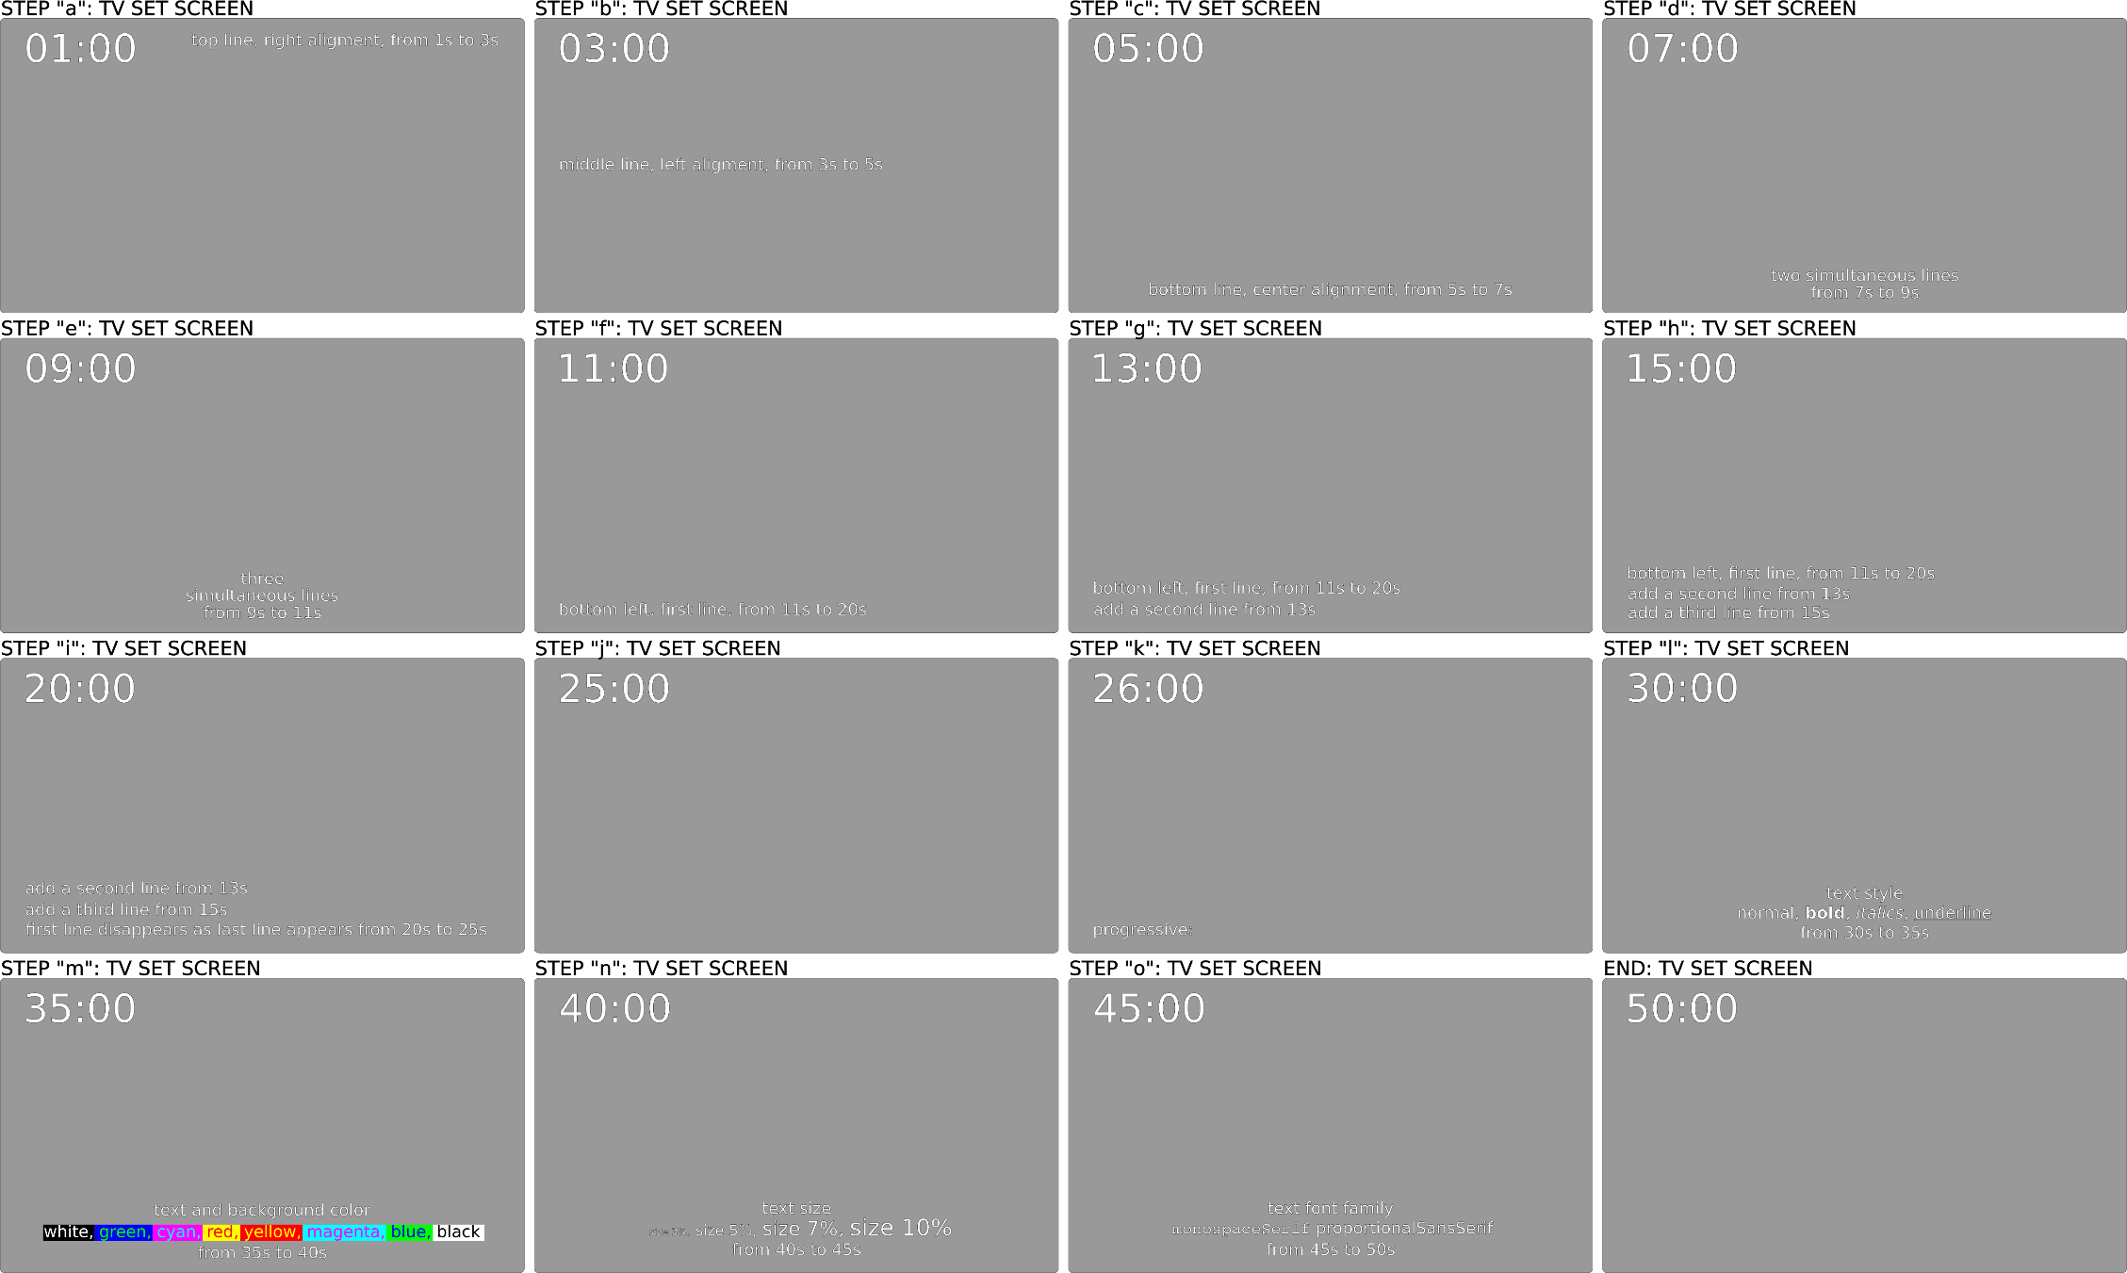
Figure 46: Captions content description for Test Case 4.1

Test 5 (Displaying non-textual information)
Each proponent’s performance shall be evaluated for the following capabilities:
Test Case ID | TC5.1
Test Status | Optional
Test Description | Requirement CC5.1:  - Shall demonstrate the system’s ability to display non-textual information, e.g., images.
Test Setup | Setup as shown in Figure 45.
Test Content | Proponents can provide their own test content. Test items shall contain:  - Video content;  - Audio content related to the video content;  - Image-based caption;  - Description of the caption content.
Test Procedure | For this test, conduct the following steps:  - Decode audio, video, and captions contents using the decoder/render. Present the result in the TV set.  - Evaluate the experience when each image sequence is displayed on the TV set, switching the captions on and off, and looking for anomalies in the image being displayed.  Perceiving any of those undesirable events specified in step 2 of this test procedure leads to failure of the test.

Test 6 (Multiple caption streams)
Each proponent’s performance shall be evaluated for the following capabilities:
Test Case ID | TC6.1
Test Status | Mandatory for Test items 1, 2, 3, 4, and 5.  Optional for Test items 6 and 7.
Test Description | Requirements CC6.1, CC7.1.1, CC7.1.2 and CC7.1.3:  - Shall demonstrate the system's ability to send multiple caption streams.
Test Setup | Setup as shown in Figure 45.
Test Content | Test items:  - Video content as specified in 4.6.2.  - Audio content as specified in 4.6.2;  - Closed caption 1 (CC-1) containing text information that represents the transcription of the audio content in one language (e.g., Portuguese). Closed caption 1 shall be formatted to use font color white on a black background color.  - Closed caption 2 (CC-2) containing text information that represents the transcription of the audio content in one language different from the chosen language on step 3 (e.g., English). Closed caption 2 shall be formatted to use font color green on a blue background color.  - Closed caption 3 (CC-3) containing text information that represents the transcription of the audio content in one language different from the chosen languages on steps 3 and 4 (e.g., Spanish). Closed caption 3 shall be formatted to use font color cyan on a magenta background color.  - Optional content. Proponents may choose not to use this. Closed caption 4 (CC-4) containing text information that represents the transcription of the audio content in one language different from the chosen languages on steps 3 to 5 (e.g., French). Closed caption 4 shall be formatted to use font color red on a yellow background color.  - Optional content. Proponents may choose not to use this. Closed caption 5 (CC-5) containing an image-based caption (description to be provided by the proponent).  - Optional content. Proponents may choose not to use this. Closed caption content 6 (CC-6) containing another image-based caption (description to be provided by the proponent).
Test Procedure | For this test, conduct the following steps:  - Decode audio, video, and captions contents using the decoder/render. Present the result in the TV set.  - Toggle between the available closed caption contents.  - Evaluate if each caption exhibition occurs in accordance with the content description. Look for anomalies in the captioning being displayed before and after switching.  Incorrect display of CC-1, CC-2, or CC-3 and/or inability to toggle between CC-1, CC-2, and CC-3, leads to failure of the test. The performance on displaying CC-4, CC-5, and CC-6 (and toggling among them) shall be registered for information but does not lead to failure of the test.

Test 7 (Emergency warning information)
Requirements CC7.1.1, CC7.1.2, and CC7.1.3: These requirements are verified during the execution of Test Case TC6.1.

Test 8 (Interoperability with different platforms)
Requirements CC8.1 and CC8.2: These requirements will not be analyzed with a feature test. The proponent’s documentation provided in the Documentation Analysis phase shall address these requirements.

Application Coding
The application coding requirements set in the TV 3.0 Call for Proposals document, against which the proposals of candidate technologies will be tested and evaluated, are repeated here for the convenience of the reader. For further details, please refer to the TV 3.0 Call for Proposals document.
use case |  | minimum technical specification |  | over-the-air delivery | Internet delivery
AP1 | Enable application re-use/interoperability with FSD_09 Ginga receiver profile (as defined in ABNT NBR 15606-1). | AP1.1 | FSD_09 Ginga receiver profile application re-use/interoperability | required | required
AP2 | Re-use, as much as possible, the implementation of the middleware components and subsystems used in FSD_09 Ginga receiver profile (as defined in ABNT NBR 15606-1). | AP2.1 | FSD_09 Ginga receiver profile middleware components and subsystems implementation re-use | required | required
AP3 | Support all the use cases supported in FSD_09 Ginga receiver profile (as defined in ABNT NBR 15606-1). | AP3.1 | FSD_09 Ginga receiver profile use cases support | required | required
AP4 | Support the new technologies to be adopted in the TV 3.0 project. | AP4.1 | support TV 3.0 transport layer | required | required
AP4 |  | AP4.2 | support TV 3.0 video coding | required | required
AP4 |  | AP4.3 | support TV 3.0 audio coding | required | required
AP4 |  | AP4.4 | support TV 3.0 captions | required | required
AP5 | Enable accessing lower-level (physical-layer/transport-layer/operating-system) information. | AP5.1 | access the identification of the TV network, the originating station, and the transmission station | required | N/A
AP5 |  | AP5.2 | access the receiver front-end parameters (RF channel, reception power in dBm and C/N in dB) | required | N/A
AP5 |  | AP5.3 | geolocation API with multiple sources of data such as transmission station, GPS, and assisted GPS (using Wi-Fi networks) | required | required
AP6 | Enable application-oriented TV. | AP6.1 | application-oriented user experience with TV | required | required
AP6 | Enable application-oriented TV. | AP6.2 | handling the presentation of all audiovisual content | required | required
AP6 | Enable application-oriented TV. | AP6.3 | application switching delay | lower is better | lower is better
AP7 | Support for Enhanced User Interface. | AP7.1 | voice interaction, pre-defined commands, and natural language | desirable | desirable
AP7 | Support for Enhanced User Interface. | AP7.2 | gesture interaction, at least with pre-defined gestures | desirable | desirable
AP7 | Support for Enhanced User Interface. | AP7.3 | multi-touch interaction, at least with pre-defined gestures | desirable | desirable
AP7 | Support for Enhanced User Interface. | AP7.4 | multimodal interaction, free input compositions | desirable | desirable
AP7 | Support for Enhanced User Interface. | AP7.5 | multi-device support, synchronous and asynchronous modes | required | required
AP7 | Support for Enhanced User Interface. | AP7.6 | multi-user identification support | required | required
AP7 | Support for Enhanced User Interface. | AP7.7 | multi-user interaction support | desirable | desirable
AP8 | Provide audience measurement common interface. | AP8.1 | standardized audience measurement API (taking multi-user identification support into account) | required | required
AP9 | Machine-learning support for context-awareness. | AP9.1 | machine-learning APIs | desirable | desirable
AP10 | Protect user privacy. | AP10.1 | API-based user privacy | required | required
AP10 | Protect user privacy. | AP10.2 | compliance with Brazilian General Personal Data Protection Act (Law nº 13.709/2018) | required | required
AP11 | Enable IP convergence. | AP11.1 | full IP convergence, both in broadcast and broadband channels | required | required
AP11 | Enable IP convergence. | AP11.2 | Internet of Things protocols and mechanisms | desirable | desirable
AP11 | Enable IP convergence. | AP11.3 | IP-based application push delivery | required | required
AP11 | Enable IP convergence. | AP11.4 | low-latency content forwarding | required | required
AP12 | Enable the streaming of accessibility services to a Smart TV or companion device app. | AP12.1 | audio description streaming to a Smart TV or companion device app | required | required
AP12 |  | AP12.2 | closed caption streaming to a Smart TV or companion device app (for it to display the closed caption or to perform automatic translation and adaptation from the closed caption to sign language) | required | required
AP12 |  | AP12.3 | sign language gloss streaming for a client-side application (in the Smart TV or companion device) to perform the synthesis of the sign language video | required | required
AP12 |  | AP12.4 | sign language video streaming to a Smart TV or companion device app | required | required
AP13 | Enable emergency warning information delivery using an interactive application. | AP13.1 | emergency warning information interactive application | desirable | desirable
AP14 | Support for Immersive TV. | AP14.1 | sensory effects (lighting, temperature, wind, scents, vibration) | desirable | desirable
AP14 | Support for Immersive TV. | AP14.2 | 3DoF video interaction | desirable | desirable
AP14 | Support for Immersive TV. | AP14.3 | 6DoF video interaction | desirable | desirable
AP14 | Support for Immersive TV. | AP14.4 | 3D object-based immersive audio interaction | required | required
AP14 | Support for Immersive TV. | AP14.5 | 3D media positioning and interaction | desirable | desirable
AP14 | Support for Immersive TV. | AP14.6 | VR / AR / XR support | desirable | desirable
AP15 | Support optimized application transport. | AP15.1 | inherent compression support | required | required
AP15 | Support optimized application transport. | AP15.2 | multi-sourced application delivery | required | required
AP16 | Support multi-sourced scalable content. | AP16.1 | multi-sourced scalable content API | required | required
AP17 | Enable future extensions to the middleware (e.g. to support new features in future receiver profiles). | AP17.1 | extensibility | required | required
AP-AR1. Provide interoperability test suite with its corresponding documentation.
AP-AR2. Provide information about available prototypes of the proposed middleware components.
AP-AR3. Provide some reference information about the middleware for TV sets manufacturing.
SBTVD Forum will define the application coding specification for TV 3.0 as a collection of selected proposals, no matter if they were submitted by different proponents. This approach focuses on delivering the best specification as a whole, for a layer that SBTVD Forum historically holds control and high expertise. Therefore, it is expected that after the evaluation phase SBTVD Technical Module members will start a joint work to select, adjust, harmonize, and improve the proposed solutions.
Selected solutions will proceed to the next phase if their respective proponents commit to contributing with SBTVD Forum on drafting the normative specifications and implementing its test suite.
In the subsequent subsections, the following definitions are adopted:
- solution: term that identifies the set of documentation and software components needed for a use case application to be executed and thus demonstrate how a specific requirement (or some of its aspects) is addressed.
- use case application: a digital TV application pushed from a server to a presentation environment that implements a demonstration of a given requirement (or some of its aspects) being addressed.

Expected deliverables
Proposals targeted at any AP requirement, given its software nature, are expected to include the needed documentation, prototypes, additional software, and hardware for a complete and independent demonstration on how the proposal is designed, how it works internally, and how it behaves under execution.
A single proposal may address just a subset of AP requirements, where AP1.1 and AP2.1 are always mandatory to be included in the subset. Proponents are not required to submit proposals for the whole AP requirement list. For fairness on the testing and evaluation procedures, proponents that wish to present their solutions targeting multiple requirements are allowed and recommended to submit different proposals, each one specifically targeted at a requirement or a small subset of requirements.
Except where otherwise noted, the expected deliverables for each submission are:
- Specification Document: Describes the proposed solution, including an architectural overview, design principles, API specifications (syntax and semantics), protocols, and any other relevant information. Proponents are expected to identify how the solution is implemented in the FSD_09 Ginga receiver profile (e.g.: extending Ginga-NCL, Ginga CC WebServices, as an application, etc.). Format: PDF file.
- Software Prototypes:
  - Runtime Prototype: Implementation of the presentation environment needed to receive a use case application and run it. Format: LXC 3.0 container (ready to run, includes all binaries and dependencies; source code if possible).
  - Push-server Prototype: Implementation of the broadcaster environment needed to transmit the use case application. Format: LXC 3.0 container (ready to run, includes all binaries and dependencies; source code if possible).
  - Prototype Specification Document: Describes the implementation of both Runtime and Push-server prototypes, including design and architecture, dependencies, programming languages, and user instructions. Format: PDF file.
- Use-case applications: applications that implement demonstrations of the addressed aspects of a given requirement. Format: Files included in the Broadcaster Container (ready to be transmitted; source code required).
  - Companion apps/servers: any other software component that shall run in a companion environment, if needed, different from the presentation and broadcaster environments. Format: LXC 3.0 container (ready to run, includes all binaries and dependencies; source code if possible).
  - End-user documentation: User instructions for all included use case applications and companion apps/servers. Format: PDF file.
- Additional hardware: any other hardware that shall be used by the apps at runtime. The hardware will be connected to one of the ports or network interfaces available in the common testing environment; the power supply must be AC 100 V to 240 V, 50/60 Hz.
  - End-user documentation: User instructions for the additional hardware. Format: PDF file.
- Proponent's testing report: describes methodology and results for test procedures carried out by the proponent on its premises (optional). The proponent's testing methodology must be in accordance with the procedures defined in this document. Format: PDF File.
Figure 47: AP Expected Deliverables

Common testing environment specification
Envisaging a fair and reproducible process, SBTVD Forum appointed Test Labs will have a common testbed setup. This common testing environment is also advised to be mounted at proponents' premises for local validations of their prototypes and apps before submission.
The common testing environment includes equipment based on commercial hardware and software platforms. It can be divided into three subsystems as follows:
- Network subsystem: specifies the network equipment, links, and protocols that interconnect the presentation subsystem, the companion subsystem, and the Internet;
- Presentation subsystem: specifies hardware and software platforms dedicated to run the runtime prototype (Presentation Environment Container);
- Companion subsystem: specifies hardware and software platforms dedicated to run the push server prototype (Broadcaster Container) as well as the companion apps/servers (Companion Container).
Figure 48 illustrates the common testing environment.
Figure 48: Common testing environment

Network subsystem
A wired network interconnects all subsystems and connects them to the Internet. A wireless network is also included only for connecting additional hardware if needed. The following equipment and specifications define the network subsystem:
Dedicated GbE L2 switch: Gigabit Ethernet switch, 24 ports (1000BASE-T), L2, 176 Gbps switching fabric. Interconnects the presentation subsystem, the companion subsystem, the wireless hotspot, and the Internet.
Dedicated 802.11ac access point: Dual-band IEEE802.11ac access point, L2, 450 Mbps bandwidth. Can be used for connecting additional hardware only.
Local NTP Server: Server PC running NTP daemon providing synchronization accuracy lower than 2 ms, 1000BASE-T interface.
Internet connection: Connection supporting at least 50 Mbps. Can be used only for media/data delivery (no application logic, except where otherwise noted).

Presentation subsystem
The presentation subsystem runs the runtime prototype included in the Presentation Environment Container. The following equipment and specifications define the presentation subsystem:
Presentation environment: ARM-based system-on-a-chip device:
Hardware specs:
Cortex-A72 (ARM v8), 64-bit, Quad-core 1.5GHz
4 GB LPDDR4-3200 SDRAM
SD Card 64GB
H.265 (4kp60 decode), H264 (1080p60 decode, 1080p30 encode)
1080p TV HDMI 2.0
Connectivity: 1000BASE-T interface, Bluetooth 5.0, 2 USB 3.0 ports. May be used for connecting additional hardware.
USB keyboard and mouse
Software specs:
Ubuntu Server Linux 20.04.1 LTS
(ubuntu-20.04.1-preinstalled-server-arm64+raspi.img.xz)
Container hypervisor LXC/LXD 3.0
Presentation Environment Container will be limited to: 2 GB RAM, 2 CPUs

Companion subsystem
The companion subsystem runs the push-server prototype included in the Broadcaster Container, as well as any companion app/server included in the Companion Container if needed. The following equipment and specifications define the presentation subsystem:
Companion environment: Business-grade Desktop PC:
Hardware specs:
Intel Core i5-6500 3.2 GHz 4-core 6 MB cache
8 GB DDR4 RAM 2133 MHz
HDD SATA 7200RPM 500 GB
Intel HD Graphics 530 (1080p@60 Hz) HDMI 1.4
H.264 hardware acceleration
1080p Monitor HDMI 1.4
Connectivity: 1000BASE-T interface, Bluetooth 5.0, 2 USB 3.0 ports. May be used for connecting additional hardware.
USB keyboard and mouse
Software specs:
Ubuntu Linux 20.04.1 LTS (ubuntu-20.04.1-server-amd64.iso)
Container hypervisor LXC/LXD 3.0
Containers’ resources will not be limited

Common testing steps
The following testing steps are commonly applied to submitted solutions, except where otherwise noted. The steps shall be executed by a group of two lab analysts.
- Start procedural recording
- Container instantiation and bootstrap tests
  - Instantiation of Presentation Environment Container in the Presentation Environment
  - Instantiation of Broadcaster Container in the Companion Environment
  - Instantiation of Companion Container in the Companion Environment (if applicable)
  - Bootstrap tests, from a container point of view: liveness, connectivity, resources
  - Clock synchronization using NTP local server, accuracy better than 2 ms
- t0: Launch push-server instance
- t1: Launch use-case app transmission
- t2: Launch companion app/server instance(s) (if applicable)
- t3: Launch prototype instance
- t4: Interact with and observe use case app and companion app (if applicable)
- Stop use-case app transmission
- Repeat Steps D to H for each use-case app included in the Broadcaster Container
- Stop procedural recording
- Fill in the evaluation form
NOTE Each instant (t1...t4) depends on the time needed to launch the previous component and will be limited to 30 s.

Evaluation methodology
Considering that the evaluation will aim at both the proposed Specification (API/Architecture, interface, framework, library) and the proposed Prototypes, together with the use case apps, the methodology will follow ISO/IEC 25010 (2011) Systems and software engineering — Systems and software Quality Requirements and Evaluation (SQuaRE) — System and software quality models. The methodology includes qualitative and quantitative evaluation criteria, organized by categories.
The following template applies to each requirement and since some categories or questions may not apply to all requirements, the template is adapted on a case-by-case basis (see 4.7.5). Qualitative questions shall be answered with "Yes", "No" or "Partially", accompanied by justification in any case. Quantitative questions shall be answered with a number in their respective unit of measurement.
Evaluation Form for Requirement AP x.y
Test procedure identification
Requirement description:
Evaluator identification data:
Proponent identification data: (anonymized)
Evaluated artifacts (identifies spec. documents, prototypes/use case apps):
Category 1: Functional Suitability
Q1.1 Does the proposed specification completely address the requirement? (Functional Completeness)
Q1.2 Does the proposed prototype and use case apps run as expected? (Functional Correctness)
Q1.3 Does the proposed use case apps demonstrate the required feature? (Functional Appropriateness)
Category 2: Performance Efficiency
Focuses on runtime environment: prototype running a use case app
Q2.1 Average CPU Load (%);
Q2.2 Peak CPU Load (%);
Q2.3 Peak Volatile memory usage (RAM in MiB);
Q2.4 Peak Persistent memory usage (HD in MiB);
Q2.5 Average network bandwidth (in/out in Mbps);
Q2.6 Peak network bandwidth (in/out in Mbps);
Q2.7 Overall latency – environment loading + app delivery + app start + data presentation (ms)
Category 3: Compatibility
Q3.1 Is the proposed specification in line with the backward compatibility with interactive receiver profiles (see ABNT NBR 15606-1)? (Co-existence)
Q3.2 Does the proposed specification use standardized/open protocols and data formats? (Interoperability)
Category 4: Usability
Q4.1 Is the proposed specification appropriate to developers’ needs? (Appropriateness)
Q4.2 Is the proposed specification easy to be learned by developers? (Learnability)
Q4.3 How prone to errors is the use of the proposed specification? (User error protection)
Q4.4 Are the use case apps easy to use? (Learnability)
Q4.5 What is the QoE level of use case apps? (User interface aesthetics) (Rating 1-5)
Category 5: Reliability
Q5.1 How far the proposed specification has been validated and adopted? (Maturity)
Q5.2 Is the proposed specification based on mature technologies? (Maturity)
Q5.3 Do the specification/prototype employ fault-tolerance methods? (Fault tolerance)
Q5.4 Do the specification/prototype employ data/system recovery methods? (Recoverability)
Category 6: Security
Q6.1 Do the specification/prototype employ user data protection? (Confidentiality)
Q6.2 Do the specification/prototype prevent unauthorized use of user data? (Integrity)
Q6.3 Do the specification/prototype ensure the identity of users? (Authenticity)
Category 7: Maintainability
Q7.1 Is the proposed specification self-contained and attachable to other software components? (Modularity and reusability)
Q7.2 Is the proposed specification easy to be modified and extended? (Modifiability)
Q7.3 Does the proposed specification provide the elements needed for a test suite specification? (Testability)
Category 8: Portability
Q8.1 Can the specification be adapted to different software environments? (Adaptability)
Q8.2 Do the specification and/or prototype depend on specific hw/sw platforms? (Installability)

Requirement-specific notes
Use case:
AP1 Enable application re-use/interoperability with FSD_09 Ginga receiver profile (as defined in ABNT NBR 15606-1).
Requirement:
AP1.1 FSD_09 Ginga receiver profile application re-use/interoperability
Minimum set of deliverables: Specification Document
Applicable evaluation categories: 1, 3, 4, 5, 7, 8
Applicable evaluation questions: Q1.1, Q3.All, Q4.1, Q4.2, Q4.3, Q5.1, Q5.2, Q7.All, Q8.All

Use case:
AP2 Re-use, as much as possible, the implementation of the middleware components and subsystems used in FSD_09 Ginga receiver profile (as defined in ABNT NBR 15606-1).
Requirement:
AP2.1 FSD_09 Ginga receiver profile middleware components and subsystems implementation re-use
Minimum set of deliverables: Specification Document
Applicable evaluation categories: 1, 3, 4, 5, 7, 8
Applicable evaluation questions: Q1.1, Q3.All, Q4.1, Q4.2, Q4.3, Q5.1, Q5.2, Q7.All, Q8.All

Use case:
AP3 Support all the use cases supported in FSD_09 Ginga receiver profile (as defined in ABNT NBR 15606-1).
Requirement:
AP3.1 FSD_09 Ginga receiver profile use cases support
Minimum set of deliverables: Specification Document
Applicable evaluation categories: 1, 3, 4, 5, 7, 8
Applicable evaluation questions: Q1.1, Q3.All, Q4.1, Q4.2, Q4.3, Q5.1, Q5.2, Q7.All, Q8.All

Use case:
AP4 Support the new technologies to be adopted in the TV 3.0 project.
Requirement:
AP4.1 support TV 3.0 transport layer
Minimum set of deliverables: Specification Document
Applicable evaluation categories: 1, 3, 4, 5, 7, 8
Applicable evaluation questions: Q1.1, Q3.All, Q4.1, Q4.2, Q4.3, Q5.1, Q5.2, Q7.All, Q8.All
Requirement:
AP4.2 support TV 3.0 video coding
Minimum set of deliverables: Specification Document
Applicable evaluation categories: 1, 3, 4, 5, 7, 8
Applicable evaluation questions: Q1.1, Q3.All, Q4.1, Q4.2, Q4.3, Q5.1, Q5.2, Q7.All, Q8.All
Requirement:
AP4.3 support TV 3.0 audio coding
Minimum set of deliverables: Specification Document
Applicable evaluation categories: 1, 3, 4, 5, 7, 8
Applicable evaluation questions: Q1.1, Q3.All, Q4.1, Q4.2, Q4.3, Q5.1, Q5.2, Q7.All, Q8.All
Requirement:
AP4.4 support TV 3.0 captions
Minimum set of deliverables: Specification Document
Applicable evaluation categories: 1, 3, 4, 5, 7, 8
Applicable evaluation questions: Q1.1, Q3.All, Q4.1, Q4.2, Q4.3, Q5.1, Q5.2, Q7.All, Q8.All

Use case:
AP5 Enable accessing lower-level (physical-layer/transport- layer/operating-system) information.
NOTE Proponents may adopt any IP-based transport and other simulated information for prototyping.
Requirement:
AP5.1 access the identification of the TV network, the originating station, and the transmission station
Minimum set of deliverables: Specification Document, Runtime Prototype, Push-server Prototype, Prototype Specification Document, Use-case applications, End-user documentation
Applicable evaluation categories: All
Applicable evaluation questions: All
Requirement:
AP5.2 access the receiver front-end parameters (RF channel, reception power in dBm and C/N in dB)
Minimum set of deliverables: Specification Document, Runtime Prototype, Push-server Prototype, Prototype Specification Document, Use-case applications, End-user documentation
Applicable evaluation categories: All
Applicable evaluation questions: All
Requirement:
AP5.3 geolocation API with multiple sources of data such as transmission station, GPS, and assisted GPS (using Wi-Fi networks)
Minimum set of deliverables: Specification Document, Runtime Prototype, Push-server Prototype, Prototype Specification Document, Use-case applications, End-user documentation
Applicable evaluation categories: All
Applicable evaluation questions: All

Use case:
AP6 Enable application-oriented TV.
Requirement:
AP6.1 application-oriented user experience with TV
Minimum set of deliverables: Specification Document, Runtime Prototype, Push-server Prototype, Prototype Specification Document, Use-case applications, End-user documentation
Applicable evaluation categories: All
Applicable evaluation questions: All
Requirement:
AP6.2 handling the presentation of all audiovisual content
Minimum set of deliverables: Specification Document, Runtime Prototype, Push-server Prototype, Prototype Specification Document, Use-case applications, End-user documentation
Applicable evaluation categories: All
Applicable evaluation questions: All
Requirement:
AP6.3 application switching delay
Minimum set of deliverables: Specification Document, Runtime Prototype, Push-server Prototype, Prototype Specification Document, Use-case applications, End-user documentation
Applicable evaluation categories: All
Applicable evaluation questions: All

Use case:
AP7 Support for Enhanced User Interface.
Requirement:
AP7.1 voice interaction, pre-defined commands, and natural language
Minimum set of deliverables: Specification Document, Runtime Prototype, Push-server Prototype, Prototype Specification Document, Use-case applications, End-user documentation, additional hardware, and its end-user documentation
Applicable evaluation categories: All
Applicable evaluation questions: All
Requirement:
AP7.2 gesture interaction, at least with pre-defined gestures
Minimum set of deliverables: Specification Document, Runtime Prototype, Push-server Prototype, Prototype Specification Document, Use-case applications, End-user documentation, additional hardware, and its end-user documentation
Applicable evaluation categories: All
Applicable evaluation questions: All
Requirement:
AP7.3 multi-touch interaction, at least with pre-defined gestures
Minimum set of deliverables: Specification Document, Runtime Prototype, Push-server Prototype, Prototype Specification Document, Use-case applications, End-user documentation, additional hardware, and its end-user documentation
Applicable evaluation categories: All
Applicable evaluation questions: All
Requirement:
AP7.4 multimodal interaction, free input compositions
Minimum set of deliverables: Specification Document, Runtime Prototype, Push-server Prototype, Prototype Specification Document, Use-case applications, End-user documentation, additional hardware, and its end-user documentation
Applicable evaluation categories: All
Applicable evaluation questions: All
Requirement:
AP7.5 multi-device support, synchronous and asynchronous modes
Minimum set of deliverables: Specification Document, Runtime Prototype, Push-server Prototype, Prototype Specification Document, Use-case applications, Companion apps, End-user documentation
Applicable evaluation categories: All
Applicable evaluation questions: All
Requirement:
AP7.6 multi-user identification support
Minimum set of deliverables: Specification Document, Runtime Prototype, Push-server Prototype, Prototype Specification Document, Use-case applications, End-user documentation
Applicable evaluation categories: All
Applicable evaluation questions: All
Requirement:
AP7.7 multi-user interaction support
Minimum set of deliverables: Specification Document, Runtime Prototype, Push-server Prototype, Prototype Specification Document, Use-case applications, End-user documentation
Applicable evaluation categories: All
Applicable evaluation questions: All

Use case:
AP8 Provide audience measurement common interface.
Requirement:
AP8.1 standardized audience measurement API (taking multi-user identification support into account)
Minimum set of deliverables: Specification Document, Runtime Prototype, Push-server Prototype, Prototype Specification Document, Use-case applications, End-user documentation
Applicable evaluation categories: All
Applicable evaluation questions: All

Use case:
AP9 Machine-learning support for context-awareness.
Requirement:
AP9.1 machine-learning APIs
Minimum set of deliverables: Specification Document, Runtime Prototype, Push-server Prototype, Prototype Specification Document, Use-case applications, End-user documentation
Applicable evaluation categories: All
Applicable evaluation questions: All

Use case:
AP10 Protect user privacy.
Requirement:
AP10.1 API-based user privacy
Minimum set of deliverables: Specification Document, Runtime Prototype, Push-server Prototype, Prototype Specification Document, Use-case applications, End-user documentation
Applicable evaluation categories: All
Applicable evaluation questions: All
Requirement:
AP10.2 compliance with Brazilian General Personal Data Protection Act (Law no 13.709/2018)
Minimum set of deliverables: Specification Document, Runtime Prototype, Push-server Prototype, Prototype Specification Document, Use-case applications, End-user documentation
Applicable evaluation categories: All
Applicable evaluation questions: All

Use case:
AP11 Enable IP convergence.
Requirement:
AP11.1 full IP convergence, both in broadcast and broadband channels
Minimum set of deliverables: Specification Document, Runtime Prototype, Push-server Prototype, Prototype Specification Document, Use-case applications, End-user documentation
Applicable evaluation categories: All
Applicable evaluation questions: All
Requirement:
AP11.2 Internet of Things protocols and mechanisms
Minimum set of deliverables: Specification Document, Runtime Prototype, Push-server Prototype, Prototype Specification Document, Use-case applications, End-user documentation
Applicable evaluation categories: All
Applicable evaluation questions: All
Requirement:
AP11.3 IP-based application push delivery
Minimum set of deliverables: Specification Document, Runtime Prototype, Push-server Prototype, Prototype Specification Document, Use-case applications, End-user documentation
Applicable evaluation categories: All
Applicable evaluation questions: All
Requirement:
AP11.4 low-latency content forwarding
Minimum set of deliverables: Specification Document, Runtime Prototype, Push-server Prototype, Prototype Specification Document, Use-case applications, Companion apps, End-user documentation
Applicable evaluation categories: All
Applicable evaluation questions: All

Use case:
AP12 Enable the streaming of accessibility services to a Smart TV or companion device app.
Requirement:
AP12.1 audio description streaming to a Smart TV or companion device app
Minimum set of deliverables: Specification Document, Runtime Prototype, Push-server Prototype, Prototype Specification Document, Use-case applications, Companion apps, End-user documentation
Applicable evaluation categories: All
Applicable evaluation questions: All
Requirement:
AP12.2 closed caption streaming to a Smart TV or companion device app (for it to display the closed caption or to perform automatic translation and adaptation from the closed caption to sign language)
Minimum set of deliverables: Specification Document, Runtime Prototype, Push-server Prototype, Prototype Specification Document, Use-case applications, Companion apps, End-user documentation
Applicable evaluation categories: All
Applicable evaluation questions: All
Requirement:
AP12.3 sign language gloss streaming for a client-side application (in the Smart TV or companion device) to perform the synthesis of the sign language video
Minimum set of deliverables: Specification Document, Runtime Prototype, Push-server Prototype, Prototype Specification Document, Use-case applications, Companion apps, End-user documentation
Applicable evaluation categories: All
Applicable evaluation questions: All
Requirement:
AP12.4 sign language video streaming to a Smart TV or companion device app
Minimum set of deliverables: Specification Document, Runtime Prototype, Push-server Prototype, Prototype Specification Document, Use-case applications, Companion apps, End-user documentation
Applicable evaluation categories: All
Applicable evaluation questions: All

Use case:
13 Enable emergency warning information delivery using an interactive application.
Requirement:
AP13.1 emergency warning information interactive application
Minimum set of deliverables: Specification Document, Runtime Prototype, Push-server Prototype, Prototype Specification Document, Use-case applications, End-user documentation
Applicable evaluation categories: All
Applicable evaluation questions: All

Use case:
AP14 Support for Immersive TV.
Requirement:
AP14.1 sensory effects (lighting, temperature, wind, scents, vibration)
Minimum set of deliverables: Specification Document, Runtime Prototype, Push-server Prototype, Prototype Specification Document, Use-case applications, End-user documentation, Additional hardware, and its end-user documentation
Applicable evaluation categories: All
Applicable evaluation questions: All
Requirement:
AP14.2 3DoF video interaction
Minimum set of deliverables: Specification Document, Runtime Prototype, Push-server Prototype, Prototype Specification Document, Use-case applications, End-user documentation
Applicable evaluation categories: All
Applicable evaluation questions: All
Requirement:
AP14.3 6DoF video interaction
Minimum set of deliverables: Specification Document, Runtime Prototype, Push-server Prototype, Prototype Specification Document, Use-case applications, End-user documentation
Applicable evaluation categories: All
Applicable evaluation questions: All
Requirement:
AP14.4 3D object-based immersive audio interaction
Minimum set of deliverables: Specification Document, Runtime Prototype, Push-server Prototype, Prototype Specification Document, Use-case applications, End-user documentation, Additional hardware, and its end-user documentation
Applicable evaluation categories: All
Applicable evaluation questions: All
Requirement:
AP14.5 3D media positioning and interaction
Minimum set of deliverables: Specification Document, Runtime Prototype, Push-server Prototype, Prototype Specification Document, Use-case applications, End-user documentation
Applicable evaluation categories: All
Applicable evaluation questions: All
Requirement:
AP14.6 VR / AR / XR support
Minimum set of deliverables: Specification Document, Runtime Prototype, Push-server Prototype, Prototype Specification Document, Use-case applications, End-user documentation, Additional hardware, and its end-user documentation
Applicable evaluation categories: All
Applicable evaluation questions: All

Use case:
AP15 Support optimized application transport.
Requirement:
AP15.1 inherent compression support
Minimum set of deliverables: Specification Document, Runtime Prototype, Push-server Prototype, Prototype Specification Document, Use-case applications, End-user documentation
Applicable evaluation categories: All
Applicable evaluation questions: All
Requirement:
AP15.2 multi-sourced application delivery
Minimum set of deliverables: Specification Document, Runtime Prototype, Push-server Prototype, Prototype Specification Document, Use-case applications, End-user documentation
Applicable evaluation categories: All
Applicable evaluation questions: All

Use case:
AP16 Support multi-sourced scalable content.
Requirement:
AP16.1 multi-sourced scalable content API
Minimum set of deliverables: Specification Document, Runtime Prototype, Push-server Prototype, Prototype Specification Document, Use-case applications, End-user documentation
Applicable evaluation categories: All
Applicable evaluation questions: All

Use case:
AP17 Enable future extensions to the middleware (e.g. to support new features in future receiver profiles).
Requirement:
AP17.1 extensibility
Minimum set of deliverables: Specification Document, Runtime Prototype, Push-server Prototype, Prototype Specification Document, Use-case applications, End-user documentation
Applicable evaluation categories: 1, 3, 4, 5, 6, 7, 8
Applicable evaluation questions: Q1.All, Q3.All, Q4.1, Q4.2, Q5.All, Q6.All, Q7.All, Q8.All

Schedule
The overall schedule for TV 3.0 standardization involves receiving proposals of candidate technologies between the end of 2020 and the beginning of 2021, evaluating and comparing the proposals in mid-2021, selecting the appropriate technologies for each system component by the end of 2021, and developing the standards in the first semester of 2022. The TV 3.0 Call for Proposals document (available at https://forumsbtvd.org.br/wp-content/uploads/2020/07/SBTVDTV-3-0-CfP.pdf) already provided the information on how to provide Phase 1 responses. Subsection 5.1 presents the deadlines and procedures for responding the Phase 2 of this Call for Proposals.

Responding to Phase 2 of the TV 3.0 Call for Proposals
The TV 3.0 Call for Proposals is open for any interested organization to submit its proposed candidate technologies for any of the system components or sub-components. One proponent can provide multiple responses, either to address multiple components or sub-components, or to provide alternative technology options for the same component or sub-component. Joint contributions from multiple organizations are also allowed and encouraged (as they indicate broader support for the proposed candidate technologies).
To respond to Phase 2 of the TV 3.0, it's necessary to provide the Phase 1 response first. Please refer to the TV 3.0 Call for Proposals document for further details.
By 29 January 2021, the following documentation shall be provided by e-mail to the SBTVD Forum:
- The full specification of the technical proposal, preferably in technical standards of internationally recognized SDOs;
- Commitment to fair, reasonable, and non-discriminatory licensing (or any other form of commercialization) of the technical proposal, as specified in the SBTVD Forum Intellectual Property Rights Policy (see the TV 3.0 Call for Proposals document, Annex A);
- All the information requested in the "Additional Requirements" subsections of the TV 3.0 component corresponding to the technical proposal, e.g., about the available implementations of the proposed technology (see the TV 3.0 Call for Proposals document);
- Commitment to contribute with SBTVD Forum on drafting the TV 3.0 normative specifications and implementing its conformity assessment tests (reference implementations, reference streams, test suites, etc.) if their proposed candidate technologies are fully or partially adopted.
This documentation shall be directed to:
Mauricio Kakassu, Superintendent, SBTVD Forum: superintendencia@forumsbtvd.org.br
Doris Guardia, Secretary, SBTVD Forum: secretaria@forumsbtvd.org.br
NOTE This documentation deadline does not apply to the delivery of hardware, software, or test content requested in the "Additional Requirements" subsections of the TV 3.0 Call for Proposals document and further specified in this document, or to the proponent's test results reports. The deadlines for those deliverables are specified as follows.
All the equipment required for testing as specified in this document, shall be delivered between 01 March 2021 and 02 April 2021 in the SBTVD Forum office, at the following address:
Rua Manoel da Nóbrega, 211 – Paraíso – São Paulo – SP – Brazil – 04001-081
The Test Labs will be responsible for picking up this equipment in the SBTVD Forum office between 05 and 16 April 2021 and returning it after the tests, between 20 September 2021 and 01 October 2021.
The proponent shall collect the equipment in the SBTVD Forum office between 04 October 2021 and 05 November 2021.
The proponent is responsible for all its inbound and outbound logistic costs, including customs clearance, if applicable.
All audio and video test content items required for testing as specified in 4.4.3 and 4.5.3 shall be delivered by 29 January 2021. All the other test content and software files required for testing as specified in this document, as well as the proponent's test results reports (including subjective quality assessment reports as specified in 4.4.2 and 4.5.2 and objective test results as specified in 4.4.3), shall be delivered by 02 April 2021. For instructions on how to submit the appropriate files, please contact the SBTVD Forum by e-mail.
All the deadlines refer to 23:59 UTC-3 time zone.
SBTVD Forum will notify the proponents upon the receiving of TV 3.0 Call for Proposals responses (Phase 1 and 2) and all related deliverables.
Proponents may be required to provide clarifications deemed necessary by the SBTVD Forum regarding their Call for Proposals responses (in Phase 1 and Phase 2), their documentation, their equipment, their software, their test content files, or unexpected test results involving their proposed candidate technologies.
Proponents may be invited to participate remotely in specific SBTVD Forum meetings, on mutually agreed dates and times, to present and discuss their proposed candidate technologies.
Questions related to this document should be directed to:
Luiz Fausto, Chair, Technical Module, SBTVD Forum: luiz.fausto@forumsbtvd.org.br
Doris Guardia, Secretary, SBTVD Forum: secretaria@forumsbtvd.org.br

SBTVD Forum Disclaimer
SBTVD Forum reserves the right to modify or withdraw this document without notice.

